Assignment 1
  - Deadline: Tuesday 20/9/2022 @ 23:59
[Total Mark for this Assignment is 8]

Digital Logic design
CS231

Instructions:
- You must submit two separate copies (one Word file and one PDF file) using the Assignment Template on Blackboard via the allocated folder. These files must not be in compressed format.
- It is your responsibility to check and make sure that you have uploaded both the correct files.
- Zero mark will be given if you try to bypass the SafeAssign (e.g. misspell words, remove spaces between words, hide characters, use different character sets, convert text into image or languages other than English or any kind of manipulation).
- Email submission will not be accepted.
- You are advised to make your work clear and well-presented. This includes filling your information on the cover page.
- You must use this template, failing which will result in zero mark.
- You MUST show all your work, and text must not be converted into an image, unless specified otherwise by the question.
- Late submission will result in ZERO mark.
- The work should be your own, copying from students or other resources will result in ZERO mark.
- Use Times New Roman font for all your answers.
Student Details:
Name: ###  CRN: ### |  | ID: ###

Question One
1.5 Marks
Learning Outcome (1):
Define the concepts, tools and techniques for the design of digital logic and integrated circuits.

Convert the following numbers to required system. Write details of conversion.

$${(57)}_{10}$$ | $${( )}_{2}$$
$${(5be)}_{16}$$ | $${( )}_{2}$$
$${(110.01)}_{2}$$ | $${( )}_{10}$$
$${(1011001000110101)}_{2}$$ | $${( )}_{16}$$
$${(412)}_{8}$$ | $${( )}_{2}$$
$${(11000011)}_{2}$$ | $${( )}_{10}$$

Question Two
1 Marks
Learning Outcome (1):
Define the concepts, tools and techniques for the design of digital logic and integrated circuits.

Given X= 101011, Y= 110111. Find X-Y and Y-X.

Question Three
2.25 Marks
Learning Outcome (1):
Define the concepts, tools and techniques for the design of digital logic and integrated circuits.

Examine each of the logic circuits below and obtain a corresponding Boolean function / expression. Mention the output after each logic operation is performed within each logic circuit (by drawing equivalent labelled logic circuit mentioning output after each logic operation is performed).

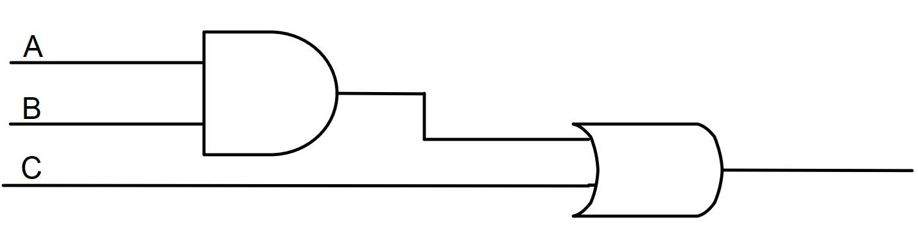

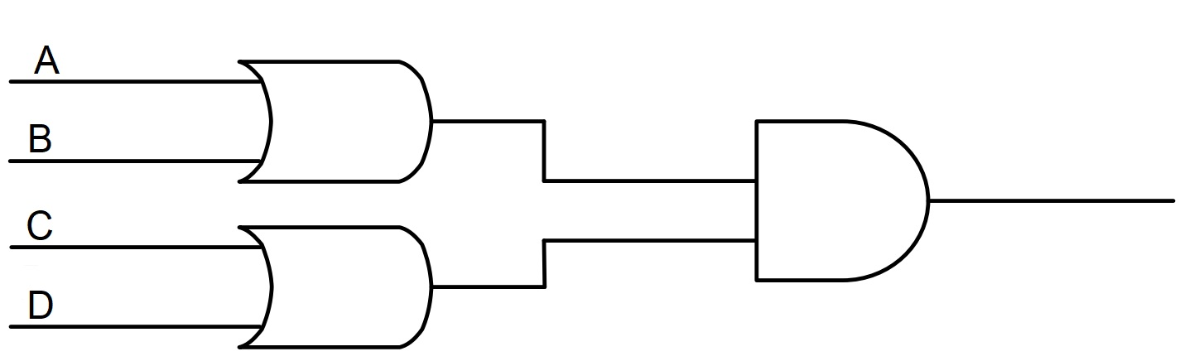

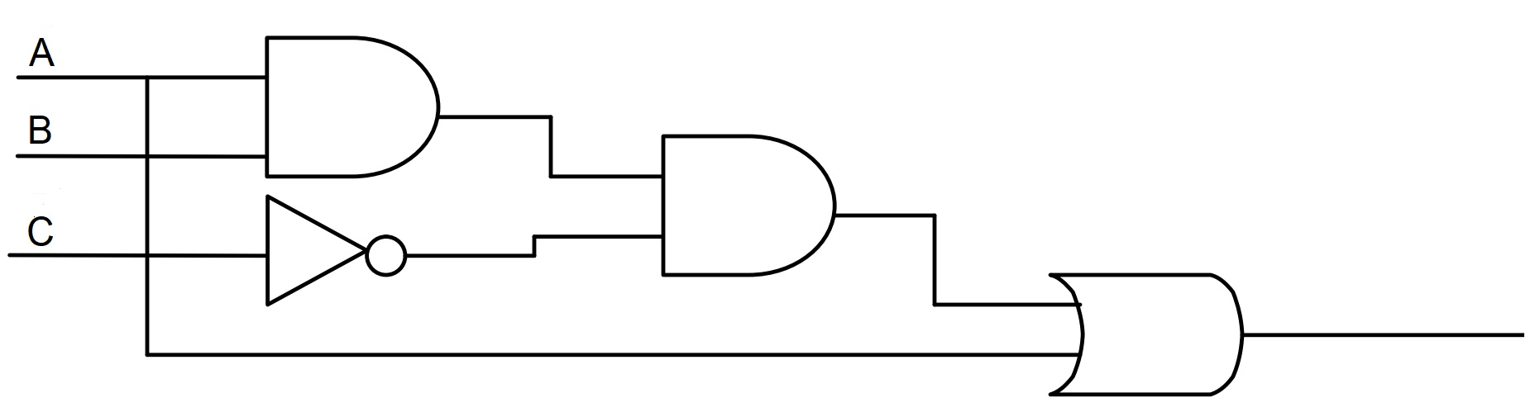

Question Four
2.25 Marks
Learning Outcome (1):
Define the concepts, tools and techniques for the design of digital logic and integrated circuits.

Analyze the logic circuit below to devise a corresponding Boolean function and find the complement of the obtained function with the help of DeMorgan’s theorem.
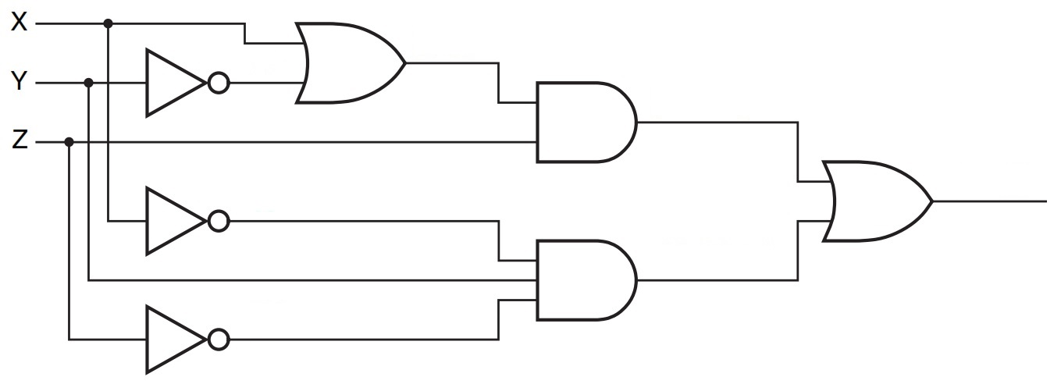
Figure 2.1
Prove that the logic circuit in Figure 2.1 is functionally equivalent to the logic circuit shown in Figure 2.2 below:
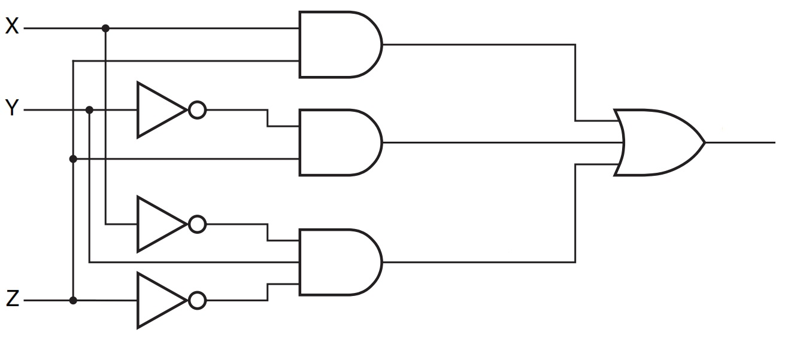
Figure 2.2

Question Five
1 Marks
Learning Outcome (1):
Define the concepts, tools and techniques for the design of digital logic and integrated circuits.

Derive truth table for the following Boolean expression:
[X + Y ( + ) ]

