Exam 1 Student Name:_______________________
N390 Fall 2021

1) (10 Points) Explain, with the aid of two or three equations, the nucleosynthesis of the lighter elements. Why is the abundance of iron in the universe relatively high? What process is primarily responsible for the formation of elements heavier than iron? Use equations to show an example of this process.

2) (10 points) What metals were known and used in antiquity. Why these metals and not others? The Bronze Age preceded the Iron Age. What is bronze and why was bronze known and used more extensively before iron. What was needed for iron to become the more available, and what properties made it more useful than other metals at the time.

3) (10 points) From the Ellingham diagram below, what is the lowest temperature at which magnesium oxide can be reduced by carbon. Write the oxidation and reduction half reactions for this process, along with the overall reaction at this temperature.

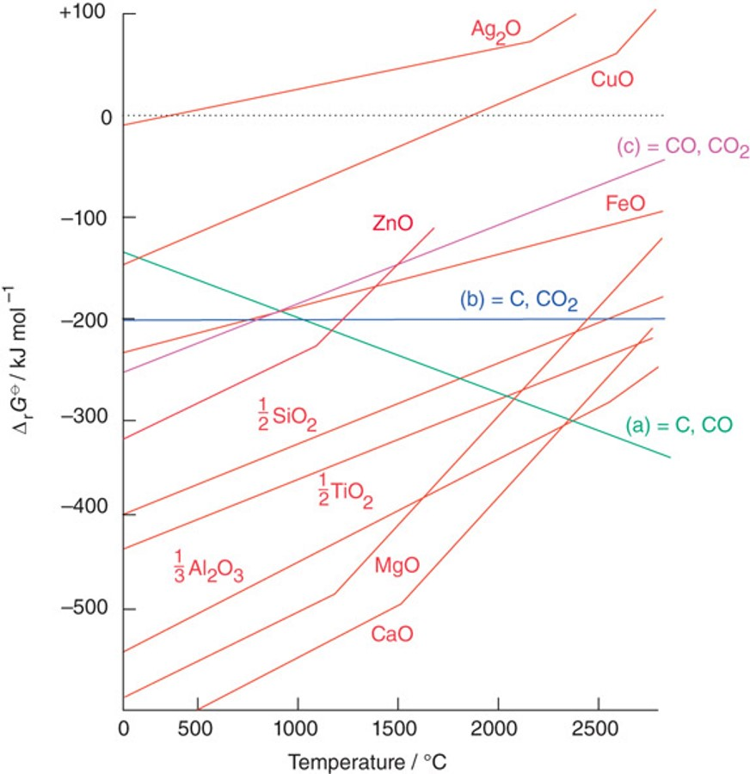

4) (15 points) Three of the structures adopted by metallic elements are face-centered cubic, body-centered cubic, and primitive (simple) cubic. Draw a unit cell for each of these structures and determine the number of metal atoms in each. In which structure is the volume occupied by atoms the greatest? Which of these structures are close-packed? For the close-packed structure, give the number of nearest neighbor atoms, the number of octahedral holes, and the number of tetrahedral holes per atom.
5) (15 points) Define lattice enthalpy. Using a Born-Haber cycle determine the lattice enthalpy of potassium chloride from the data below. Draw a graph that shows each step in the cycle.

Process | ΔHº (kJ/mol)
Sublimation of K(s) | +89.0
Ionization of K(g) to K⁺(g) | +425
Dissociation of Cl₂(g) | +244
Electron Attachment to Cl(g) | -355
Formation of KCl(s) | -438

6) (10 points) Give the condensed ground state electron configurations of the following:
a. S b. Mo c. Ti⁺ d. Gd³⁺ e. Fe

7) (15 points) For the hypothetical linear H₅ molecule sketch the linear combinations of 1s atomic orbitals that make up the molecular orbitals for this molecule. Order these orbitals in terms of energy, identifying the most bonding and the most antibonding orbitals. Indicate the number of nodes for each orbital. How does the MO diagram for this molecule relate to the band structure of solids?

8) (15 points) Draw the band structure diagrams for a conductor, an insulator, an intrinsic semiconductor, a p-doped semiconductor, and an n-doped semiconductor. Indicate occupied levels, empty levels, and relative band gaps. Give an example of each of these materials.

