Identifying the Mode of Inheritance

We have examined the inheritance patterns of two genes that control two different traits in dihybrid crosses of yeast and drosophila, similar to the work done by Mendel. We also became familiar with the concepts of dominance and recessive for the alleles of a single trait and how that affects our phenotypic ratios. However, not all traits exhibit these simple Mendelian phenotypic ratios even though the underlying principles of segregation and independent assortment are at work. There are other exceptions to Mendelian inheritance that are due to exceptions in segregation/independent assortment and we will examine one of these later in the semester.

We will focus on a set of non-Mendelian phenotype ratios that do not violate the laws of segregation and independent assortment in this lab:

Lethal alleles: a double dose of two alleles results in death before reproduction

Example: Mexican hairless dogs

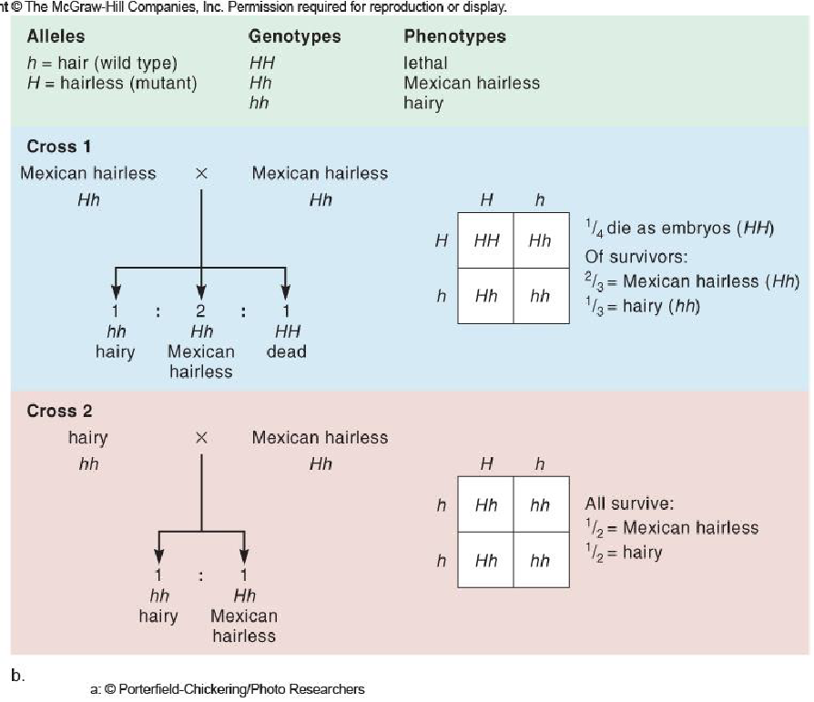

Incomplete Dominance: The heterozygous phenotype is between those of the two homozygotes

Example: Snapdragon flower color
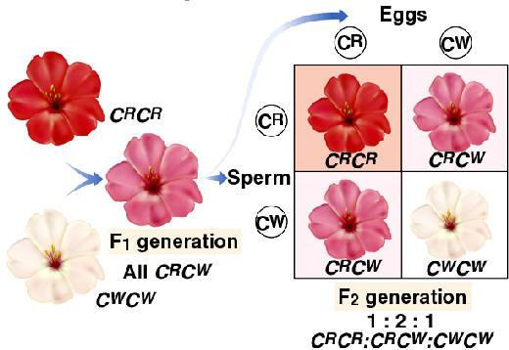

Co-dominance: The heterozygous phenotype results from the expression of both alleles; this heterozygous phenotype is distinct (not an intermediate form) from either homozygotes

Example: Checkered chickens

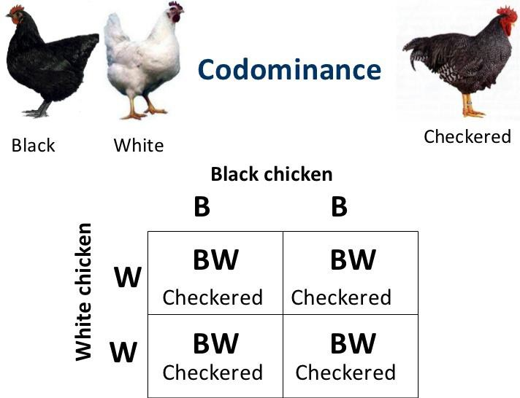
Sex-linked: Genes (and their alleles) that are passed only on the X-chromosome (very rare for y-linked) and result in different phenotype ratios based on sex of the organism
Example: White eye drosophila
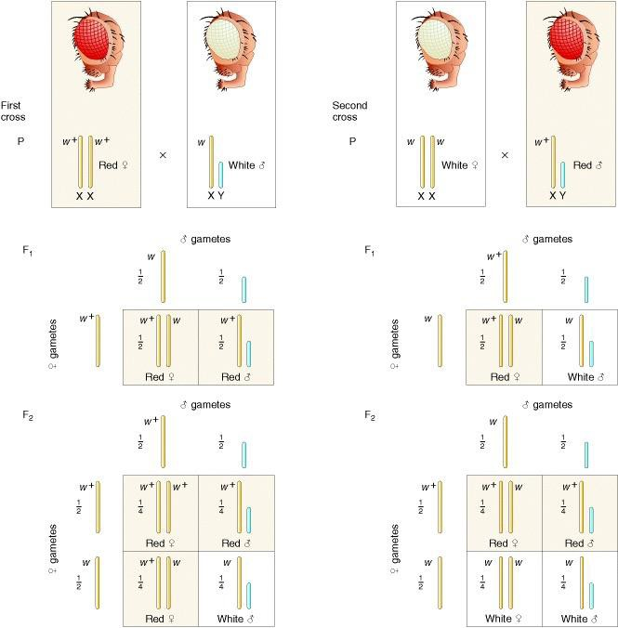
Copyright © 2000, W. H. Freeman and Company.

Just as we saw in our previous work with drosophila and yeast, we can use Punnett squares to help us understand both the phenotype and genotypes resulting in a test cross. The test cross is another fundamental tool devised by Gregor Mendel. In its simplest form, a test cross is an experimental cross of an individual organism of dominant phenotype but unknown genotype and an organism with a homozygous recessive genotype (and phenotype). We can see that these exceptions should result in much different phenotypic outcomes from simple dominance and recessive allele crosses.

The objectives of this lab exercise:

You are tasked with determining the type of inheritance in Drosophila monohybrid crosses. Your goal will be to examine and characterize the mutant phenotypes, perform the crosses to the F2 generation and using Punnett square and chi-square analyses determine the mode of inheritance for the mutant trait.

Specific learning outcomes :
- Continue to practice basic handling and culture techniques for working with Drosophila
- Apply concepts and principles of Mendelian and non-Mendelian inheritance patterns with an unknown mutant
- Use Punnett squares to predict outcomes and verify the resultant inheritance and its phenotypic ratios
- Perform a chi-square statistical analysis of experimental results

Methods

Please refer to ‘Anesthetization and Handling Procedures’ and ‘Sexing flies’ from our previous Drosophila lab. Don’t forget to use some of the resources posted on our Cougar Courses page as well.

Week 1: Perform the first cross.

- Examine flies for phenotype and gender and record in table on Page 6. What are the two mutant phenotypes?

- Perform the first cross using 6 virgin wild type flies and 2 male mutant flies. Label this vial F1 with your group name.
  - Carefully inspect your vials. Your virgin female vial should contain NO males or larval stages.
  - MAKE SURE YOU HAVE AT LEAST ONE LIVE MALE BEFORE TURNING IN VIAL. YOU SHOULD BE ABLE TO DIFFERENTIATE WITHOUT MAGNIFICATION.

Week 2 (NO LAB; Veteran’s Day):
- Remove parental flies from the F1 vial.

Week 3:
- Observe F1 phenotypes and gender (since your trait could be X linked) and record in your lab notebook.
- Transfer 6 females and 2 males F1 flies to a new vial of food and label this vial F2 with your group name.

Week 4 (NO LAB; Thanksgiving Day):
- Remove F1 parental flies.

Week 5:
- Observe results of F2 progeny and record in lab notebook.

For your notebook (Lab Report) - Results

Identify the mutant trait. Begin by examining carefully the wild-type fly phenotype and compare to the mutant fly phenotype. Pay special attention to the eyes, body color and wings. All parental flies are true breeding homozygous.

Table 1: Parental phenotypes (blank rows for any other observations you make)
.
Phenotype | Wild type females | Mutant males
Eye color
Eye shape
Body color
Wing shape

Predictions
Use this area to create Punnett squares that reflect your predictions for the F1 generation if the inheritance of the mutant traits are (follow the instructions for the practice Punnetts you turned in in Week 4. Be sure to label your Punnett squares clearly):
- autosomal dominant
- autosomal recessive
- sex linked dominant
- sex linked recessive
- incomplete dominant (take a guess on what that might look like)
- co-dominant (again take a guess)
- lethal dominant
- lethal recessive

Table 2: F1 phenotypes (left cell) and counts (right cells) (add rows as needed for any additional observations you need to make)

Phenotype | Female | Males
Trait 1
Trait 2

Indicate the phenotype and gender counts of all flies that were collected for the parental cross.

Males:

Females:

Predictions
Use this area to create Punnett squares that reflect your predictions for the F2 generation derived from F1x F1 backcross.
This should be based on what you learned from the F1 outcomes. In other words, from F1 observations have some of the inheritance patterns now been eliminated from your analysis? Label clearly.

Table 3: F2 phenotypes
.
Wild wild males | Wild wild females | Mutant mutant males | Mutant mutant females

Mutant wild males | Mutant wild females | Wild mutant males | Wild mutant females
Define mutation | Define mutation | Define mutation | Define mutation

Statistical analysis
Based on the outcomes from F1 and F2 progeny, you should now have some idea on the type of inheritance that you feel this mutant allele follows.

Given your phenotype ratios from your predictions, do your results match these ratios? Use chi-square analyses to determine if you will reject or retain your null (that your ratios match predicted).

What do you conclude is the mode of inheritance and chromosome location occurring for these mutant alleles?

