Samsung – Changing Strategies to Build a Global Brand
Samsung Electronics is the largest component of South Korea’s largest chaebol —one of the giant family-controlled conglomerates that have been instrumental in building the country’s economy over the last half century. Samsung’s electronics unit started out in 1970 making cheap TV sets for the Sanyo label. Over time it morphed into a technically innovative company that was one of the pioneers in developing flat-screen displays, plasma TVs, multifunction cell phones, and other digital devices. But until the mid-1990s, the unit competed primarily by (a) producing technical components or low-cost manufactured products for firms with better-known brands, such as Dell, Hewlett-Packard, and General Electric and (b) selling me-too consumer products—such as TVs and microwave ovens—under the Samsung brand through discount chains such as Wal-Mart at very low prices. Samsung’s cost-driven competitive strategy worked well until 1996, but then several shocks in its market and competitive environments forced a major reevaluation. First, the global market for memory chips and other components Samsung supplied for other electronics brands softened due to increased competition and excess capacity. At about the same time, sales of Samsung’s own branded products were also declining. As Yun Jong-yong—a company veteran who was brought in as CEO of the electronics unit—complained, Samsung could build a TV that was technically as good as a Sony, but because of the down-market image of the Samsung brand, its TVs sat at the back of the store or piled up in discount chains. Finally, the Asian financial crisis of 1997 made a major strategic shift essential for the unit’s survival.

Competitive and Marketing Strategies
Mr. Yun initiated an ambitious new competitive strategy aimed at developing and marketing technically superior products while building an image of Samsung as a stylish, high-quality brand commanding a premium price. The objective was to establish a unique competitive position using technical innovation and design to appeal to younger and relatively upscale customers around the world. “If we were to continue competing only on price,” Mr. Yun argued, “the Chinese would slaughter us.”

Technical Innovation and R&D
In order to implement its new competitive strategy, Samsung had to become a pioneer in developing new digital technologies. While Sony and other rivals had a substantial lead in consumer electronics, that lead was rooted in the analog world. The digital world required new technical innovations. Consequently, the firm shifted substantial resources into R&D focused on technologies such as large-area LCDs, display drivers and chip sets, and mobile telephony. In the 2010 fiscal year it spent 9.1 trillion won ($7.9 billion)—about 6 percent of the unit’s total revenue—on R&D. One quarter of the company’s workforce—some 44,000 people are engaged in R&D activities in more than 40 research centers around the world.

New Product Development and Design
But cutting-edge technology does not guarantee market success. It must be incorporated into products that deliver benefits that at least some segment of consumers will consider to be worth the price. Some of those benefits may be subjective—attractive styling, or a cool image. Therefore, new product development at Samsung usually involves a team of designers who collaborate closely with the firm’s engineers, manufacturing people, and marketers. To ensure they stay in touch with consumer tastes in different countries, the firm’s 450 designers are assigned to design centers in cities such as London, Tokyo, Shanghai, and San Francisco, and the company’s market researchers run focus groups and user surveys in many markets around the world.

Marketing Programs to Build the Samsung Brand
Revamping Samsung’s marketing efforts was also critical to the success of its new competitive strategy because even the most technically sophisticated and well-designed products are likely to fail unless potential customers know they exist, can acquire them easily, and think they are worth the money. Therefore, Eric Kim was recruited from outside the firm to head a global marketing effort for Samsung Electronics. One of his first moves was to reorganize the firm’s distribution channels. Consistent with the strategic objective of establishing Samsung as a high-quality brand worthy of a premium price, many of the company’s products were pulled out of low-priced discount chains and distributed through service-oriented electronics specialty stores and web retailers—such as Best Buy and Amazon.com—instead.
To ensure consistency in Samsung’s marketing communications across world markets, Mr. Kim consolidated the firm’s roster of advertising agencies from 55 down to a single global advertising
group—British-based WPP. He then launched the firm’s first brand-building campaign with fashion forward TV commercials showing off the company’s cool sense of style as well as the technical sophistication of its products. The firm also makes extensive use of more contemporary promotional tools such as product placements, sponsorships, and internet advertising to strengthen its brand. For instance, Samsung provides both financial and technical support for a variety of sporting and cultural events in every major region of the world. It is a sponsor of the Olympics, Asian Games, and other international events, but it also supports regional and local events—such as the Montreal Jazz Festival and the Chelsea Football Club in the United Kingdom—as a means of staying close to local customers.

The Results
Samsung Electronics’ revamped competitive strategy and the marketing programs designed to implement it have been a smashing success. According to studies by Interbrand (a brand consultancy), the global value of Samsung’s brand increased by more than 200 percent over the first decade of the twenty-first century, overtaking Sony as the most valuable consumer electronics brand. And in spite of the fact that Apple’s iPhone and iPad gate crashed Samsung’s position as the “cool designer” in the smartphone market, the brand’s value increased another 20 percent in 2011. As a result, the unit’s global revenues reached 165 trillion won (about $143 billion) in the 2011 fiscal year, and after-tax profits were 13.7 trillion won.

The slide below shows the elements of a business strategy according Collis model. This slide will help you understand the process of creating business strategies.

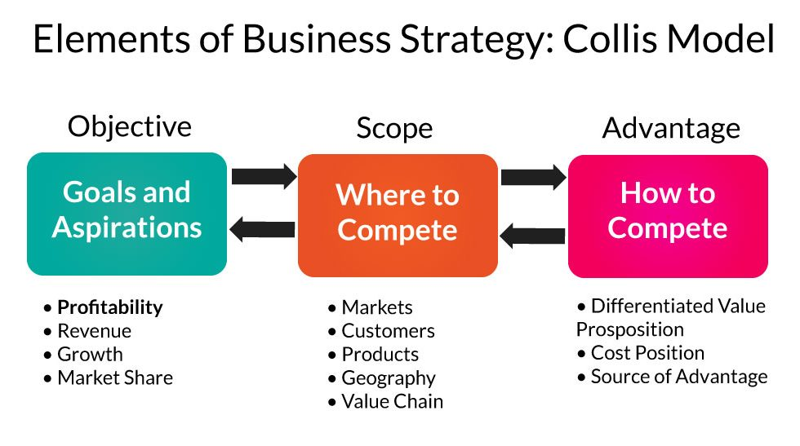
Collis, D. J. (2019). The Value Potential of New Business Models. Harvard Business School Strategy Unit Working Paper, (20-028).

Note the 4 areas of business strategy (for Samsung Electronics) below:

- Product-market investment strategy (where to compete) – product scope. Which product categories? Just one (focus) or many (broader electronics class)? Examples, phones, computers, TVs, appliances, etc.
- Value proposition – what do we offer that has perceived value (benefits) for the markets? The value proposition applies to all products sold under the Samsung brand name. This is different than a unique selling proposition for a specific product such as phones. What tangible and/or psychological/social/emotional/experiential/ value expressive benefits offered across all products (i.e., cool/modern designs, latest technologies, etc.).
- Assets and competencies – what people, facilities, knowledge, technologies, and funding are needed to offer the value proposition to the market? If management lacks these, they will need to acquire them through partnering with organizations, hiring new people, buying/leasing real estate, co-branding, licensing, and/or other ways of being able to provide the value proposition.
- Functional strategies – what changes will management need to make in functional areas such as operations, HR, marketing, finance, supply-chain, manufacturing, etc.?

As you’ve seen in the above Samsung case, all 4 of these business strategies needed to change in order to reposition the Samsung brand and focus on a new market. This assignment should help you understand business strategy and p rovide the context for marketing strategy.

The article above is in this site if you would like to view it in a different format.
https://proechosolutions.com/asheville-marketing/how-samsungs-marketing-strategy-turned-them-into-a-technological-powerhouse

Questions:
Consider Samsung Electronics and its marketing strategy, and respond to the following after looking at the Samsung Electronics SBU (business strategy):
POST about 4 PARAGRAPHS addressing the following three questions. (Use headings: 1.), 2.), 3.) There is no need to repeat the questions.

  - Refer to the 4 areas of business strategy shown above. Briefly discuss each from the perspective of the old business strategy and the new business strategy.
  - What are the most essential ‘drivers’ or factors that contributed to Samsung’s ability to revitalize and reposition the brand? Explain.
  - Do you think that the new business strategy is a good fit for Samsung? Explain why or why not?

