Project 1: Excitatory synaptic transmission

Most information transfer between neurons in our brains occurs at specialized contacts called chemical synapses. Synapses that are made by approximately three quarters of all neurons in the brain are excitatory synapses, which release an amino acid neurotransmitter called glutamate onto their postsynaptic targets. The postsynaptic neuron has receptors on its cell membrane capable of sensing the glutamate and responding by opening ion channels. The receptor and ion channel is the same protein, which is referred to generically as a ligand-gated ion channel or ionotropic receptor. The ones specific for the neurotransmitter glutamate are called ionotropic glutamate receptors and their channels are selective for positively charged ions (e.g. Na⁺). The passage of Na⁺ ions down their electrochemical gradient through these channels results in depolarization of the resting membrane potential closer to action potential firing threshold – hence the synapse being referred to as ‘excitatory’. The ionotropic glutamate receptors typically playing this role are the AMPA-type glutamate receptors (AMPARs) (Figure 1A)
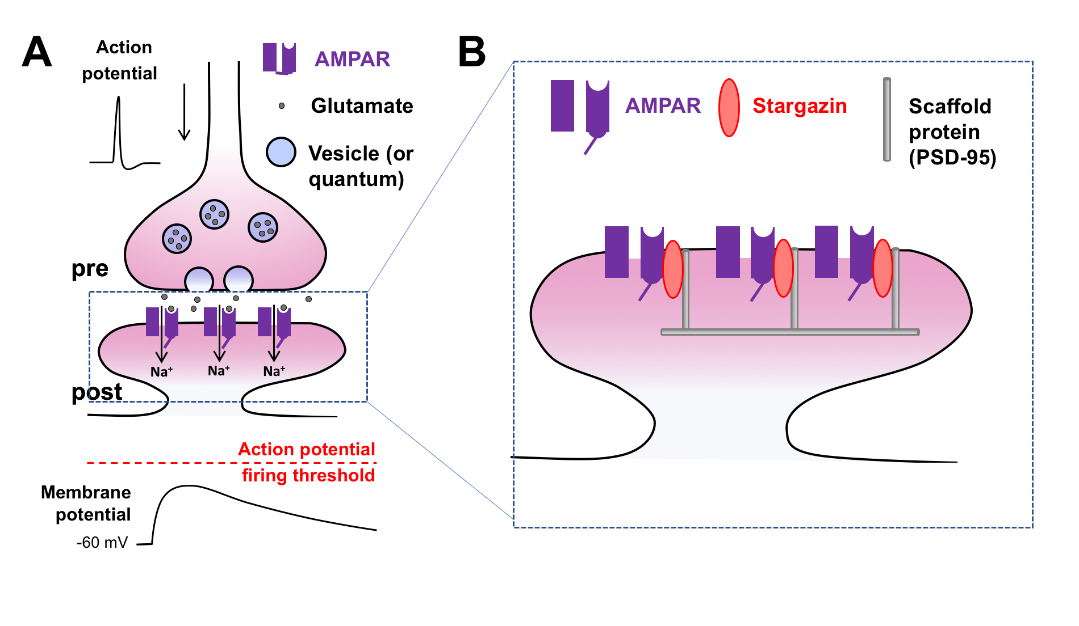
Figure 1. Panel A (top) illustrates action potential-triggered synaptic transmission at an excitatory chemical synapse from the vertebrate central nervous system. Note that only one synapse is depicted in this figure and the remaining parts of the neurons are omitted. ‘Pre’ refers to the presynaptic neuron and ‘Post’ refers to the postsynaptic neuron. Panel A (bottom) illustrates the effect that excitatory synaptic transmission has on the resting membrane potential. Panel B illustrates how AMPA receptors are maintained at synapses in the postsynaptic neuron.
The way by which neurotransmitter is released makes chemical synaptic transmission a quantized process, meaning that neurotransmitter release occurs in discrete steps. Within the presynaptic terminal, the neurotransmitter is packaged into hundreds of membranous vesicles, where each vesicle is referred to as a quantum. Release of neurotransmitter requires that one or more vesicles (or quanta) undergo fusion with the cell membrane by a process called exocytosis. Whether a quantum of glutamate is released is a matter of probability; while the presynaptic cell is resting, individual quanta are randomly and spontaneously released at low frequency, while action potential firing dramatically increases the probability of release, typically causing the release of multiple quanta. The size of the postsynaptic response to a single quantum of neurotransmitter (i.e. the quantal size) is a measurement researchers often use as an indicator of synaptic strength. Experimentally, this is achieved by preventing all action potential firing with a sodium channel blocking drug and then recording the remaining low frequency random and spontaneous release events in the postsynaptic neuron. These events are referred to as miniature postsynaptic currents.
One mechanism that neurons use to regulate synaptic strength is to modify the number of AMPA-type glutamate receptors. AMPARs are not uniformly distributed over the postsynaptic neuron. Instead, these receptors are strategically anchored opposite the presynaptic terminals to a scaffold within the postsynaptic density (PSD) so that they are in the optimal position to sense presynaptically released-glutamate. AMPARs cannot interact directly with the PSD but they can form a complex with another transmembrane protein called stargazin, which does interact with scaffold proteins in the PSD (Figure 1B). In addition to this role, stargazin also increases the probability of AMPAR channel opening and slows the rate of AMPAR channel closing.
In this project, one aim of the researchers was to understand to what extent AMPARs rely on stargazin to remain localized at the postsynaptic side of the synapse (Bats et al., 2006). To test this hypothesis, they recorded mEPSCs from hippocampal neurons expressing a mutated version of stargazin, called stargazin ∆C, which is incapable of interacting with the PSD scaffold.
Specifically, the experiments were designed as follows:
- Hippocampi were dissected from rat embryos, then neurons were dissociated and plated onto glass coverslips and maintained with culture medium in an incubator
- After one week in culture, neurons were transfected with DNA expressing either wild-type (normal) or mutant stargazin together with a fluorescent protein (as a marker for successful transfection)
- By the second week in culture, coverslips of transfected neurons were transferred to a sample chamber on a microscope and perfused with artificial cerebral spinal fluid (aCSF). The composition of the aCSF solution was (in mM): NaCl (145), KCl (2.5), CaCl₂ (2), MgCl₂ (2), HEPES (10, pH 7.4) and glucose (10). The aCSF also contained drugs to block sodium channels (tetrodotoxin a.k.a. TTX) and ionotropic GABA receptors (picrotoxin).
- Sparsely transfected neurons with large pyramidal cell bodies were identified by their fluorescence and their cell bodies were approached with an electrode for whole-cell voltage clamp recording. Upon entering the whole-cell configuration, neurons were held at -60 mV and randomly occurring spontaneous miniature excitatory postsynaptic currents (mEPSCs) were measured over a period of several minutes. The recorded mEPSCs were likely mediated by AMPA-type glutamate receptors because the aCSF contained 2 mM magnesium and the neuron was voltage clamped near its resting membrane potential.
- mEPSC events were detected using a threshold criterion where the recording trace deviated by more than 5 pA (which is 2.5 times greater than the standard deviation of the recording noise) (see the example traces in panel B below). The amplitude and frequency of mEPSCs were measured and compared between cells expressing wild-type (WT) and mutant (∆C) stargazin. These experimental groups are abbreviated by the authors as Stg WT and Stg ∆C respectively. As an additional control, they compared the data to the results obtained from nearby non-transfected cells.

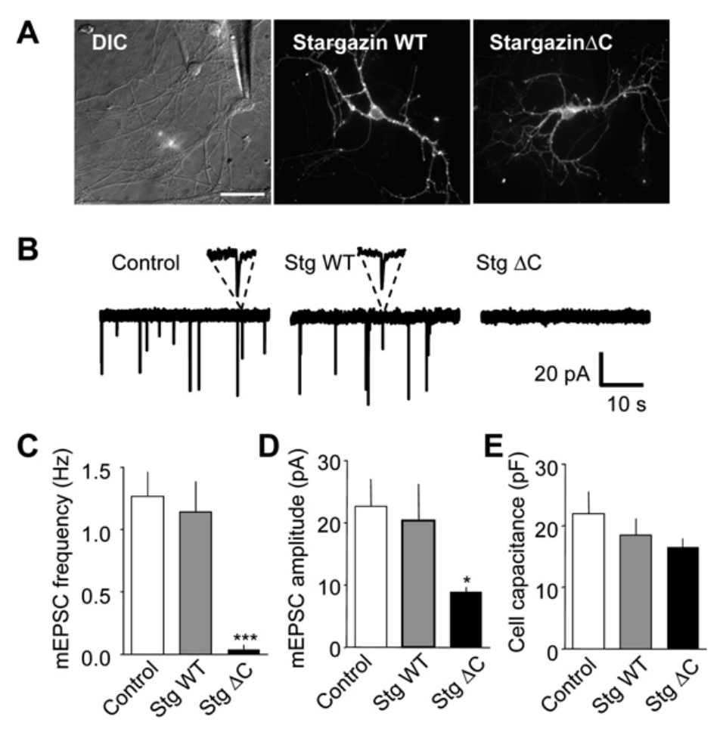
The questions in this problem set ask you to consider this data set and think about the methods used to collect, analyse and interpret the data.

PART 1.
- What ion channels do TTX and Picrotoxin act on and what is their effect on these channels? What is the reason that the authors added these drugs to the aCSF during their recordings?
- Why do we still observe excitatory synaptic currents in the presence of TTX?
- Is there another synaptic ligand-gated ion channel not inhibited by these drugs? Why is the contribution of these likely to be negligible?
Hint: Look at the other components of the aCSF; also consider where in the CNS the neurons have come from

PART 2.
- The recordings in this paper were made using the voltage-clamp technique. What is the difference between current clamp and voltage clamp and what do they measure?
Hint: Think about what the word ‘clamp’ literally means (i.e. to hold)
- In the way these recordings were done, how does the methodology compare with early experiments on the squid giant axon, where Hodgkin and Huxley measured currents underlying the action potential?
Hint: Think about where the electrode is in relation to the channels one is measuring

PART 3.
- Irrespective of the study in question, what factors could explain an apparent decrease in mEPSC amplitude?
- Are these biological phenomena of potential interest to the researcher? Or are they artefacts of the experimental technique or manipulation?

PART 4.
- In what ways could a researcher assess if the detected mEPSCs represent a single quantum?
- See the ‘Stargazin’ worksheet in the excel spreadsheet, which provides data for one cell overexpressing stargazin WT. By eye, how many peaks can we resolve in the ‘mEPSC amplitude’ histogram and what does that suggest to us?
Hint: a peak here is considered a point where neighbouring points are both lower than the point in question
- Is there something missing from the excel plots that would make them easier to interpret? What exactly would you add?

PART 5.
- mEPSCs could be reasonably detected in these experiments at a threshold of 5pA. How does this compare with the average size of mEPSCs?
- See the ‘Simulation’ work sheet of the excel file. Why does the apparent frequency of mEPSCs drop when we simulate a 50% drop in the mEPSC amplitude? By examining the CELL formulae, in the spreadsheet, explain how this simple simulation was conducted.
- In principle, what factors could explain an apparent decrease in mEPSC frequency?
PART 6.
- What variables should be specified/considered by the researcher when constructing a histogram? How can changing these variables influence the appearance of the histogram?
Hint: The effect of changing one of these variables is illustrated in the comparison of the two versions of the histograms plotted for mEPSC amplitudes on the 'Stargazin' worksheet.
- In R (or Excel), plot a cumulative frequency histogram of the mEPSC amplitudes. Illustrate using this plot how one can quickly read off the median amplitude from the graph.

References
Bats, C., Groc, L. and Choquet, D. (2006) The interaction between Stargazin and PSD-95 regulates AMPA receptor surface trafficking. Neuron. 53(5):719-34

