Assignment 1
  - Deadline: Tuesday 20/09/2022 @ 23:59
[Total Mark for this Assignment is 8]

Web Design
IT404
Instructions:
- You must submit two separate copies (one Word file and one PDF file) using the Assignment Template on Blackboard via the allocated folder. These files must not be in compressed format.
- It is your responsibility to check and make sure that you have uploaded both the correct files.
- Zero mark will be given if you try to bypass the SafeAssign (e.g. misspell words, remove spaces between words, hide characters, use different character sets, convert text into image or languages other than English or any kind of manipulation).
- Email submission will not be accepted.
- You are advised to make your work clear and well-presented. This includes filling your information on the cover page.
- You must use this template, failing which will result in zero mark.
- You MUST show all your work, and text must not be converted into an image, unless specified otherwise by the question.
- Late submission will result in ZERO mark.
- The work should be your own, copying from students or other resources will result in ZERO mark.
- Use Times New Roman font for all your answers.
Student Details:
Name: ###  CRN: ### |  | ID: ###

Question One
1.5 Marks
Learning Outcome(s):
CLO 1: Identify most HTML tags and CSS properties and use a text editor to construct the basic HTML and CSS structure for a webpage.

Determine the issues in the following code and rewrite the correct one? You are required to take a screenshot of your output?

<!DOCTYPE HTML>
<html>
<head>
ASSIGNMENT 1
</head>

<body>
<p> Do not forget to add a screenshot <p>
Web technology is my favorite course
</body>

</html

Answer (1 mark/correction, 0.5 mark/screenshot)

Question Two
2 Marks
Learning Outcome(s):
CLO2: Develop websites that present information, graphics, and hypertext using CSS and JavaScript.

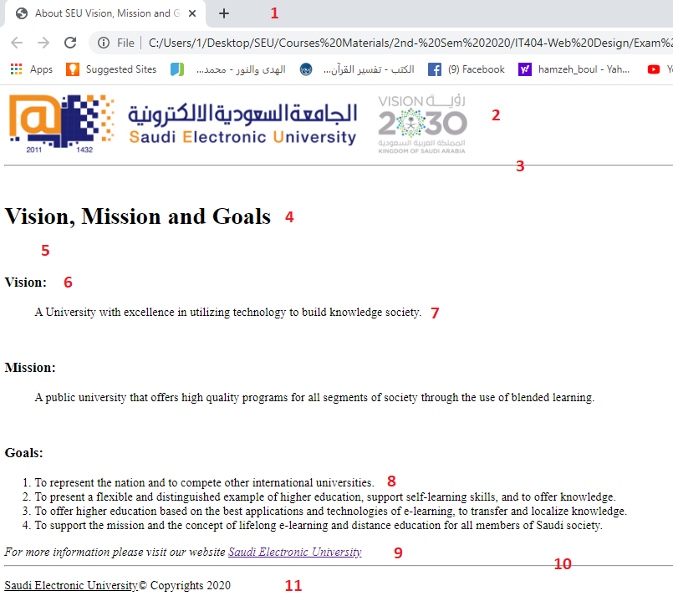
Write the source HTML document for the Webpage shown below, taking into consideration all points from 1-11:

Marking criteria:
Point | Description | Marks
1 | Title | 0.2
2 | Image (English-SEU logo) | 0.2
3 | Horizontal line | 0.1
4 | Heading | 0.2
5 | Whitespace | 0.2
6 | Heading | 0.2
7 | Blockquote | 0.2
8 | List | 0.2
9 | Address & link to SEU website | 0.2
10 | Horizontal line | 0.1
11 | Underlined & Copyright | 0.2

Question Three
Learning Outcome(s):
CLO1: Identify most HTML tags and CSS properties and use a text editor to construct the basic HTML and CSS structure for a webpage.

1.75 Marks
Write the necessary HTML code to display the following web page. (Note: Required tags for describing the page given as in red color font)
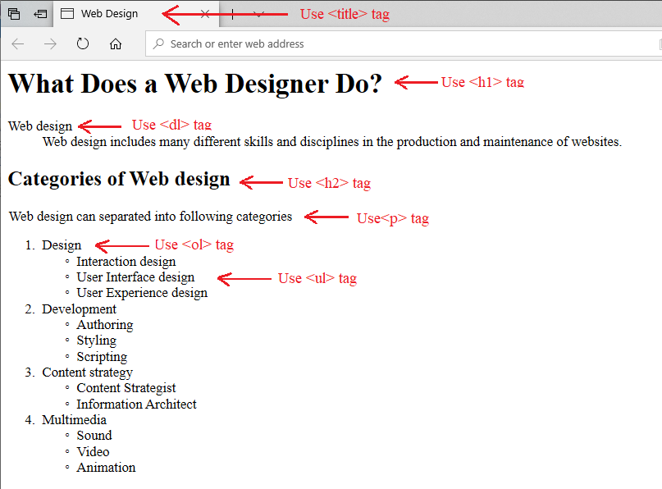
Marking criteria:

Answer (0.25 mark for each required tags)

Question Four
2.75 Marks
Learning Outcome(s):
CLO1: Identify most HTML tags and CSS properties and use a text editor to construct the basic HTML and CSS structure for a webpage.

Write the necessary HTML code to display the following web page.
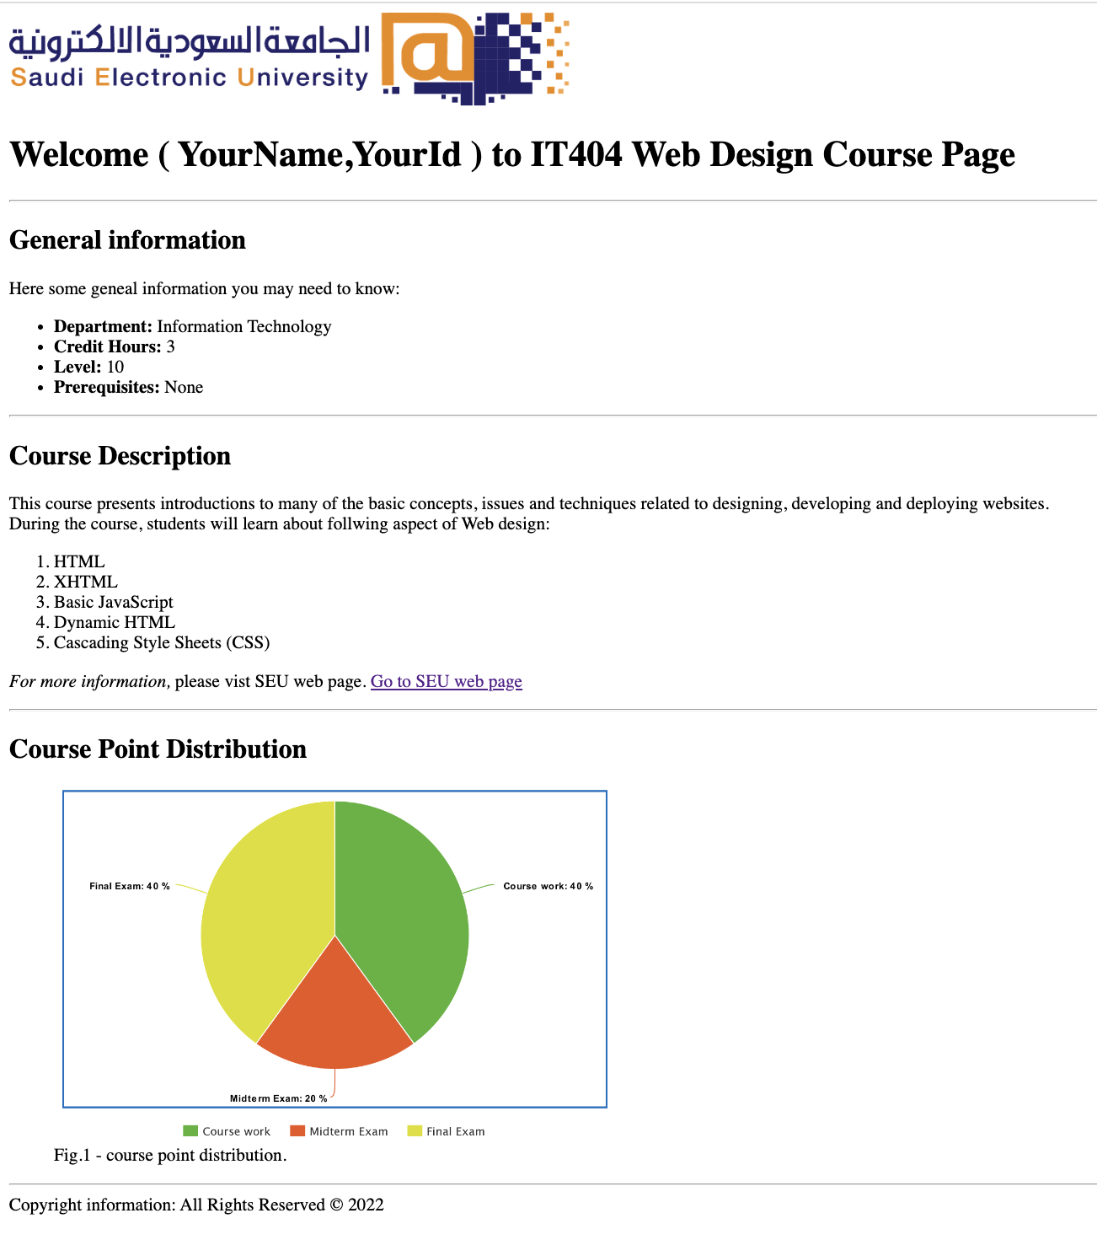
Page1.html
Notes:
- You must copy and paste the “HTML script” as your answer for this question. DON’T just take screen shot for your HTML script. It must be editable script.
- Take a screen shot for your output web page and paste it as a part of your answer.
- Complete the missing data (YourName,YourId ) with your name and your id.
- Organizing Page Content by make a use of (Header, Section and Footer).
- You can use the following images:
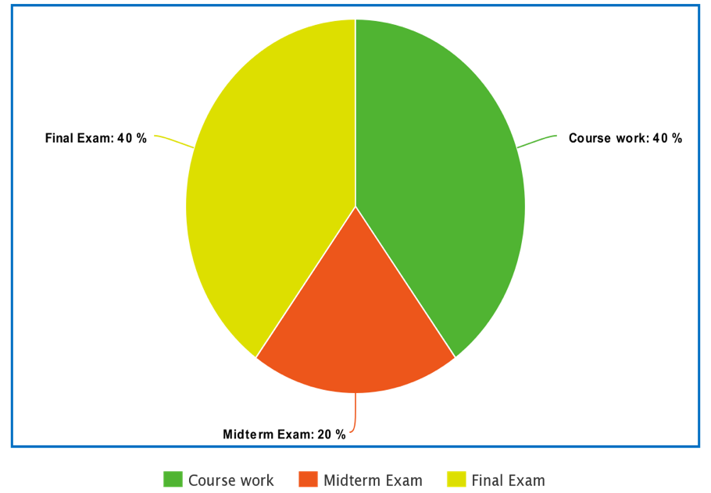
Marking criteria:
Point | Description | Marks
1 | Title | 0.25
2 | Image (English-SEU logo) | 0.5
3 | Heading | 0.25
4 | Whitespace | 0.25
5 | Heading | 0.25
6 | List | 0.25
7 | Address & link to SEU website | 0.5
8 | Horizontal line | 0.25
9 | Underlined & Copyright | 0.25

