Write Now Exercise
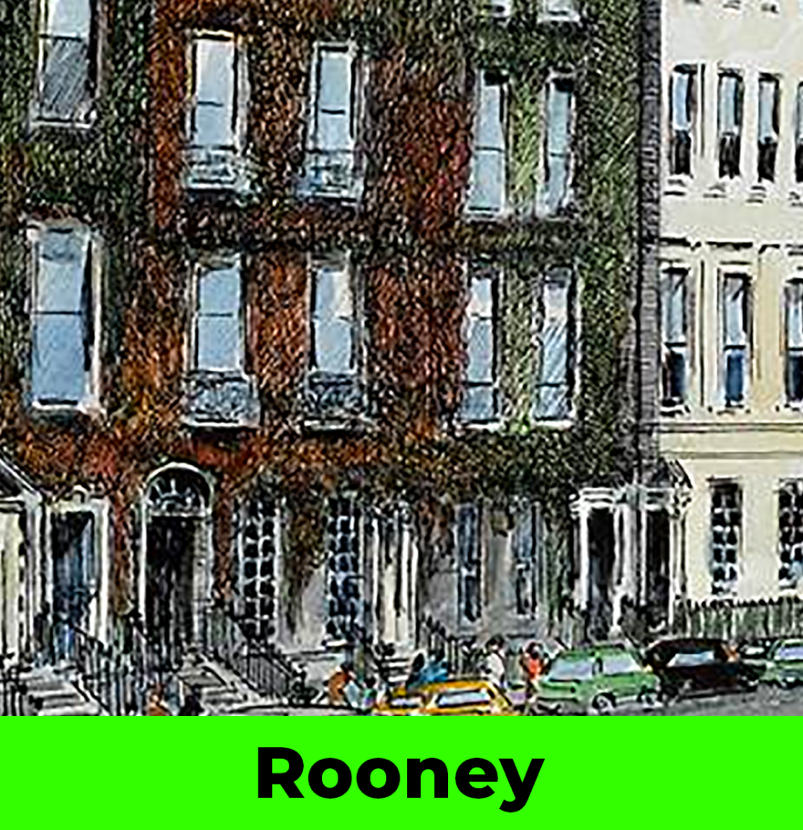
Sally Rooney, “Unread Messages” (2021)

• A response may require a few paragraphs. A given paragraph need not be long, if its content is focused and of high quality.
• The ten questions that feature below also appear embedded in the text of the short story itself, and …
that is the best way (really, the only sensible way) to access them.
If page numbers are needed, put them before punctuation.

QUESTION #1 • Throughout this Write Now homework, ensure that you cite any and every source you use. Having completed your reading of “Unread Messages, compose two brief paragraphs. A paragraph can be as short as two sentences, provided that it conveys relevant, quality information.

In the first paragraph, suggest a reason or reasons why W.H. Auden (1907-1973) seems an appropriate poet to invoke as the short story opens. Almost certainly, you will have to conduct some basic research into Auden, who was born and raised in England but, in 1939, moved to the United States. He would end up holding both British and American citizenship. You may see a connection between Rooney’s “Unread Messages” and some aspect or aspects of Auden’s life-story, politics, sexuality, or literary output (for example, a poem, play, or travelogue). Although you are free to use any appropriate, credible source, you may find helpful this mini-biography of Auden. (You will probably have to be logged onto the Georgia Southern network to access it, as it is a library resource.)

In the second paragraph, suggest why at least two or three major aspects of Fyodor Dostoevsky’s final novel The Brothers Karamazov (1879-1880) fit with the narrative that Rooney’s “Unread Messages” presents. Some basic research into this classic of Russian literature will prove helpful. A good resource is this plot summary from the scholarly initiative called Masterplots. (You will probably have to be logged onto the Georgia Southern network to access it, as it is a library resource.)

QUESTION #2 • The name Lola is short for Delores, which means “sorrows,” a reference to the Seven Sorrows that the Virgin Mary endured, most notably the death by crucifixion of her firstborn son, Jesus. By virtue of its inclusion of the term “assassinated,” the foregoing paragraph suggests death. Once you’ve finished “Unread Messages,” identify — and analyze the significance of — two other sites in the text that hint at mortality. Whenever you quote from the short story, provide the relevant page number. For instance: When at work, the protagonist, Eileen Lydon, checks her social-media feeds and finds one from “a female journalist speaking out about death threats” (page 4). (In your answer, you are welcome to use this example, if you wish.) By the way: The song “Lola” (1970) is a popular-culture classic. Performed by The Kinks and written by that British band’s lead singer, Ray Davies, the song has, as its title character, an individual who “walked like a woman but talked like a man,” a condition that may imply trans identity.

QUESTION #3 • In your opinion, why does the unidentified, third-person narrator present so precisely the numerical details in the foregoing paragraph (“5:34 p.m.”; “a twenty-eight-minute walk”)? Cite some evidence from elsewhere in the text to bolster your fundamental argument.

QUESTION #4 • Male pulchritude (facial and bodily beauty) emerges as a theme in Rooney’s short story, “Unread Messages.” Mindful of the phrase “insanely handsome” in in the foregoing paragraph, discuss, in three or four sentences, the significance of the short story’s concern with the physical attractiveness of men. Be sure to cite and analyze several portions of the text. The material you quote does not have to be lengthy.

QUESTION #5 • This short story can carry the label “metaliterary,” for it is a work of literature that discusses works of literature and, indeed, the greater book industry. (Consider, for example, such phrases as “boxes of books”; “best-selling novels”; “an American book deal”; “the difficulties of finding a publisher”). In your opinion, what constitute two major points that the story intends to make about the place of literature in the lives of individuals who exist in — and attempt to navigate — modern, technologically advanced Western society?

END

