COVER PAGE

Table of Contents
List of Figures I
List of Tables II
ABSTRACT III
CHAPTER 1 1
Background Knowledge 1
1.1. Introduction 1
CHAPTER 2 3
Literature Review 3
2.1. Literature Review 3
CHAPTER 3 8
Intravascular Tubes 8
3.1. Types of IV Set Manufacturing 8
3.2. IV Set Manufacturing Process 9
3.3. IV Set Manufacturing Machines 10
3.4. IV Syringe Descriptions 11
CHAPTER 4 14

Methodology 14
4.1. Methodology 14
4.2. Design 18
4.3. Fabrication 21
4.4. Measuring principle 22
4.5. Optical device precision 23
CHAPTER 5 25
Operating Instructions 25
5.1. Instructions for Operation 25
5.2. Flexible in use 25
5.3. Special application areas 25
CHAPTER 6 27
Laser Wire 27
6.1. Laser Wire Setups 27
CHAPTER 7 29
Conclusion 29
7.1. Conclusion 29
References………………………………………………………………………...30

List of Figures
Figure 3.1: Syringe with methods 12
Figure 3.2: Needle Gauges 13
Figure 4.1: Methodology 14
Figure 4.2: Optical Rays 16
Figure 4.3: Displays 17
Figure 4.4: Laser Light Source 19
Figure 4.5: Receiver Source 19
Figure 4.6: Laser Source on Base 20
Figure 4.7: Laser Beam Detector Design 21
Figure 4.8: Measuring Principles 23
Figure 4.9: Optical View 24
Figure 6.1: Laser Wire Setup 27

List of Tables
Table 4-1 15
Table 4-2 22

ABSTRACT
From optical methods, the laws of reflection and refraction, ray tracing techniques, conservation of energy within a bundle of rays, and the condition of constant optical path length provide a foundation for the design of laser beam shaping systems. Optical design methods are presented for shaping the irradiance profile of both rotationally and rectangular symmetric laser beams. Applications of these techniques to design reflective and refractive laser beam shaping systems are presented.

CHAPTER 1
Background Knowledge
  - Introduction
Medical grade tubing and balloons must be held to extremely tight tolerances for wall thickness, concentricity, and ovality. Manufacturers need a system with repeatable measurements, high accuracy, easy useability, and can be used online or offline. Lumetrics offers off-the-shelf solutions to address the metrology needs of these products and provide optomechanical or software development expertise required to develop a custom measurement solution.
IV Set Manufacturing Medical devices assume a considerable function in the conclusion, therapy, and checking a few ailments. Medical clinic gear is carefully intended to keep up thorough wellbeing norms to guarantee the most extreme prosperity of patients. You will get the best IV set manufacturers in Pune.
A mixed set is utilized to manage intravenous treatment, wherein a fluid substance is conveyed legitimately into the patients' vein. It gives clinical faculty an energetic and viable intention to convey liquids and drugs during ailments, such as lack of hydration, lopsided electrolyte characteristics, particular medicine conveyance, or blood bonding.
When it comes to CDSCO medical device license process, the Operon strategist makes the lengthy process easy and smooth with the best technical team working for you, along with excellent assistance, timely responses, and affordable fees structure.
In any case, the sort of organization relies on the rate and kind of mixture and the sort of arrangement holder utilized. These are also disposable infusion sets. An IV Set Manufacturing ought to consistently be custom-made to the patient and the arranged treatment methodology.
Efficient and accurate measurement of the critical parameters has always been an essential subject in manufacturing. Especially for the workpieces with a large round hole whose diameter is more significant than 250 mm, such as vehicles, marine engine cases, and large gas turbine impellers, the measuring accuracy of the inner diameter directly determines the assemble efficiency and products' quality. Internal dimensional inspection is traditionally performed by micrometer, caliper gauge, and other telescopic mechanical tools. "Large size" measurement traditionally refers to a measurement size exceeding 500 mm, but with the improvement of measurement accuracy requirements, "large size" measurement refers to a size exceeding 250 mm. The coordinate measuring machine (CMM) can complete large measurement tasks because of its high accuracy and advanced technology. However, the costs and measurement efficiency restrict the wide use of CMM. To reduce costs and time and increase measurement efficiency for dimensional inspections, researchers and engineers have been exploring a series of in situ measuring methods in recent years. Consequently, non-contact measurement technology has become the research focus of industrial inspection. The main non-contact measurement methods include the visual detection method and laser scanning method, etc. According to the principle of a circumscribed circle of a triangle which is formed by three points, not on the same straight line, our research group developed an inner diameter measuring device with three-laser displacement sensors; it is mainly through these three-laser displacement sensors scanning the hole that the task is completed, so the laser beam direction must be calibrated before measurement. Bi et al. developed a method to calibrate the laser beam direction using CMM and spherical targets. It depends on the CMM and particular spherical target, limiting it from wide use. On the other hand, Sun et al. used CCD (Charge Coupled Device) cameras to calibrate the laser beam direction.
This method can only calibrate one beam direction at a time. Xie et al. completed the calibration task through a planar target etched with grid lines to generate calibration points. This method's measurement range was small, and there were certain restrictions on the use of the environment. Lee and Shiou proposed a method with five laser beams to measure complex curved surfaces, but it is not suitable for calibration of the laser beams' direction with too large an angle. Kai et al. proposed an algorithm to calibrate the laser beam direction with a CCD camera in a small field of view. Yu et al. used the grating scale to calibrate. Still, this method was unsuitable for industrial applications because the grating scale needs auxiliary equipment to complete the measurement and calibration tasks. The system could become more complex and expensive. Due to the influence of various factors in the industrial field, the accuracy of the high precision grating scale is affected too.
The general problem in spot laser beam direction calibration is their small range, strict environmental restrictions, and only one laser beam can be calibrated. This paper proposes an actual mathematical model of the inner diameter measurement device and calibrated three laser beams' direction through CNC (Computerized Numerical Control) machine tools and standard ring gauge. The main contributions of this paper are to calibrate the direction of three laser beams simultaneously and realize the in-situ calibration of the laser beam direction. After the calibration, the inner diameter measuring device can independently measure and abandon the auxiliary of CNC.
There are many diverse applications of lasers in science and technology. These applications use various unique properties of lasers, such as the high intensity, coherent, monochromatic light of lasers. For illumination applications, the laser beam needs to illuminate the target surface uniformly. Truncating a Gaussian beam with an aperture can illuminate the target surface more uniformly with a laser beam. However, intensity apodization techniques are inefficient.

CHAPTER 2
Literature Review
  - Literature Review
In the past decade, the high-numerical-aperture (N.A.) focusing of a cylindrical vector beam has attracted considerable interest because of its novel focusing property focal region. Several unique focal field distributions, such as spherical spot, optical chain, flattop focus, light cage, naming a few. In particular, considerable attention has been devoted to generating light needles with an ultra-long depth of focus (DOF), narrow radial width, uniform intensity, and high-purity polarization state. Many methods have been proposed to create optical needles with these properties. For example, by focusing a radially polarized Bessel–Gaussian beam with a high-NA lens and a diffractive optical element (DOE), a longitudinally polarized needle with 0.43λ beam size and approximately 4λ DOF was first obtained. An ultra-long light needle (~14λ) with a strong transversally polarized field, uniform intensity along the optical axis, and subwavelength beam size (~0.9λ) was obtained by focusing hybrid polarized vector beams through a dielectric interface under an annular high-NA lens. By modulating the Bessel-Gaussian radially polarized vector beam using the cosine synthesized filter under a reflective parabolic mirror system, a super-Gaussian optical needle with the minimal spot size (0.36λ) and pure longitudinal polarization was generated. This letter reports a flexible and straightforward method to produce a multi-segmented optical needle with tunable DOF and intervals between adjacent segments. This goal can be achieved by inverting and focusing the field eradiated from a sectional-uniform line source antenna to the vicinity of the focus in a 4Pi focusing system.
Both have possible applications in scanning laser microscopy. In this paper, the authors have calculated the electric fields of azimuthally and radially polarized beams near the focus of an aplanatic system. These equations will be the basis for future calculations that will model our experimental results. Using an example that approximates a high numerical aperture microscope objective, the world showed some of the significant differences between these beams and uniformly polarized beams. Its solid longitudinal field distinguishes the radially polarized beam at high numerical apertures. The azimuthally polarized beam is distinguished by a purely transverse annular [1].
In this research, it has been calculated that the radially polarized doughnut mode is the light field with the symmetry best matched to the problem of focusing a collimated beam. As a result, the smallest spot size is reached with this geometry. The longitudinal field component, which appears at the focus, offers even better resolution. These ideas may well be combined with other concepts to increase resolution, such as a phase-shifting mask w11x and the solid immersion lens w24x. The final point regarding a new generation of near-field probes is highly speculative and needs more investigation [2].
It has described a unique far-field beam shaping technique - focus shaping using generalized cylindrical vector beams. A simple polarization rotator setup is proposed for the generation and modification of generalized cylindrical vector beams, which, in turn, can be to modify the focal intensity shape. At a particular condition, a flattop focus can be generated. The focus shaping technique may find wide applications, such as optical tweezers, laser printing, and material processing [3].
It is experimentally demonstrated for the first time that a radially polarized field can be focused to a spot size significantly smaller than linear polarization. The effect of the vector properties of light is shown by a comparison of the focal intensity distribution for radially and azimuthally polarized input fields. For intense focusing, a radially polarized field leads to a longitudinal electric field component at the focus, which is sharp and centered at the optical axis. The relative contribution of this component is enhanced by using an annular aperture [4].
The researchers calculated hole cross-sections and corresponding absorbed laser fluence for mild steel with azimuthal and radial polarization. The guiding effect is taken into consideration. From the simulations, azimuthal polarization is more energy efficient in this case [5].
It has shown how a radially polarized doughnut beam and a focusing system with properly chosen principal surfaces can yield a nearly spherical central spot in the focal region, with reduced spot volume and uniformly low side-lobe intensities.
Other polarization states, mainly circular polarization because of their high symmetry, may yield similar results. Calculated normalized axial side-lobe heights as a function of QMAX for an aplanatic (dashed curve), an inverse-dipole (dotted curve), and a Herschel-type (solid curve) 4p focusing system [6].
Passive methods have also been used to generate CV beams in free space. These methods convert those more commonly known spatially homogeneous polarizations (typically linear or circular polarization) into spatially inhomogeneous CV polarizations. Consequently, devices with spatially variant polarization properties are typically required. For example, axial birefringence and dichroism have been applied to generate a CV beam outside the laser cavity. Simple setups with a radial analyzer made either from birefringent materials [7].
A radial analyzer is a device that has its local polarization transmission axis aligned along either the radial or the azimuthal directions. In general, birefringent radial analyzers have better polarization purity than dichroic radial analyzers, while the setup for a dichroic radial analyzer is more compact. A circularly polarized collimated beam needs to be used as the input to the radial analyzer. The beam after the radial analyzer will be polarized either radially or azimuthally, depending on the type of radial analyzer used. However, one crucial factor that requires caution is Berry's phase [8].
A spiral phase element (SPE) with the opposite helicity is necessary to obtain an accurate CV beam to compensate for the geometric phase. An SPE can be fabricated with various lithographic techniques, such as electron-beam lithography and gray-scale lithography, or generated by a liquid crystal (L.C.) spatial light modulator (SLM). An interesting simple tunable SPE using a deformed, cracked glass plate was reported [9].
Typically, active methods involve laser intracavity devices that force the laser to oscillate in CV modes. Intracavity devices can be axial birefringent (intrinsic birefringent, form birefringent, or induced birefringent) components or axial dichroic components to provide mode discrimination against the fundamental mode. One of the earliest experiments utilized an intracavity axial birefringent component [10].
Recently radial polarization was also the ideal source for surface Plasmon excitation with axially symmetric metal/dielectric structures. Surface Plasmon resonance (SPR) is an electromagnetic excitation at the dielectric/metal interface and is due to the interaction of metals with the incident light [11].
The confinement, field enhancement effect, and short effective wavelength of the surface Plasmon field make it very attractive for sensing, imaging, and lithography applications. For example, it has been reported that much smaller patterns can be created by using plasmonic lithography [12].
Plasmon excitation has a strong dependence on excitation polarization. For example, in an attenuated total reflection configuration, only p polarization can excite SPR. The initiative leads to an exciting application of radial polarization in plasmonic focusing. It is pointed out that optimal plasmonic focusing can be obtained with radial polarization for a rotationally symmetric setup [13].
A wide variety of digital innovations are revolutionizing healthcare, and technology in the medical field is here to stay. The primary purpose of this innovation is gathering information, leading to more specific, personalized, cheaper, faster, more efficient patient care. This idea of the design and fabrication of an IV fluid feed system will be helpful in this regard. This Arduino-based project will assist doctors and nurses in patient monitoring. This Arduino-based project will play a significant role in the medical field if it is implemented. The work of an automatic IV fluid feed system is a little redundant. But it provides excellent scope for further works. This system can be implemented in other projects and systems. A saline bag and two injection syringes are used in this system, but the number of injection syringes and the saline bag can be increased as per requirements. In this system, data input is given by mobile Bluetooth. The wireless technology can be implemented in this system [14].
The rate-limiting factors for flow through an i.v. cannulas are internal diameter and length; however, the largest readily available cannula in most hospitals in the U.K. is four standard wire gauge
(SWG), with an internal diameter of 1.65 mm, and thus the possible increases in inflow from altering this factor are limited. The maximum flow obtained of 9.78 ml s_1 for a 4-gauge cannula is equivalent to nearly 600 ml min_1 and has previously been shown to be the maximum flow obtainable from any make of 14-gauge, i.v. cannula under 300 mm Hg of pressure [15].
In optical microscopy, a tightly focused optical field is used as a probe to investigate the sample properties within the focal volume and generate contrast for imaging. For a conventional optical microscope with a single objective lens, the axial extent of the focused spot is always several times larger than the transversal extent, resulting in lower longitudinal resolution. A tightly focused spherical spot with a diffraction-limited size that provides equal axial and transversal resolutions is strongly desirable. A 4Pi microscopy has been developed, which involves using two opposing objective lenses with high N.A.s [16], has been developed to improve axial resolution.
In conclusion, under the illumination of a radially polarized vector beam, a high-NA FZP is modified to create the sharpest possible super-Gaussian optical needle of purely longitudinal polarization. This optical needle is realized using the strong dispersion effect of the FZP, caused by slightly changing the structural wavelength of the FZP relative to the illumination wavelength. The dispersed light field resembles a super-Gaussian optical needle by selecting the optimal structural wavelength and adding a narrow comb window function to the center shaded FZP. A high-NA Fresnel zone plate (FZP) illuminated by a radially polarized vector beam was used to form a super-Gaussian optical needle with 0.366λ beam size and a strong longitudinally polarized field [17].
An interferometry pattern between two annular laser beams is used to construct three-dimensional (3D) trapped structures within an optical tweezer's setup. In addition to being fully translatable in three dimensions, the trapped structure can be rotated controllably and continuously by introducing a frequency difference between the two laser beams. These interference patterns could play an essential role in the creation of extended 3D crystalline structures. To the best of our knowledge, the realized needle is only a single segment. However, a multi-segmented light needle may be desirable in applications such as multiparticle acceleration, multiparticle trapping, and manipulation [18].
The generation of an electron beam through longitudinal field acceleration from a tightly focused radially polarized (TM01) laser mode is reported. The longitudinal field is generated by focusing a TM0 few-cycle laser pulse with a high numerical aperture parabola. The created longitudinal field in the focal region is intense enough to ionize atoms and accelerate electrons to 23 keV of energy from a low-density oxygen gas [19].
The impact of optical forces in the physical and biological sciences extends from regular uses in trapping to more recent concepts of forces and torques, enabling the manipulation of objects ranging in size from biological cells down to a single atom. These mechanical effects of optical fields have profound and far-reaching consequences, and attention is increasingly focused upon the opportunities for the non-contact assembly of particles into specific geometries. The present overview focuses on the two aspects of multiparticle trapping and optical binding. These can broadly be grouped as methods based on light-mediated inter-particle interactions, offering the potential to organize large numbers of micro- or nano-particles using optical forces alone [20].
The differential equations of specular axisymmetric optical surfaces have been derived for arbitrary source radiant emittance distributions, arbitrary receiver irradiative distribution, and a general receiver surface. The equations are derived for two geometric configurations, and ideal solutions are presented for each configuration. The ideas presented here could also be used to develop the differential equations of spherical lenses that perform the same function as the reflective surfaces in this paper. The formulation would be identical to that presented here, except the ray trace equations would be formulated from refraction law rather than reflection [21].
They have developed the equations that define the shapes of the spherical surfaces of two plans on a spherical lens that will redistribute the intensity profile of a beam of parallel light rays into a beam of parallel light rays with a constant or uniform intensity distribution. We have shown how these equations may be solved numerically and that the output beam can be expanded such that its diameter may be greater than the diameter of the input beam. Several examples were shown for the critical case of the laser beam. The laser beam, which has an intensity distribution that is Gaussian in nature, was converted to a beam with a uniform intensity profile utilizing a lens system designed by the above equations [22].
The GA method produced the desired system: a system with a uniform irradiance profile on the spherical output surface and with an exit pupil very close to 50 mm in a reasonably efficient manner and while requiring virtually no user input. The GA started with a randomly defined system and found a good solution in approximately 7 hrs. The self-consistency check, which involves integrating the input intensity function over the input plane and the output intensity function over the output surface, indicates that energy is conserved. The slight difference in the two values ~1.9% error can be attributed to the minor deviations from the mean in the output intensity profile data set. Nevertheless, this error would undoubtedly fall within an acceptable range of fabrication for a spherical surface such as ours [23].
Wires will play an essential role as the standard monitor for beam size measurements with a micro-meter resolution for the beam delivery system at any future linear collider. Some R&D work is still necessary to elevate preliminary laser wire designs to a compact, non-invasive and fast-scanning device. In this paper, the latest R&D together with recent measurements and simulations are presented. Schemes to measure the beam size in a bunch train and from train to train are presented with an evaluation of scanning techniques that meet these requirements. Results from simulations and measurements with a laser focus system and of a proposed Compton calorimeter are reported. Furthermore, plans are outlined to install a fast laser wire experiment at the PETRA accelerator at DESY [24].
CHAPTER 3
Intravascular Tubes
An intravenous (IV) injection or infusion must be used for some medications, meaning they're sent directly into your vein using a needle or tube. The term "intravenous" means "into the vein." With IV administration, a thin plastic tube called an IV catheter is inserted into your vein
  - Types of IV Set Manufacturing
Most imbuement sets are comprised of PVC material to guarantee high quality, simplicity of fixing, protection from sanitization techniques, and are moderately more affordable. Given the motivation behind utilization, the IV implantation set is separated into two kinds:
    - Micro-drip set
This mixture set is utilized for pediatric patients and explicit grown-up patients who require a little, intently controlled portion of IV arrangement as it conveys a bit with each drop.
The set implants enormous amounts of IV arrangement at quick rates as it conveys a considerable amount with each drop.
IV Set Manufacturing is isolated into two fundamental classifications dependent on the liquid sort. One is for moving blood and the other for giving non-blood items, for example, saline. There are different varieties of these two center sorts. Yet, the essential segments of an IV mixture set that stay consistent over the entirety of its varieties are:
- Long sterile cylinder
- Connector
- Dribble chamber
- V-track regulator
- Spike
While IV sets are all used for similar reasons, there are various types of IV sets available depending on the specific therapeutic need.
    - Filtered IV Sets
Filtered IV sets have a small micron filter inside them to remove any potential contaminants from IV products. The filtration protects the patient receiving the infusion by filtering out any particulate matter, bacteria, or air emboli in the medication or solution.
It also protects the patient from phlebitis that particulates or bacteria can cause in the medication. Filtered IV sets are used with various medications, and the filters are available in several sizes. Filter sizes get as small as .22 micron for filtering out bacteria up to a 5-micron filter that filters larger particles.
    - Vented IV Sets
Vented IV sets, also known as vented IV tubing, are ideal for hard plastic or glass containers. Vented IV sets have a small vent that can be opened and closed to allow air to enter and displace the fluid as it leaves. The fluid will not flow from a rigid IV container unless it is vented.
    - Non-Vented IV Sets
Non-vented IV sets are just the opposite of vented IV sets – they don’t have any vents in the tubing. Non-vented IV sets work great with flexible plastic containers like the home pump Eclipse.
Non-vented tubing must also be primed to rid the tube of air. Non-vented tubing allows a vacuum to be created within the plastic IV bag to collapse as it is emptied.
    - Gravity Tubing
Gravity tubing, or gravity administration sets, rely on gravity and flow rate regulators to infuse medicine into patients. Gravity infusion rates can be set in drops per minute, which will equate to the milliliter per hour infusion rate.
One example of gravity tubing is our dial-a-flow tubing. The bag is hung on a pole above the patient with gravity infusion, and gravity creates the pressure required to deliver the medication.
The spike is penetrated/fitted into a sterile container containing a pre-filled IV arrangement. The trickle chamber permits the liquid to stream each drop in turn and makes it simple to see the stream rate. The long sterile cylinder with a V-track regulator helps control the stream rate. The IV set has a connector that can be joined to the entrance gadget. The Y-sets, T-sets, and V-sets are distinctively formed three-way connectors that permit extra implantation set to be associated onto the similar line for the conveyance of anti-infection agents or different consistent liquid dribbles.
  - IV Set Manufacturing Process
IV set manufacturing process is a cycle comprised of four phases: Filling – Pressurizing – Cooling – Remolding. These four phases legitimately decide the framing nature of our items. These four phases are an endless cycle. When complete, we can duplicate items in groups.
We affirm the crude materials; our center is no contamination all through the way toward bundling.
- Turning on the warming switch, and deliberately set the temperature of each segment.
- To get into a self-loader or full-programmed working state.
- Utilize the vernier calipers to check the size of the needle.
- Imperfection in appearance, for example, silver staining or a weld mark.
- Innovative inquiries, for example, a flying edge, shrinkage, or paste lack.
- Execution questions, for example, warpage or embrittlement.
Get together beginnings with a framework check for any issues or deformities with the gathering through the needle machine and the gas gracefully framework. We turn on the Main force flexibly of the get-together machine and guarantee the crisis power gracefully is dynamic. We draw the needle coat, center bar, elastic plug, and infusion needle into each fortification. We turn on the vibrating container to change the taking care of speed.
The molding process manufactures individual components by the use of molds on various molding machines. These components are assembled in different subassemblies such as Drip chamber Assembly, Clamp & Roller Assembly, Male Luer assembly, Y connector sealing with a rubber tube.
Drip Chamber, Disc Filter, Airway spike, Airway cap, and spike protector are assembled to make Drip chamber sub-assembly. The process occurs on the Drip chamber assembly machine. Clamp and rollers are assembled on a particular automated machine.
Male Luer lock connector and plain stopper are sub-assembled to make Luer assembly. Y connector and tube are sealed to make Y connector sub-assembly. The above subassemblies and tubes are assembled on the final assembly machine to make the final product. IV Set Manufacturing is then packed and sealed on an automatic packing machine. A fully packed pouch is then sterilized in a sterilization plant.
  - IV Set Manufacturing Machines
Machinery used:
- Injection molding machine
- Set molds for various parts like Drip Chamber, Airway spike, Airway cap, spike protector, clamp, roller connector, male lure lock.
- Sealing machine
- Automatic packaging machine
- Blister Packaging machine
- Sterilization Plant
- Scrap Guiding machine
- Weighing scale
- Water Pump
- Air Compressor
- Chilling Plant
- Testing Equipment
- Electrical Fittings & Socket
The molding process manufactures all the components. At that point, they are sub-gathered in various subassemblies, for example, Drip chamber Assembly, Clamp, and Roller Assembly, Male Luer get together, Y connector fixing with an elastic cylinder. All these subassemblies are then gathered alongside tubes in a programmed get-together machine.
  - IV Syringe Descriptions

    - Needle Sizes
Needles are labeled differently than syringes. The packaging will have a number, then a "G," and then another number. For example, a 22 G 1/2 needle has a gauge of 22 and a length of half an inch.
    - Needle Gauge
If you need to inject yourself with a small amount of medication, it will usually be less painful to use a thin, high-gauge needle instead of a broader, lower-gauge needle [25].
A wider needle with a lower gauge is often a better choice for more significant amounts of medicine. While it might hurt more, a broad, low-gauge needle will deliver the injection faster than a thin, high-gauge needle [26]
    - Needle Length
As far as the needle length, the best choice will depend on a person's size (a small child would need a shorter needle than an adult) and where the needle will be inserted [27]. Some medications can also be absorbed superficially (directly underneath the skin), while others need to be injected into the muscle.
      - Subcutaneous injections go into the fatty tissue just below the skin. Since these are relatively shallow shots, the needle required is small and short—typically one-half to five-eighths of an inch long with a gauge of 25 to 30.

      - Intramuscular injections go directly into a muscle [28]. Muscles are more profound than the subcutaneous layer of skin, so the needle used for intramuscular injections must be thicker and longer. 20 or 22 G needles that are an inch or an inch-and-a-half-long are usually best [29].
For these injections, you must consider the amount of body fat the needle has to go through. While a thin person might be able to use an inch-long needle, someone heavier might need a needle that is an inch-and-a-half-long.
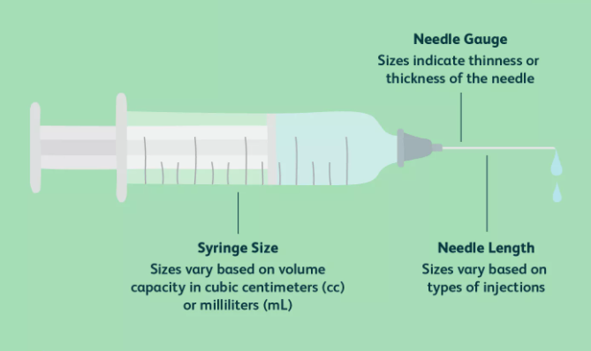

Figure 3.1: Syringe with methods
    - Needle Gauge
The gauge refers to the inner measurement or opening of the needle. Needles are routinely available in various gauge sizes, including 18, 21, 23, and 25 gauge, as shown in the image.
The needle gauge becomes a consideration when the patient's vein is narrow, fragile, or superficial. In such cases, a gauge size with a LARGER number (e.g., 25 G) may be preferred over a standard needle gauge (e.g., 21 G) to minimize damage to the blood vessel and minimize the associated pain in the collection.
However, with a larger gauge size comes a smaller bore and a smaller internal diameter of the collection needle. When blood cells are forced by the vacuum pressure of large volume evacuated tubes to enter the tight space of a tiny needle gauge quickly, hemolysis may occur. Hemolysis can cause inaccurate results (slight to significant) when testing several analytes. Potassium, for example, can be falsely increased in a hemolyzed sample.
Phlebotomists must exercise judgment between maintaining patient comfort and maximizing sample integrity when selecting an appropriate needle gauge for each patient.

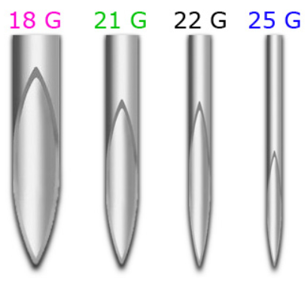

Figure 3.2: Needle Gauges

CHAPTER 4
Methodology
  - Methodology
The system is proposed to achieve the objectives and aims of the optical method of inner and outer diameter detection of IV tubes like the syringe. The proposed method is a very sharp and reality intelligence proposal, and this will get by fabricating the laser beam detector technology. It will be discussed entirely, specifically on the design and fabrication of our project as described by Figure 4.1.
Figure 4.1: Methodology
    - Formulation Phase
In the formulation phase, everyone must take the how one would create the design of the project? How would adopt the parameters? How would one develop a good model? By considering the feasibility of my design from the research survey, which I would have done already. Also, considering the chosen parts' market availability and information coherence helps determine cost. Further, the availability of alternatives is also crucial in case of failure or design changes. We'll use the SOLIDWORKS modeling software in the prototype and parts design due to the simplification of 3D modeling. For the concept or the imagination of my prototype, it is decided to put my idea on paper to use the MS VISIO software to draw a sketch. The sketch is crucial for the designing phase as it shapes the prototype. It also helps the team integrate their imagination into the modeling software, laying a good foundation for a successful project.
    - Conceptual Phase
In this phase, the design and fabrication processes determine the size using the generated prototype view. There is no need to make it very huge since it's only a prototype. The next step involves 3D printing of the parts of my prototype laser beam diameter detector. Firstly, I have a strong opinion on using the units in SOLIDWORKS as meters. However, the process will be more straightforward after confirming the availability of 3D printing machines in the area. The information will inform the decision on using MMGS and the final project size.
    - Configuration Phase
In the configuration phase, it is decided how to go on with our components and their fabrications? Then firstly, it is decided to complete the concept of how much smaller the user wants to check from the laser beam? The configurations are presented in Table 4-1 shown below:
Table 4-1
Elements | Specifications
Measuring Range | 34mm
Smallest diameter detectable target | >0.3mm
Distance Light source | 150-700mm
Distance target receiver | 20-50mm
Linearity | ±10µm
Resolution | 1µm
Repeatability | ≤3μm
Measuring Rate | 2.3KHz
Light source semiconductor laser | 670mm Class-1
Analog Output | -10 to +10V
Digital Output | RS232 or RS422
Switching Output | LC-display, 3 x LED; Sync-Out
Shock acc. | IEC 68-2-29
Vibration acc. | IEC 68-2-6
Operation temperature | 0̊ to 50̊ C
Storage temperature | -20̊ to 70̊ C
Power Supply | 24V D.C.
Cable Length | According to requirements
Controller | I.P. 40
Display | LCD
Receiver | I.P. 64

    - Parametric Design
This phase specifies the dimension of each part, the total length of the complete assembly of the prototype, and the degrees of freedom it can achieve. The parameters of design can be managed, but the electrical components should be considered when designing any type of prototype. In designing every project, the person should also think about the fabrication process, where the critical work of circuiting is performed.
According to geometrical optics, the phase and amplitude of the optical field are evaluated independently. First, the ray paths are evaluated throughout the optical system, which enables computing the phase in terms of the optical path length of rays passing through the system. The amplitude of the optical field is determined by monitoring the intensity variations along each ray. The optical ray’s visualization is shown in Figure 4.2.
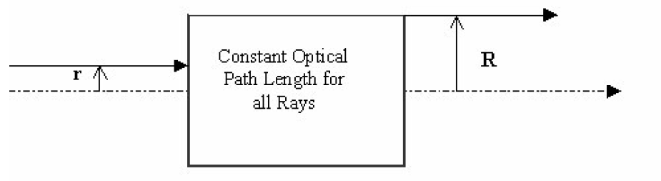
Figure 4.2: Optical Rays

    - Detailed design
This phase explains all specifications and the complete working procedure of the prototype which are remaining. For instance, the primary function is measuring the inner and outer diameter of the IV tubes attached to the syringe. On the other hand, the controller glove contains the motor drivers, microcontrollers, resistors, capacitors, and power supply of 24V D.C. supply. A display meter is attached with the connection of the laser beam detector to get the measurements attained by the laser beam light source. The external controllers and display centers show the measurements when the specimen is put in front of the laser beams. And the remaining lasers lights rays and the shadow of the object generated received by the receiver end, and then the controllers display the results on the screen. This laser beam detector is designed to get the inner and outer diameter of IV syringes and tubes. The display meter is shown in Figure 4.3.
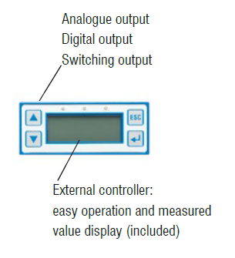
Figure 4.3: Displays
Rays generally characterize the direction of propagation of radiant energy, except near foci or the edge of a shadow where interference and diffraction occur. As such, a ray is a mathematical construct rather than a physical quantity. Snell's law relates the direction of the incident and refracted rays at an interface between media of different indices of refraction, which can be written in vector form in eq.1
$$n^{'}A=n^{'}a+[n^{'}cosi^{'}-ncosi]n$$
where and are unit vectors along with the incident and refracted rays, is a unit vector along the normal to the interface surface with the general orientation of the incident ray, n,n are the indices of refraction of the incident and refracting media, are the angles of incidence and refraction. When mirrors are involved in the above equation can be used to compute the direction of the reflected ray by setting and using the optics sign convention.
Wavefronts commonly describe beam propagation. A wavefront is a surface of a constant phase of the wave or optical path length from the source or reference surface. Each ray generally follows the path of shortest time through the optical system according to Fermat's Principle, which states that a ray from points P to Q is the curve C connecting these two points such that the integral in eq.2
$$OPL\left(C\right)= \int_{c}^{1}{n (x, y, z)ds}$$
The equation shows an extremum (maximum, minimum, or stationary). The quantity is the index of refraction of the medium and is the infinitesimal arc length of the curve. For a homogeneous medium, the optical path length between P and Q is the geometrical path length between the two points times the medium's index of refraction. In general, the optical path length divided by the speed of light in free space, c, gives the time for light to travel from point P to Q along with the ray path C. The ray path C can be determined using the calculus of variations n(x,y,z)ds When the index of refraction is a smooth function.
An overview of using the conservation of energy conditions to design laser beam shaping systems is presented in this section. First, systems in the configuration are considered. It is shown how to relate the input and output beam diameters to conserve energy for a Gaussian input beam. Then, it is shown how to use energy conservation to design beam shaping optics when a non-collimated output beam is an incident upon a curved detector.
When a beam shaping system does not have either a collimated input or output beam or the output reference surface is curved, the conservation of energy condition needs to be revised to incorporate the actual geometry. In these cases, it is generally not possible to integrate the resulting conservation of energy conditions. Instead, the optical design of these beam shaping systems can be accomplished by incorporating the mapping of the ray trace equations into the expression of conservation of energy for the beam shaping system and then solving the resulting differential equation for the contour of the reflecting or refracting surfaces.

  - Design
Firstly, the base of the laser beam detector for holding the transmitter laser light and receiver with these dimensions' length of 200mm and with the width of 91mm. The base of the detector and receiver has a height of 48mm with two Y-shaped stands for holding the object of IV tubes. IP-40 controller for the laser detector comes with 15 different cycles, with all parameters being site settable. The system has an optional label length error, an optional RS 485 (R.J. 11/R.J. 45) interface for VFD control and internally supported Delta and Invertek protocols. Further, the system also comes with a 16 critical soft membrane keyboard and 20 x 4 Backlit LCD with 4 LED indications that offer the desired man-machine interface. The 3D design of the laser light source is shown in Figure 4.4.
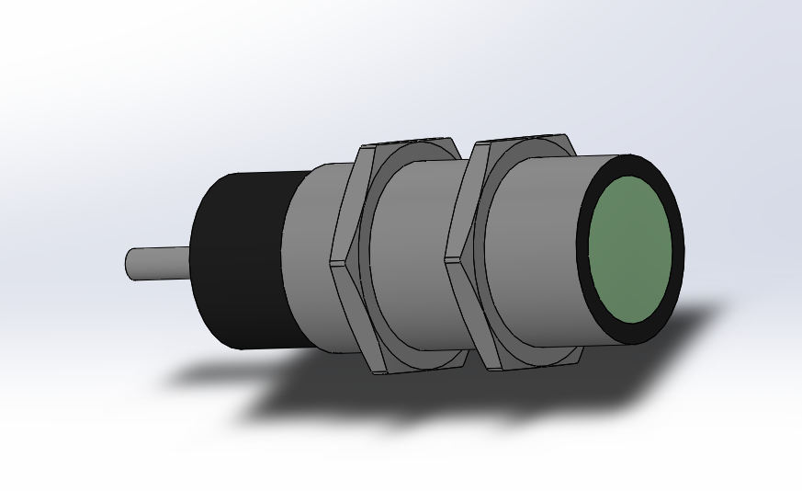
Figure 4.4: Laser Light Source
The GDD IP Receiver is a new compact, low consumption unit designed for resistivity measurements. It features high capabilities allowing it to work on any field conditions. It can be configured in multi-pole or multi-dipole reception. On the other hand, the receiver uses a PDA hand-held P.C. to process data acquisition. A VGA display allows monitoring the results live on the field. The operating system is Windows C.E., and the software can easily be updated via the internet. The 3D design of the receiver source, which is generated on the SOLIDWORKS, is shown below in Figure 4.5. Finally, it also contains the design of an optical device for measuring the inner and outer diameter of the syringe tube. It measures 200mm in length, 48 mm in height, and 91 mm in width, as shown in Figure 4.6.
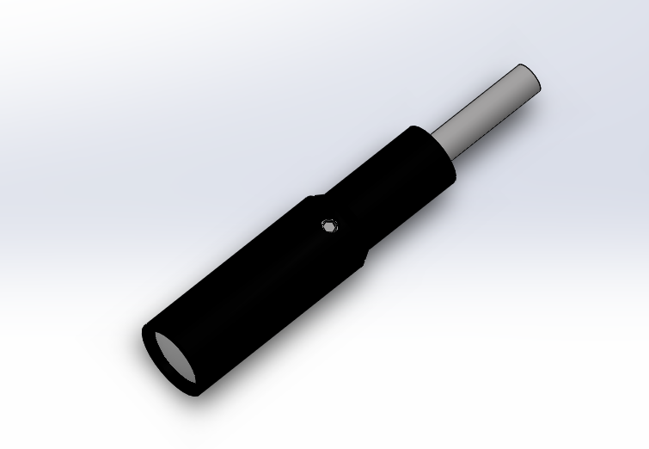
Figure 4.5: Receiver Source
Figure 4.6: Laser Source on Base
Reception poles/dipoles 8 poles/dipoles, expandable to 32, for dipole-dipole, pole-dipole or pole-pole arrays. The GRx8-32 offers twenty fully programmable windows for higher flexibility in the definition of the I.P. decay curve.
User modes are available for arithmetic, logarithmic, semi-logarithmic, Cole-Cole, IPR-12, and user defined. Chargeability values, Resistivity, and I.P. decay curves can be displayed in real-time thanks to the VGA screen. Before data acquisition, the GRx8-32 can be used as a one-channel graphic display for monitoring the noise level and checking the primary voltage waveform through a continuous display process. Capacity to store up to 64 000 readings for eight poles/dipoles, memory expandable up to 512 000 readings upon PDA model. Each reading includes the complete set of parameters characterizing measurements. Data is stored on Flash-type memory that does not require any lithium battery for safeguard.
I.P. ratings for lights are a vital area of consideration in home and industrial design when planning/installing a lighting setup, particularly in bathrooms, kitchens, outdoor areas, and any other spaces that are likely to be exposed to particulates or moisture ingress from various sources (including weather).
While lighting systems use the same I.P. rating numbers and definitions as any other enclosure, it's also important to be aware of different 'zones' in each room or area and how they might impact the I.P. demands your lights need to meet. When someone wants to measure the inner and outer diameter of an IV syringe or any tube, it can the putted on the Y-shaped stands, and the object should be stationary. When the laser light is put on the object's body, it creates the object's shadow, and the laser gives the values on the receiver, then one can read the values of dimensions on the display meter. The 3D model of the laser beam detector is shown in Figure 4.7.
Figure 4.7: Laser Beam Detector Design
  - Fabrication

    - Optical Design of Laser Beam Shaping Systems
The optical design of a laser beam shaping system seeks to define the optical components adequately so that the system can be analyzed, fabricated, and tested. The process generally requires specification of the shapes of and spacing between the optical surfaces and the index of refraction of all the media. For the refracting beam expander system illustrated, the shape of surfaces s and S must be determined. The conservation of energy condition and the constant optical path length condition can be solved simultaneously with the ray trace equations for when they are given. In contrast to conventional optical design, the present method of solving differential equations defines the optical surfaces s and S by producing tables of numerical data (r,z) for surface s and (R, Z) for surface S. It does not seem possible to solve this differential equation analytically for z(r) and Z(R). The first element of a beam shaping system can be expressed as a function of r in eq.3
$$z\left(r\right)=\int{f\left(r\right)dr+C}$$
Where C is a constant, and f(r) relates to the optical configuration. The shape of the second surface can be computed from the following expression in eq.4
$$Z\left(r\right)=z\left(r\right)+g(r)$$
Where g(r) is another function from the configuration. In the next paragraph how to design a one-mirror, two-lens, and two-mirror beam shaping systems that can uniformly illuminate a detector with an input laser beam and expand or magnify the beam diameter.
The optical design of laser beam shaping systems involves incorporating the geometrical optics intensity law for propagation of a bundle of rays (conservation of energy) and the constant optical path length condition into the ray trace equations for the optical system and then determining the geometrical shapes of several optical surfaces (or GRIN materials) so that the beam shaping design conditions are satisfied. The constant optical path length condition will not be part of the design process for beam shaping applications that only need to illuminate a given surface with a specific irradiance distribution.
    - Raw materials used for IV Set Manufacturing
The raw material used for manufacturing of IV Sets is listed below in Table 4-2
Table 4-2
Sr. No | Name of the raw material
1. | Polypropylene
2. | Highly kink resistant non-Toxic Medical grade PVC Tube
3. | HDPE
4. | Packing Material
5. | Non-toxic grade PVC
6. | Filter (Nylon +HDPE)
7. | Printing Ink

  - Measuring principle
This laser beam measuring device is based on the principle of light quantity measurement. A lens spreads out the light of a laser diode to a parallel light curtain aimed at the receiving unit. The light is guided via various filters and lenses through a precision shutter to a light-sensitive detector in the receiving unit. The amount of occurring light is provided by analog electronics and output as an analog signal.
Schematic of a system constructed by two confocal high-NA objective lenses. A sectional uniform line source antenna, with the current constant, is centered at the foci of two high-NA objectives and aligned along the optical axis (denoted by yellow arrows). The field radiated from the antenna (denoted by black arrows) is completely gathered by two identical objective lenses to their pupil planes. Next, the field at the pupil planes is inversely propagated (denoted by red arrows) with a relative π phase shift (denoted by blue arrows) and focused by the 4Pi focusing system. The mathematical techniques of measuring through laser beam are shown in Figure 4.8
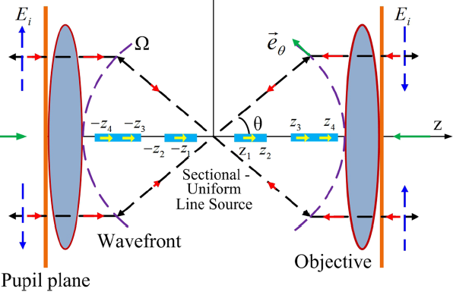
Figure 4.8: Measuring Principles
  - Optical device precision
Micrometers from Micro-Epsilon operate according to the Thru-Beam principle. Here, the transmitter produces a parallel light curtain transmitted via a lens arrangement into the receiving unit. The beam is interrupted if there is an object in the light path. The shadowing generated by this object is recorded by the receiving optical system and output as a geometric value. Several types of Thru-Beam technology are used across the six different sensor models in the range to cover as wide a field of applications as possible. Optical micrometers can be used for dimensional measurements in production, quality assurance, and service tasks. Factors such as the diameter, gap, height, position, and also the received amount of light or opacity can be measured. The optical view of laser beam working is shown below in Figure 4.9.
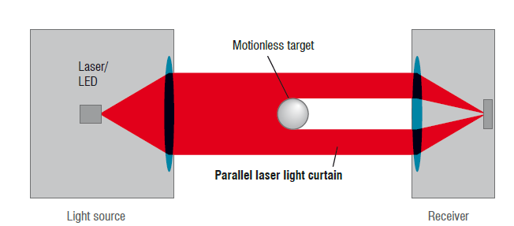
Figure 4.9: Optical View

CHAPTER 5
Operating Instructions
  - Instructions for Operation
The instruction for using the laser beam diameter or dimension detector is given below for the users, which can increase the device's lifetime.
    - Cleaning
We recommend cleaning the front surface of the probe regularly. The cleaning of the laser light source and receiver reduces the error for generating the values.
    - Dry cleaning
You can use an anti-static brush for lenses or blow down the front surface using dehumidified, clean, oil-free compressed air.
    - Wet cleaning
Use a clean, soft, lint-free cloth or a lens cleaning tissue and pure alcohol (isopropanol) to clean the front surface. Never use commercial glass cleaners or other cleaning agents.
  - Flexible in use
Micrometers are primarily used as part of the manufacturing process and quality control of a production line, measuring continuous material and single parts. The relevant technologies used here, such as laser intensity measurements and CCD chip imaging, are suitable for a wide variety of applications. The compact models in the laser products family work for production line applications and integration into machine tools and other production machinery. High measuring rates ensure a high, continuous production rate.
  - Special Application areas
All laser beam sensors function without a rotating mirror and so are entirely wear-free. The parallel light curtain is produced by a special lenses arrangement in the light source (transmitter). High-quality components in the optical receiving system, e.g., filter and lenses, enable high accuracy. Therefore, the laser beam devices are ideally suited to applications requiring high precision and complete reliability. The laser beam diameter measuring model ranges can be modified for customer-specific applications, for example:
- Carry case version for service tasks.
- Customized cable lengths, modified cable outlet.
- Version with the reduced light source to receiver gap.
- Version with deflection mirror for installation in tight spaces.
- Customer-specific software, e.g., measurement programs, statistics.
- Customer-specific linearity adjustment.
- High accuracy and measuring rate
- Resolution from 0.1μm
- Measurement objects from 0.02mm
- Wear-free measurement for long service life
- Different models for numerous application areas

CHAPTER 6
Laser Lights
  - Laser Light Setups
The setup for a laser wire beam profile monitor is sketched in Fig.6.1. A high-power laser beam is divided into two different optical paths for scanning the horizontal and vertical beam size. The scanning is foreseen to be done either with piezo-driven mirrors or with acoustic scanners. Before the interaction with the electron beam the laser, beams are focused. The electron beam is then bent away while the Compton scattered photons travel along a straight line where they are detected with a calorimeter. Scattered electrons will be bent more strongly than particles with the nominal beam energy enabling detection at a location after the bending magnet. The method shown below is the old method in which the chances of the error are very high, and there is the matter of tiny objects and dimensions. In this old method, the light from the laser beam is splatted and curved by the splitter and mirror on the object, and then the dimensions are calculated by the electron beam trajectory and gamma rays.
Laser sensors are used in various fields of application for industrial automation. The variety in application areas entails a demand for different types of laser sensors. There are applications for detections, measurements, or positioning. What different laser sensors have in common are the advantages that the use of laser light provides. A first advantage is the high light intensity, which enables accurate measurement, positioning, or detection (down to nanometers). Another advantage is the measurement speed. The chances are very high due to the use of light as a medium. The complete overview of the laser beam diameter detector is shown in Figure 6.1.
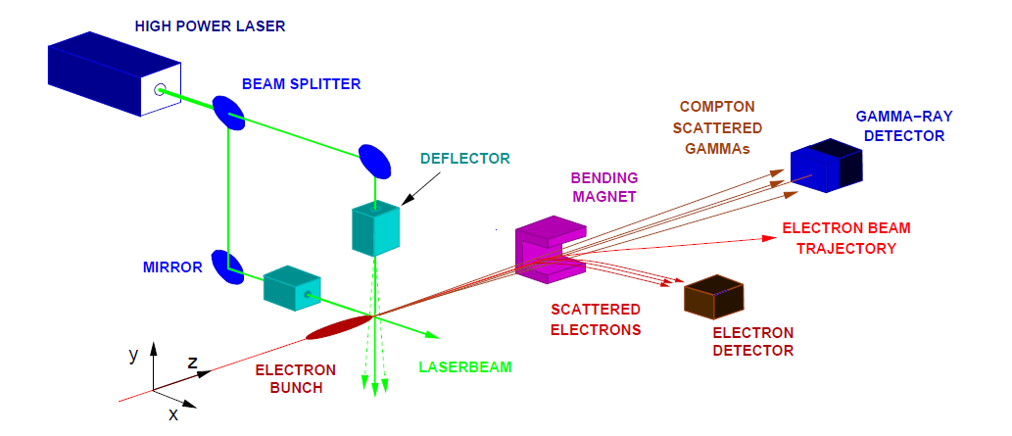
Figure 6.1: Laser Wire Setup
Laser Wire is an optical glass that is so fine. The bending properties mimic more closely to a wet noodle than a wire. Because no electricity streams through it, it's perfectly safe to the touch, and can be sewn into fabrics, clothing, safety wear, automotive applications, and much, much more. The emitter part of the laser light grid sends out parallel laser beams from a laser light barrier. These laser beams then shine on a line sensor on the receiver side. An object will wholly or partially obstruct the laser light barrier, which will not reach the receiver. The number of obstructed beams is used to measure.
An object in the laser curtain makes it possible that the receiver part does not receive a part of the laser curtain. The parallel laser beams allow the object to cast a shadow on the receiver. The transmitter and receiver can be used as separate modules or complete forms in a U-shape mounting. The line sensor consists of hundreds of small light-sensitive cells, so-called pixels. The laser light that falls on pixels ensures that these pixels emit an intensity signal. Pixels that do not receive laser light do not emit a signal. In case a pixel is half exposed, it also emits a half intensity signal. The sensor processor converts the intensity signals of each pixel into a video signal. This video signal is used to set a threshold value. Where the video signal crosses the threshold represents the edge of an object in the laser curtain. With one edge, it is possible to use it as a position. Two edges make it possible to measure the diameter. With three or four edges, it is also possible to measure the distance between two objects. The measurement accuracy starts from 2μm, depending on the measurement range of the set. The changing can easily make the changes in the apparatus of the only receiver. If the user wants to measure the dimensions other than the diameter, the user needs only to change the receiver sensors for other geometric measurements.

CHAPTER 7
Conclusion
  - Conclusion
Designed as a transmitter and receiver, it guides the light directly to the object via fiber-optic cable. The approach is ideal in cramped spaces or challenging installation environments since the electronics unit can be mounted long-distance. Different fiber optics can determine whether the light beam between the transmitter and the receiver has been interrupted. An optical laser beam theory for the design of laser beam shaping systems has been presented. This theory of laser beam shaping is based on the conservation of radiant energy within a bundle of rays, which is also known as the intensity law for the propagation of a bundle of rays, the ray trace equations, and the constant optical path length condition for cases when the contour of the incident wavefront is maintained as the beam passes through the system. When the syringe's needle is placed anywhere, this laser beam detector measures the inner and outer diameter of the needle. It is presented on the digital display meter attached to the laser beam detection device. Measure diameters, positions, or distances from or between objects very accurately. Diameters or widths of objects can be measured within the range of the sensor but can also be measured using two sensors.

References
1. Youngworth, K. & Brown, T. Focusing of high numerical aperture cylindrical-vector beams. Opt. Express 7, 77–87 (2000).
2. Quabis, S., Dorn, R., Eberler, M., Glöckl, O. & Leuchs, G. Focusing light to a tighter spot. Opt. Commun. 179, 1–7 (2000).
3. Zhan, Q. & Leger, J. R. Focus shaping using cylindrical vector beams. Opt. Express 10, 324–331 (2002).
4. Dorn, R., Quabis, S. & Leuchs, G. Sharper focus for a radially polarized light beam. Phys. Rev. Lett. 91, 233901 (2003).
5. Zhan, Q. Cylindrical vector beams: from mathematical concepts to applications. Adv. Opt. Photon 1, 1–57 (2009).
6. Bokor, N. & Davidson, N. Toward a spherical spot distribution with 4p focusing of radially polarized light. Opt. Lett. 29, 1968–1970 (2004).
7. Q. Zhan and J. R. Leger, “Microellipsometer with radial symmetry,” Appl. Opt. 41, 4630 4637 (2002).
8. Q. Zhan and J. R. Leger, “Interferometric measurement of Berry’s phase in space-variant polarization manipulations,” Opt. Commun. 213, 241–245 (2002).
9 C. Rotschild, S. Zommer, S. Moed, O. Hershcovitz, and S. G. Lipson, “Adjustable spiral phase plate,” Appl. Opt. 43, 2397–2399 (2004).
7. Chen, W. & Zhan, Q. Creating a spherical focal spot with spatially modulated radial polarization in 4Pi microscopy. Opt. Lett. 34, 2444–2446 (2009).
8. Yu, Y. Z. & Zhan, Q. Creation of identical multiple focal spots with prescribed axial distribution. Sci Rep. 5, 14673 (2015).
9. Wang, J., Chen, W. & Zhan, Q. Creation of uniform three-dimensional optical chain through tight focusing of space-variant polarized beams. J. Opt. 14, 055004 (2012).
10. D. Pohl, “Operation of a Ruby laser in the purely transverse electric modeTE01,” Appl. Phys. Lett. 20, 266–267 (1972).
11. H. Raether, Surface Plasmons on Smooth and Rough Surfaces and Gratings (Spinger-Verlag, 1988).
12. T. W. Ebbesen, H. J. Lezec, H. F. Ghaemi, T. Thio, and P. A. Wolff, “Extraordinary optical transmission through sub-wavelength hole arrays,” Nature 391, 667–669 (1998).
13. W. Chen and Q. Zhan, “Optimal plasmonic focusing with radial polarization,” Proc. SPIE 6450, 64500D (2007).
14. International Journal of Scientific & Engineering Research Volume 8, Issue 10, October-2017 989 ISSN 2229-5518 IJSER © 2017 http://www.ijser.org “DESIGN AND FABRICATION OF AUTOMATIC IV FLUID FEED SYSTEM”.
15. British Journal of Anaesthesia 1995; 75: 361–365 “An evaluation of methods of increasing the flow rate of i.v. fluid administration”.
16. M. C. Lang, T. Staudt, J. Engelhardt, and S. Hell, New J. Phys. 10, 043041 (2008).
17. Liu, T., Tan, J. B., Liu, J. & Wang, H. T. Modulation of a super-Gaussian optical needle with high-NA Fresnel zone plate. Opt. Lett. 38,
18. MacDonald, M. P. et al. Creation, and manipulation of three-dimensional optically trapped structures. Science 296, 1101–1103 (2002).
19. Payeur, S. et al. Generation of a beam of fast electrons by tightly focusing a radially polarized ultrashort laser pulse. Appl. Phys. Lett. 101, 041105 (2012).
20. Čižmár, T., Dávila-Romero, L. C., Dholakia, K. & Andrews, D. L. Multiple optical trapping and binding: new routes to self-assembly J. Phys. B: At. Mol. Opt. Phys. 43, 102001 (2010).
21. J.H. McDermit and T.E. Horton, “Reflective optics for obtaining prescribed irradiative distributions from collimated sources,” Applied Optics 13, pp. 1444-1450, 1974.
22. P.W. Rhodes and D.L. Shealy, “Refractive optical systems for irradiance redistribution of collimated radiation: their design and analysis,” Applied Optics 19, pp. 3545-3553, 1980.
23. N.C. Evans and D.L. Shealy, “Design and optimization of an irradiance profile shaping system with a genetic algorithm method,” Applied Optics 37, pp. 5216-5221, 1998.
24. “R&D TOWARDS A LASER BASED BEAM SIZE MONITORFOR THE FUTURE LINEAR COLLIDER” G.A. Blair, T. Kamps, H. Lewin, F. Poirier, S. Schreiber, N. Walker, K. Wittenburg Royal Holloway University of London, Egham, Surrey, TW20 0EX, UK Deutsches Elektron–Synchrotron DESY, D-22603 Hamburg, Germany
25. Gill HS, Prausnitz MR. Does Needle Size Matter? J Diabetes Sci Technol. 2007;1(5):725-729. doi:10.1177/193229680700100517
26. Weiss M, Hug MI, Neff T, Fischer J. Syringe size and flow rate affect drug delivery from syringe pumps. Can J Anesth. 2000;47(10):1031-1035. doi:10.1007/BF03024878
27. Hamborsky J, Kroger A, Wolfe S, eds. Centers for Disease Control and Prevention. Epidemiology and Prevention of Vaccine-Preventable Diseases. Chapter 6: Vaccine Administration. 13th edition. Washington, DC; Public Health Foundation, 2015
28. Salari M, Estaji Z, Akrami R, Rad M. Comparison of skin traction, pressure, and rapid muscle release with conventional method on intramuscular injection pain: A randomized clinical trial. J Educ Health Promot. 2018;7:172. Published 2018 Dec 28. doi:10.4103/jehp.jehp_216_18
29. Centers for Disease Control and Prevention. Vaccine Recommendations and Guidelines of the ACIP: Vaccine Administration. Updated June 21, 2019

