Case 3: Work Zone incident

Summary
On July 18, 2006, a 21-year-old male road construction worker (the victim) was fatally injured when a dump truck partially loaded with asphalt backed over him. The victim was a member of a road construction crew working at night on a state highway paving project. The dump truck driver was backing through the work zone, with the truck's back up alarm sounding, toward the next section of roadway to be paved when the truck struck the victim. The paver and paving crew had already re-positioned to the next section of roadway to be paved. The dump truck driver was watching the driver's side mirror as he was backing to align the truck with the re-positioned paver. As he was backing he did not see anyone behind the truck. He then saw something appear out from under the front of the truck, at which time he stopped the truck. Evidence suggests the victim had his back to the dump truck. The victim had not been assigned tasks within the workzone, but may have been shoveling spilled asphalt. Emergency medical services (EMS) personnel were called and arrived on the scene to find the victim deceased.

Introduction
On July 18, 2006, a 21-year-old male road construction worker (the victim) was fatally injured when a dump truck partially loaded with asphalt backed over him. On August 9-10, 2006, investigators conducted an investigation of the incident. The case was reviewed with the paving contractor’s Safety Director; the Department of Transportation (DOT), Office of Employee Safety and Health; and, the compliance officer assigned to the case. None of the coworkers or supervisors who were working on the night of the incident were available to be interviewed. A copy of the state police report was reviewed. DOT provided photographs taken the day after the incident. Photographs of the site were also taken by investigators.
Employer
The victim's employer, a paving corporation, employed approximately 140 employees during peak season, and had approximately 85 employees working throughout the year. The company had been in operation since the mid-1940s. The company worked a variety of state contracted and commercial projects. A typical highway paving crew consisted of approximately 15 crew members. The company operated 30 dump trucks and contracted 30 independently owned trucks. The night of the incident the employer was working a state Department of Transportation project with one area supervisor and one project supervisor.
Victim
The victim was 21 years of age, and had been employed for 3 months as a general laborer with the paving company. His primary responsibility was that of a van driver to transport workers who did not possess driver's licenses to and from the job site. When not driving a van, he would sometimes perform duties such as flagger or laborer.

Equipment
The project was being completed with one paver, two rollers, a sign truck, a distributor truck, and 15 dump trucks. All dump trucks hauling asphalt on the project were owned and operated by independent contractors. The truck involved in this incident was a 2005 model year dual axle dump truck measuring 33’4” in length and 8’ 7” in width. The truck was inspected by VOSH and found to have properly functioning lights and back up alarm.
Safety program and training
The paving contractor employed a full-time Safety Director who was not on site at the time of the incident. Site supervisors are responsible for site safety, and safety problems are reported to the company Safety Director, as necessary. The company had a comprehensive written safety and training program, but no site specific plan was available for review.
Classroom training and informal bi-monthly "toolbox" safety talks were provided to company employees. There was no evidence found that the victim had received any type of internal work zone safety training prior to the incident. No training program was targeted towards sub-contractors. No safety procedures were specified in the contract language other than the use of traffic signage specified by DOT requirements.
This was the employer’s second fatal back over incident; the prior fatality occurred in 1993.

Investigation
The employer had been contracted by VDOT to pave an urban stretch of 4 lane divided state highway. Paving of the highway travel lanes had been completed, and before lane line painting could begin, the paving of the turn lanes approaching the intersections needed to be completed. An independent trucking company had been contracted to assist with hauling asphalt from the asphalt plant to the project site.
Work on the turn lanes began on the evening of July 18, 2006, at approximately 8:00 p.m., with closure of the inside westbound lane adjacent to the concrete median and the set up of the work zone. Traffic cones were used to close the westbound lane and channel traffic past the work zone (Diagram 1). The project area was described as being very dark with the absence of street lights along the work zone. Parking area lighting from adjacent business establishments provided the only ambient lighting in the project area.

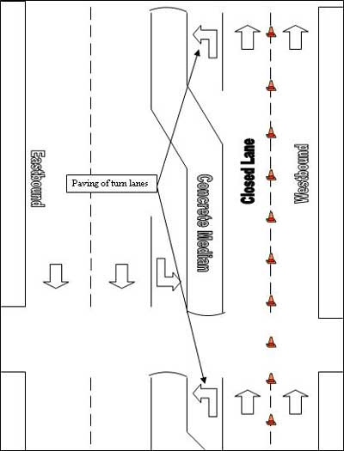
Diagram 1: Overhead view of workzone

After paving a turn lane, operators of the paver and dump truck loaded with asphalt would proceed to the next turn lane. The paving company’s Safety Director stated to investigators that the employer’s normal standard operating procedure (SOP) briefed verbally to drivers was for trucks not to back through the intersections. The stated SOP was for the trucks to perform a u-turn and enter the east bound lane and travel back past the paver before turning back into the west bound lane, approaching the paver from the rear while driving forward (Diagram 2). The truck would then pull forward in front of the paver, thereby minimizing the backing distance to the paver. Spotters were located only at the paving machine to assist the driver in aligning the truck with the paver. No written SOP for trucks backing through the work zone was provided to investigators.
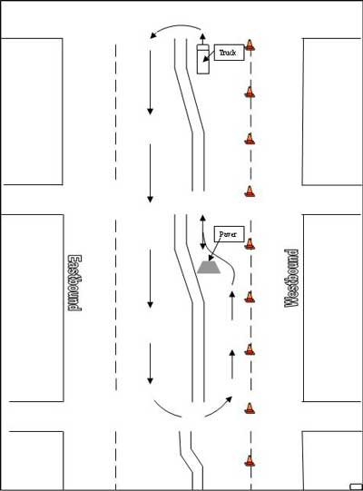
Diagram 2: Depiction of truck approaching paver in accordance with stated SOP

At the time of the incident, the paving crew had just finished a turn lane and had backed the paver through the closed lane to the next turn lane which was located at an intersection approximately 150 yards east of the previous turn lane. The paving crew had walked with the paving equipment to the next intersection. The victim had not walked with the rest of the crew, but had remained further back in the closed lane (Photo 1). None of the work crew or the on site supervisor knew why the victim had not accompanied the rest of the work crew to the paver. According to the site supervisor he was not assigned any tasks in the work zone.
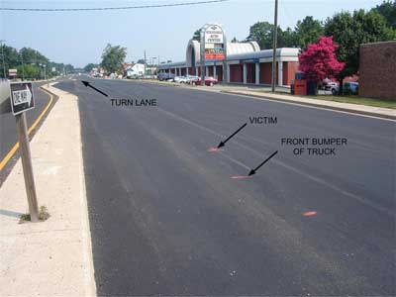
Photo 1. View facing west towards turn lane paved just prior to incident. Photo illustrates the location of the victim after being struck in relation to the truck after coming to rest in the inside west bound lane.

As the driver was backing the dump truck through the work zone (backing east through the closed westbound lane) he was looking through his driver’s side mirror to aide in aligning the truck with the paver while approaching the intersection. The driver stated he did not see anyone behind the truck. As he was backing the truck he felt a bump and noticed something appear out from under the front of the truck (Diagram 3). The driver stopped and got out of the truck. A VDOT Consultant Inspector, who was at the project site, was signaled that there was a problem. The inspector looked up and saw what appeared to be a high visibility traffic vest in the road. EMS personnel and the Virginia State Police were notified at approximately 11:00 p.m. The victim was pronounced dead at the scene.
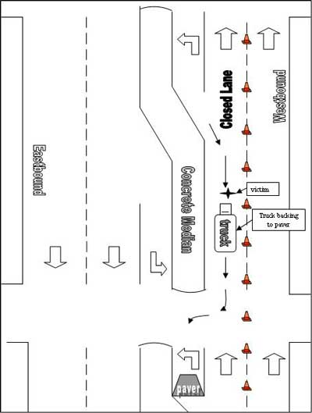
Diagram 3: Truck backing through westbound lane towards paver

Evidence suggests the victim had his back to the truck when he was struck. He was struck by the rear right side of the truck and the right side tires passed over him. The truck was approximately 100 feet from the intersection it was approaching when it struck the victim (Photo 2). The victim was wearing a high visibility vest and hard hat. A shovel normally used to shovel asphalt spill back onto the roadway was beside the victim. Although the victim had not been assigned any tasks within the work zone, he may have been shoveling spilled asphalt at the time he was struck by the truck. The paving company’s safety director stated the back up alarm and lights were functional on the truck. Other than flood lights on the paving equipment and working lights on the trucks, no supplemental lighting sources were present at the site. The work crew had been provided with hard hat lights.
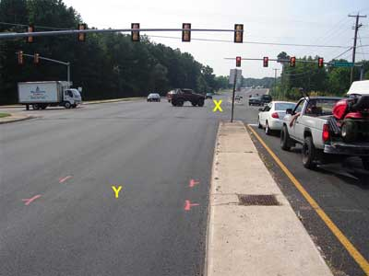
Photo 2. View facing east towards intersection and turn lane where paver was being re-positioned. Truck was backing towards the turn lane denoted by "X". The "Y" denotes resting position of rear truck tires after striking victim.

Cause of Death
The medical examiner's office reported that the cause of death was multiple crushing trauma.

