Programming Assignment 7 Instructions
Matthew 6:21
“For Where your treasure is, there your heart will be also.”
This week you have been asked to create SQL Server Database to keep track of donations from members of the church. You are tasked with creating the database, the form, and a query. Please see the requirements below.
- Project
  - You must save your project using your initials in the name
**This is required and the project will not be accepted otherwise.

- Create a SQL Server Database
  - Create a Service-based Database in the project called yourinitialsDonations.mdf with the following fields and their settings to the database.
  - Primary Key should be ID, Set the Identity Specification (Is Identity) = True
Name | Type | Null?
ID | int | Not Null
FirstName | Varchar(50) | Not Null
LastName | Varchar(50) | Not Null
Amount | Money | Not Null
DonationDate | Date | Not Null
  - The following data is required for your database. Please remember you do not need to enter the ID as it will be entered for you. **You must enter four entries of your own with your name, your instructors name, and two names of your choice. The amounts and dates can be of your choice for your entries. Your assignment will not be accepted without this.
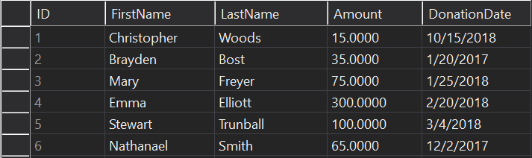
- Create a dataset

- Create a Data form like the one below using the Donations.mdf database file.
  - Update the backcolor to a picture of your choice.
  - Update the backcolor and forecolor of the buttons
  - Use appropriate naming conventions for controls.
  - Lock the controls on the form.
  - The amount text box must be formatted to currency
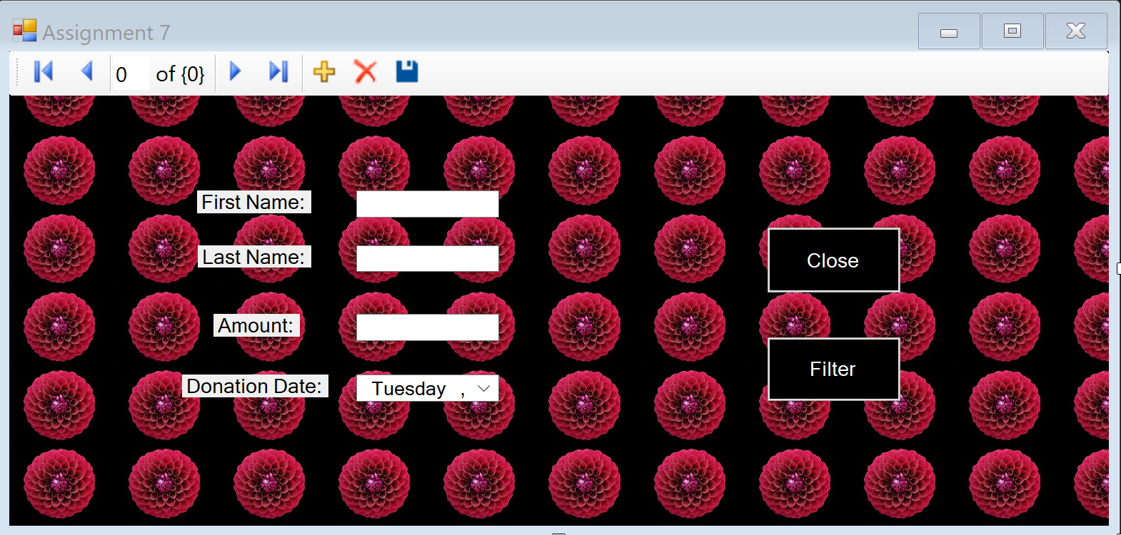
- Create a Try Catch for the Save Item Click and create a message box for the Changes saved and the Exception if not saved.
- Create a SQL Query (SELECT which returns rows) using the query builder to display all donations greater than or equal to $50.
- The Filter Button uses the query to only display values filtered by the query.
- The close button closes the application.

This assignment is due by 11:59 p.m. (ET) on Monday of Module/Week 7.

