Cease and Desist Letter Assignment Instructions
Instructions:
You will write a cease and desist letter relating to a copyright infringement issue. The letter will be formatted as if it were to be submitted to an attorney for review. The assignment will be based on a hypothetical fact situation that an intellectual property paralegal would be likely to encounter.

Hypothetical Situation:
You are a paralegal at a Lynchburg law firm that regularly handles intellectual property matters. In fact, a sizeable portion of the firm’s new clients are photographers, as it seems like everyone is dabbling in photography these days. Your firm represents Phoebe Smith who operates a single-member LLC, Phoebe’s Photography, LLC, here in Lynchburg, Virginia. Phoebe does mostly weddings and high school senior photos. She has, however, recently begun to travel the countryside taking nature shots, that is, pictures of the beautiful landmarks that the Virginia countryside has to offer. She has also traveled outside of Virginia, all in attempts to take better, more awe-inspiring photographs.
Phoebe has a website (www.phoebesphotographyllc.com) that displays some of her photographs to potential customers to see if they like her work. Each of the photographs have a standard watermark and note “Phoebe’s Photography, LLC” in the bottom right hand corner. Moreover, Phoebe has enabled controls on the website that are supposed to prevent copying-and-pasting of the images. There is also a disclaimer on the website that states website users are not allowed to copy the pictures, but Phoebe has never “registered” any of the photos or anything of that nature.
A few nights ago, Phoebe stumbled upon a website of a local contractor who was using her nature shots of the Lynchburg area on his website. The contractor is Ken Doe, a local general contractor/handyman, who operates Ken’s Contracting, LLC.
Phoebe and her LLC have engaged your law firm to get Ken to take down her pictures. After some initial research, you find out that Ken’s Contracting, LLC, has a mailing address of 101 Main Street, Lynchburg, Virginia, 24502. The client interview also revealed that all of the copyright ownership is vested in Phoebe’s LLC, not Phoebe personally. The mailing address for your law firm is 123 Bedford Ave., Lynchburg, VA, 24502. The law firm name that you work at is Jackson & Lee, PLLC.
Based on this information, and using the legal resources available to you through the Liberty University Library, conduct research regarding (i) the law surrounding the intellectual property issues here and (ii) the form and substance of a cease and desist letter. Your textbook has an example of a cease and desist letter at Exhibit 6-4. Then, prepare a cease and desist letter instructing Ken to remove the images or face a civil suit.

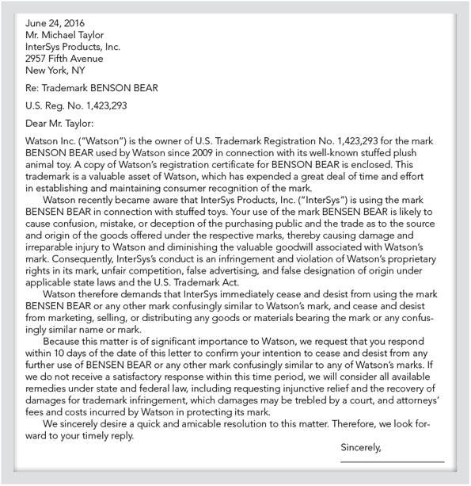
Submit the assignment by 11:59 p.m. (ET) on Monday of Module/Week 5.

All these names, addresses, and facts are purely fictional. Any resemblance to real persons, living or dead, is purely coincidental.

