Assignment 1
  - Deadline: Thursday 01/10/2020 @ 23:59
[Total Mark for this Assignment is 5]

Web Design
IT404

Instructions:
- You must submit two separate copies (one Word file and one PDF file) using the Assignment Template on Blackboard via the allocated folder. These files must not be in compressed format.
- It is your responsibility to check and make sure that you have uploaded both the correct files.
- Zero mark will be given if you try to bypass the SafeAssign (e.g. misspell words, remove spaces between words, hide characters, use different character sets or languages other than English or any kind of manipulation).
- Email submission will not be accepted.
- You are advised to make your work clear and well-presented. This includes filling your information on the cover page.
- You must use this template, failing which will result in zero mark.
- You MUST show all your work, and text must not be converted into an image, unless specified otherwise by the question.
- Late submission will result in ZERO mark.
- The work should be your own, copying from students or other resources will result in ZERO mark.
- Use Times New Roman font for all your answers.
Student Details:
Name: ###  CRN: ### |  | ID: ###

Question One
1.5 Marks
Learning Outcome(s): LO1
Identify most HTML tags and CSS properties and use a text editor to construct the basic HTML and CSS structure for a webpage.

Write the required HTML tags for displaying the contents marked in the red color below:
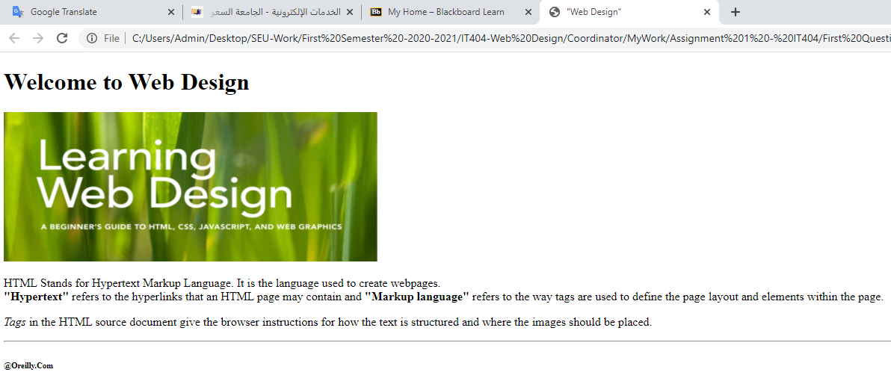

Answer:

Question Two
1 Mark
Learning Outcome(s): LO1
Identify most HTML tags and CSS properties and use a text editor to construct the basic HTML and CSS structure for a webpage.

Some of the markup elements in the following code of HTML web page have been incorrectly used according to the specification of HTML. Correct all of them in the code.

<!DOCTYPE html>
<html>
<head>
<meta name="viewport" content="width=device-width, initial-scale=1.0">
</head>
<body>
<title> Vision 2030 </title>
<h2>SAUDI ARABIA</h2>
<h2>THE HEART OF THE ARAB AND ISLAMIC WORLDS
<h4>The Council of Economic and Development Affairs established 13 Vision Realization Programs </h4></h2>
<ol>
<li> Quality of Life </li>
<li> Financial Sector Development Program</li>
<li>Housing Program</li>
<li>Fiscal Balance Program</li>
<li>National Transformation Program</li>
<li>Public Investment Fund Program</li>
<li>Privatization Program</li>
<li>National Companies Promotion Program</li>
<li>National Industrial Development and Logistics Program</li>
<li>Strategic Partnership Program</li>
<li>Hajj and Omrah Program</li>
<li>Human Capital Development Program </li>
<li> National Character Enrichment Program </li>
</ul>
<h6>© All rights reserved to Saudi Vision 2030<\h6>
</body>
</html>
Answer:

Question Three
1 Mark
Learning Outcome(s): LO1
Identify most HTML tags and CSS properties and use a text editor to construct the basic HTML and CSS structure for a webpage.

Write an HTML code that produces the following output when executed in a web browser.
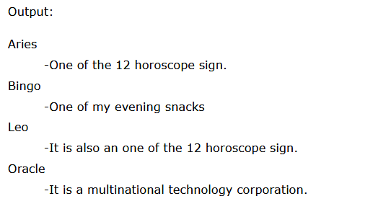
Answer:

Question Four
1.5 Marks
Learning Outcome(s): LO1
Identify most HTML tags and CSS properties and use a text editor to construct the basic HTML and CSS structure for a webpage.

Write a complete HTML code that produces the following output using the paragraph tags and alignment attributes.
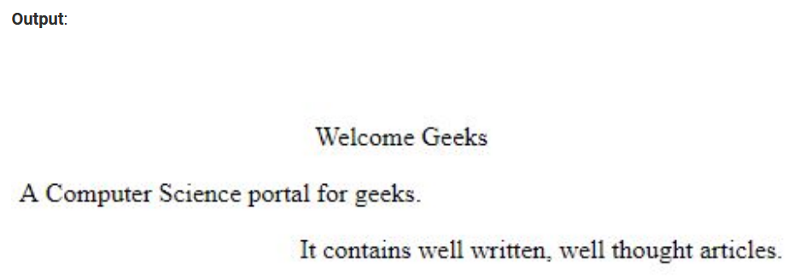
Answer:

