ME 304
Experimental Investigation of a Micro Vortex Diode

Report Evaluation: | Comments:
Technical Content: (%) 50 | This report MUST be re-edited and proper English syntax and grammar MUST be used. It is next to impossible to follow the description. There is no underlying theory to support it.
Writing (%) 40
Combined Score:45

Introduction
The microvalves obtained a vital role in vaporous and fluid liquid vehicle and control marvels. These diodes act as pressure-driven singularities with impedances relying upon the heading of the stream. Along these lines, for a given distinction of weight, the outright estimation of the stream rate contrasts with the bearing of the applied weight inclination: this characterizes the alleged forward and turn around streams. For each estimation of the weight distinction, the productivity of the diode is characterized as the contrast between the forward and the opposite streams, standardized by the forward stream.
For the microdiodes carrying on as microvalves with a high spillage rate, it is critical to focus on the most elevated productivity, by upgrading the plan. This prompts producing challenges and to an unwavering quality constrained by breaking or obstructing dangers, especially with complex liquids. An elective arrangement comprises utilizing microdiodes, which can in various cases assume the job of microvalves without moving parts. Additionally, its structure is more advanced than the plan of the recently referred to diodes, which offers bigger enhancement viewpoints using CAD software.

It has never been made and tried in micrometric measurements. The laminarization of the stream with the scaling down doesn't permit an immediate misuse of the outcomes set up for vortex diodes of a millimetric size. The rule of this diode, called a vortex diode. Its proficiency is fabricated on millimetric measurements, and commonly higher than that of different kinds of diode. The dimension of the proposed CAD model as shown on figure 1 below.
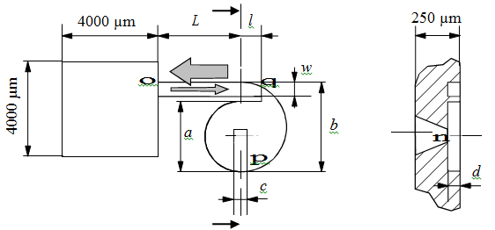
Figure 1: Vortex micro diode CAD Model

Project Setup
This model to be proposed that been recorded and reported in this paper has its specifications as follows:
$$a = 500 μm$$
$$b = 750 μm$$
$$c = 150 μm$$
$$d = 80 μm$$
$$l = 210 μm$$
$$L = 750 μm$$
$w = 200 μm$
Figure 2: Process Step
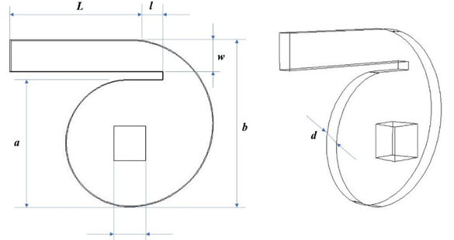
Figure 2: Schematic representation of reference vortex diode from Anduze et al. [1].

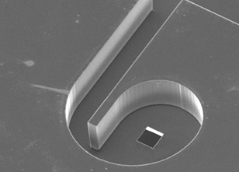
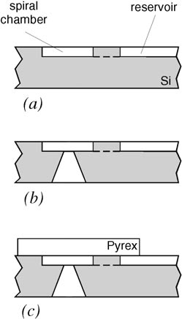

Figure 4: Microdiode SEM
Figure 3: Process setup

Project Procedure
For the first procedure, 3 µm thick resist layer is kept on the front side, going about as a veil layer for the profound responsive particle carving (DRIE) as shown on figure 3. In the process, we abstain from faceting impacts because of the presence of new planes for open edges and bringing about auxiliary twisting as respects to the underlying structure. The utilization of a non-remunerated cover and the concealment of a silicon nitride testimony step disentangle the procedure.
The upside of DRIE would be the verticality of the dividers of the scratched structures is regarded freely of crystallographic direction of the cover. So as to maintain a strategic distance from any mechanical distortion of the final structure when a distinction of weight is applied which can be up to 10⁵ Pa, the microdiode is stuck to a 1 mm thick stainless-steel plate (20 x 20 mm2) and 100 µm thick.
Flow rates are estimated both upstream and downstream from the microdiode, which empowers outlet of the microdiode, which is important to identify potential breaks and to improve accuracy and its functionality. The microsystems just as the metrology segments are restricted in an encompassing chamber, the temperature of 298–328 K. Another testing process is the used of flow of water at T 293 K. With respect to vortex microdiode, the proficiency is better than for a progression of isopropanol. For a 10⁵ Pa pressure contrast, the proficiency runs from 0.16 to 0.27 tentatively and from 0.14 to 0.29 numerically. Once more, a methodical discrepancy among simulation and test under 9%, as shown on figure 4 below:
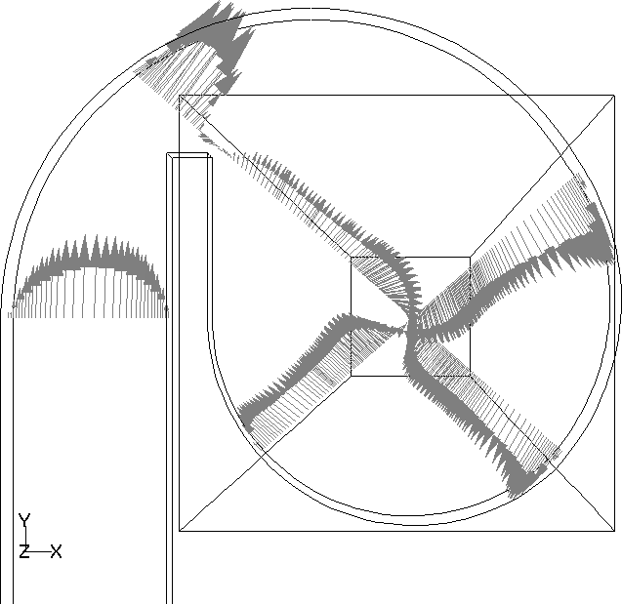
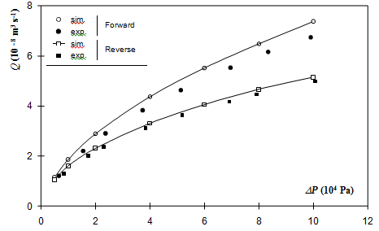
q
C
n
p
Figure 5: Flow of water at 293K Figure 6: OP = 10⁵ Pa & T = 298 K

The Reynolds number is presently somewhere in the range of 100 and 800. The result in this testing and simulation process empowering for the assessment of the productive optimization. The formulation of the vortex micro diodes should be contemplated, this part being regularly approached to work in a beat system, when connected to a micro pump. The numerical reproduction has end up being a prescient instrument. Thus, it will be utilized to check the impact of the various measurements as shown on the figure 1 design and to check whether the structure can be improved.

References
[1] Amirouche, Farid & Zhou, Yu & Johnson, Tom. (2009). Current Micropump Technologies and their Biomedical Applications. Microsystem Technologies. 15. 647-666. 10.1007/s00542-009-0804-7.
[2] Zhang, D.; Lv, J.; Jiang, Y.; Chen, H.; Fu, J. A (2014). A piezoelectric microvalve with a flexure-hinged driving frame and microfabricated silicon sealing pair. Mechatronics, 24, 511–518.
[3] Olsson, P. Enoksson, G. Stemme, E. Stemme, (1995). A valve-less planar pump in silicon, in: Proceedings of the Transducers ‘95/Eurosensors IX, Stockholm, Sweden, pp. 291–294.

Amirouche, Farid & Zhou, Yu & Johnson, Tom. (2009). Current Micropump Technologies and their Biomedical Applications. Microsystem Technologies. 15. 647-666. 10.1007/s00542-009-0804-7.
Zhang, D.; Lv, J.; Jiang, Y.; Chen, H.; Fu, J. A (2014). A piezoelectric microvalve with a flexure-hinged driving frame and microfabricated silicon sealing pair. Mechatronics, 24, 511–518.
Olsson, P. Enoksson, G. Stemme, E. Stemme, (1995). A valve-less planar pump in silicon, in: Proceedings of the Transducers ‘95/Eurosensors IX, Stockholm, Sweden, pp. 291–294

