The Effect of Fittings on Pressure Drop in Fluid Flow Through Pipes

Introduction
Fluid mechanics is an extremely important subject in chemical engineering. A large portion of the raw materials and products produced in chemical plants are in the form of liquids and gases. Internal flow systems are responsible for transporting these fluids. Most piping systems are not straight, smooth runs. Instead, they have turns, couplers, reducers, valves, sensors, and other fittings, which increase the pressure drop due to friction. An increase in pressure drop will change the size of a pump required to transport a fluid. If the additional pressure drop due to friction across the fittings in the system is not considered, the pump in the system may be undersized and not function properly.
This experiment will look at the pressure loss due to friction in four different scenarios: a straight pipe, a straight pipe with one open globe valve, and two non-linear pipe configurations. The difference in pressure drop between the straight pipe and each subsequent scenario will be used to determine the friction factors for the valve and non-linear configurations. The fluid dynamics through fittings is extremely complicated. One way to simplify the process is to calculate an equivalent length calculation using the Fanning friction factor. The Fanning friction factor will be referred to as the friction factor throughout this lab. The equivalent length of a pipe fitting is the length of a smooth straight pipe that would produce the same amount of pressure drop as seen across the fitting. The equivalent length can then be used to accurately size a pump for an internal flow system.
Objective
This experiment aims to determine the friction factor-Reynold’s number relationship for an incompressible, Newtonian fluid flowing in a 3/4" copper pipe. The experiment will produce pressure drop data for various flow rates in four different piping arrangements, which will be used to calculate friction factors. Part of the objective in this lab is to measure the equivalent lengths of an open globe valve, a 90° elbow, and a 45° elbow. The equivalent lengths will be statistically compared to the accepted values for these fittings using percent errors. It is suspected that the results of this lab will show accurate measurements for the equivalent lengths.
Theory
This experiment investigates the effects that fittings have on turbulent flow of an incompressible, Newtonian fluid through a pipe. The pressure loss of each system will be used to determine the Fanning friction factor. For a smooth pipe, the friction factor is a function of only the Reynolds number¹, which is a ratio of the inertial forces to viscous forces within a fluid. A diagram can be made that plots the friction factor as a function of the Reynolds number. This diagram, often called a Moody diagram, can be used to predict pressure drop in a pipe. For turbulent flow, the frictional loss for fittings can be expressed by the equivalent length. The equivalent length reports the losses in a piping element as the length of straight pipe which would have had the same loss¹. A total mechanical energy balance is shown below in Equation 1:
$ΔP+ \frac{1}{2}ρΔV^{2}+ ρgΔz+W+\sum{}F=0$ Eq 1
Where $ΔP$ is the pressure drop across the loop, $ρ$ is the density of a fluid, V is the average velocity of the fluid, g is the gravitational acceleration constant, z is the elevation, W is the work done by a shaft, and F is the total frictional force, respectively. In a pipe with constant cross-sectional area, the inlet and outlet velocities must be equal to satisfy mass conservation. There is no pressure loss due to gravity because the pressure difference between the taps is measured at the same elevation. The system is defined as the piping between the two pressure taps and does not include the pump, so no shaft work is done on the system. The friction factor is assumed to be constant, so it does not change across any fitting. The flow is assumed to be isothermal, and the fluid properties are assumed to be constant over small changes in pressure. Finally, it should be noted that the friction-factor, Reynold’s number relationships determined in this lab negate the need to account for the relative roughness of the pipe because the pipe is of the same material in the entire apparatus. With these assumptions made, the analysis of the system can be conducted. The simplified mechanical energy balance with these assumptions applied is expressed in Equation 2 below:
$ΔP=\sum{}F$ Eq 2
This simplified energy balance shows that the pressure drop of our system is equal to the summation of the frictional forces. The summation of the frictional forces can be expressed as Equation 3 shown below:
$\sum{}F=2f_{F}ρV^{2}\frac{L_{1}}{D_{1}}+2f_{F}ρV^{2}\frac{L_{2}}{D_{2}}+ 2f_{F}ρV^{2}\frac{L_{3}}{D_{3}}+…$ Eq 3

Where $f_{F}$ is the friction factor, $\frac{L_{1}}{D_{1}}$ is the ratio of length to diameter of the straight pipe, and $\frac{L_{2}}{D_{2}}$ along with subsequent numbers are the equivalent lengths of each fitting in the system.
This equation will first be applied to a straight section of pipe that has no fittings in the system to calculate a friction factor as shown below in Equation 4:
$f_{F}=\frac{D_{1}∆P}{2ρV^{2}L_{1}}$ Eq 4
Where D₁ is the inside diameter of the pipe and L₁ is the length of the pipe. Using the assumption that the friction factor is constant for a constant Reynold’s number, this value can be applied to the other systems in this experiment. From this friction factor, the equivalent length of a fitting can be found. The equivalent length of a fitting in a straight pipe is shown below in Equation 5:
$\frac{L_{2}}{D_{2}}=\frac{ΔP}{2f_{F}ρV^{2}}-\frac{L_{1}}{D_{1}}$ Eq 5
Methods
Apparatus and Equipment
An apparatus was constructed to analyze the fluid dynamics of water flowing through pipes. The apparatus consists of four parallel loops (“A”, “B”, “C”, and “D”) in series with a Myers QP10 1HP centrifugal pump and a reservoir of water. Each loop has a shutoff valve, an upper and lower pressure tap, and a unique piping arrangement between the taps in a vertical orientation. Loop “A” is the simplest arrangement, with only straight 3/4” copper pipe between the taps. Loop “B” has an open globe valve between the taps. Loop “C” has four 90° elbows in the geometry shown in Figure 1a. Loop “D” has four 45° elbows in the geometry shown in Figure 1b.
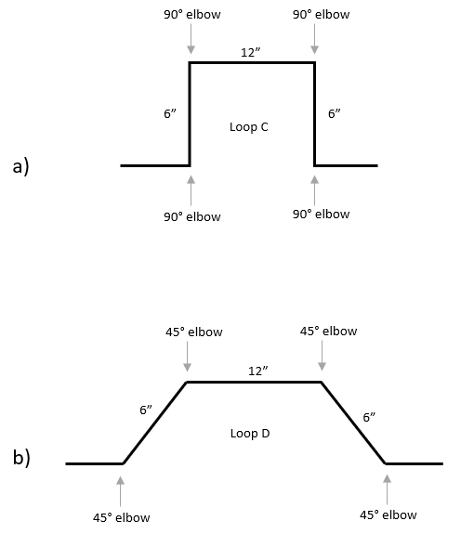
Figure 1: a) Geometric configuration of Loop C. b) Geometric configuration of Loop D.
The pressure difference between the taps is measured using an Omega PX273-030DI differential pressure sensor and is displayed on an Omega DPG41-E pressure indicator. The pressure sensor is situated so that each of the pressure tap streams are measured at the same elevation, which essentially eliminates the pressure drop due to gravity. Pressure tap selector valves are in place for both the top and bottom pressure taps and can be used to switch the pressure sensor reading. An Omega FTB6110 analog flow meter is used to measure the flow rate of water through the apparatus, which is displayed on an Omega DPF700 digital flow indicator. The discharge from the pump flows into the lower manifold of the loops through the main flow globe valve but can also flow into the reservoir through a bypass globe valve. The bypass globe valve can be used to vary the flow rate through the loops. In this experiment, the apparatus will be used to measure the volumetric flow rates and pressure drops across each loop individually for varying flow rates. A schematic of the apparatus is displayed in Figure 2.
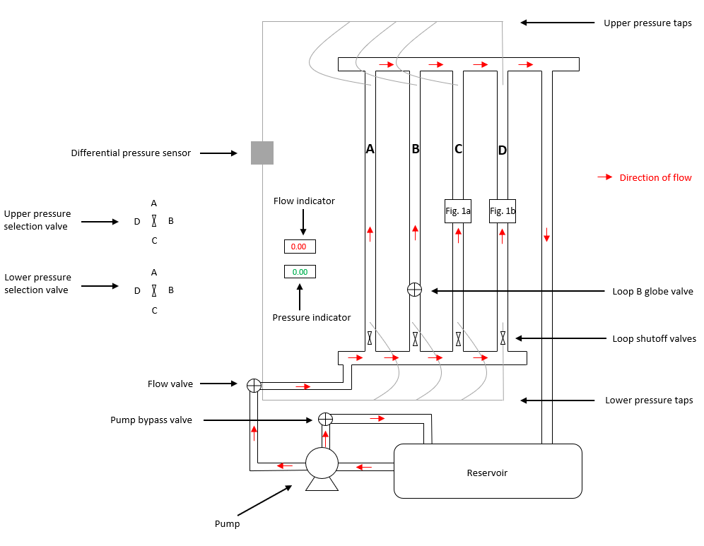
Figure 2: Schematic of the experimental apparatus.
Experimental Design
The pressure drop across each loop will be measured as water is pumped through the apparatus. These measurements will be made for five different volumetric flow rates. The flow rate will start at above 1.0 GPM (to create turbulent flow) and will be increased by increments of approximately 1.0 GPM. Experimenting on each loop will result in five pressure drops per loop. This procedure will be repeated sequentially for loops “A”, “B”, “C”, and “D”. The fluid properties such as density and viscosity will be held constant by running the experiment at constant temperature. Any variation in pressure will have negligible effects on the fluid properties because density and viscosity change minutely over small ranges in pressure. The pressure drop and volumetric flow rate data will be used to determine the relationship between the friction factor and Reynold’s number for each loop. After the friction factors have been calculated, the equivalent lengths of the fittings and valves in loops “B”, “C”, and “D” will be calculated using the procedure shown in the Sample Calculations section of the Appendix.
Methods of Analysis
A mechanical energy balance will be set up for the system in each trial, that is for each flow rate in each loop. The system will encompass the piping arrangement between the two pressure taps in each loop. The Reynold’s numbers and friction factors will be calculated using the collected pressure drop and volumetric flow rate data. Equation 2 shows the simplified energy balance used to calculate the total frictional dissipation in the system. The friction factor will then be calculated using Equation 4. The collected data will produce five friction factors and five Reynolds numbers for each loop. The relationship between the friction factor and the Reynolds number will be determined by plotting the friction factor versus the Reynolds number. By subtracting the frictional dissipation caused by the straight portions of pipe from the pressure drops in loops “B”, “C”, and “D”, the pressure drops associated with the fittings or valves will be determined. This will be used to calculate the equivalent lengths. The data will produce five equivalent length calculations for each loop, which will be statistically analyzed to determine the averages and standard deviations. The experimental equivalent lengths will be compared to the accepted values using percent error.
Safety
The piping systems were used in principle to provide a safe environment that protects the fluid from changing its temperature, pressure, density, and viscosity. Also, the piping system must protect engineers, operators, and people from getting in touch/contact with the fluid itself that the fluid may be toxic or hot. However, in this experiment, the fluid is water, so the significant concern is that experimenters can get wet in case of an explosion or leakage of the piping system. Preventing such exploding or leakage can be accomplished by first supervising the piping system and ensuring the validity of a stable structure involving no leakage. Then, the bypass valve must be opened before the flow valve to avoid sudden high pressure from occurring and resulting in an explosion.
Anticipated Results and Sample Analysis
Once the experiment is performed, the friction factors of the desired piping system will be determined using the material’s and system’s properties. When the friction factor is calculated, the equivalent length can be determined using equation 5. The resulted experimental equivalent length will be statically compared with the literature values via an unequal variance T-test. The unequal variance T-test indicates if the experimental and literature values have a significant difference. In addition, experimental and literature values should be statically compared and similar.
Expected Conclusions
The theory behind this report is sound; therefore, it is anticipated that the results will agree with the accepted values for the equivalent lengths of the fittings. However, it is possible that one of the assumptions made is wrong. Primarily, it is assumed that the friction factor in the fittings is the same as the friction factor for a straight pipe at the same Reynold’s number. This may not be true for fittings made from materials other than copper. If the friction factor is different, this will decrease the accuracy of the equivalent length calculations. There may also be sources of experimental error that lead to minor inaccuracies in the results. The sources of error may be unprecise or inaccurate reading of the pressure gauges and volumetric flow meters, improper calibration of these gauges, and the inherent error associated with these gauges. The results will be analyzed thoroughly to find where improvements in this experiment can be made.

References
- Green, D. W., & Southard, M. Z. (2019). Perry's Chemical Engineers' handbook (9th ed.). McGraw Hill Education.

Appendix
Experimental Protocol:
Initial Start-up:
- Energize the electronic meters and turn on the two manifold pressure gages
- Open all four loop selector valves
- Open fully the globe valve on loop “B” (Turn counter-clockwise all the way)
- Open fully the main flow valve (Turn counter-clockwise all the way)
- Open fully the pump bypass valve (Turn counter-clockwise all the way)
- Check the digital (red) flow rate meter. It should read 0.000 US GPM
- Check to make sure that there is water in the tank
- Energize the pump
- Wait 10-15 seconds for air to be expelled out of the system
- Check the calibration of the digital (red) flow meter by using a stopwatch and the analog volume meter. You may slowly close the bypass valve to increase the water flow through the experiment. Any gallons per unit time measurement should work to check to make sure the digital (red) meter is calibrated.
- Check the differential pressure between the upper and lower manifolds. The loop differential pressure between the pressure taps, indicated by the differential digital (green) pressure gage, will be lower if the gauge is still calibrated. -Check the plastic differential lines for water. The presence of water in the lines will change our “true” readings
Experimentation:
- Start with the pump main flow valve and the pump bypass valve fully open
- Close all the loop selector valves except for loop “A”
- Switch the upper and lower pressure tap selector valves so to “A” to ensure pressure readings are from loop “A”
- Check that the flowrate is greater than 1.0 GPM to ensure the flow is in the turbulent regime. If the flowrate is less than 1.0 GPM, close the pump bypass valve until 1.0 GPM is reached
- Record the initial flowrate and pressure difference
- Close the pump bypass valve a half turn to increase the flowrate through loop “A”
- Record the new flowrate and pressure difference
- Repeat steps 6 and 7 until the pump bypass valve is fully closed or until five trials are achieved
- Open fully the pump bypass valve
- Now open the loop selector valve for the next desired loop
- Close the loop selector valve for the previous loop analyzed
- Switch the upper and lower pressure tap selector valves to the desired loop
- Repeat steps 4 through 12 until each loop has been analyzed
Sample Calculations
