Business issues and the contexts of HR (CHR) assessment template

Business strategy development and the role of HR – briefing document

Name: Wael AlGhamdi

Word count: 2892

FACTORS AFFECTING AN ORGANISATION & HR FUNCTION
Business Strategy Development and the Role of HR
A.C 2.2 Tools for analyzing the business environment
The business environment involves the geographical, political, economic, social, cultural and industrial environment within which a business operates. The tools include Porter’s Five Forces, SWOT analysis and PESTEL analysis
Porter’s Five Forces
Businesses operate within competitive environments and Porters Five Forces is a strategy for analyzing the competition that an organization faces. Porters Five Forces analyzes five competitive forces that influence the competitiveness of a business (CGMA, (2013). 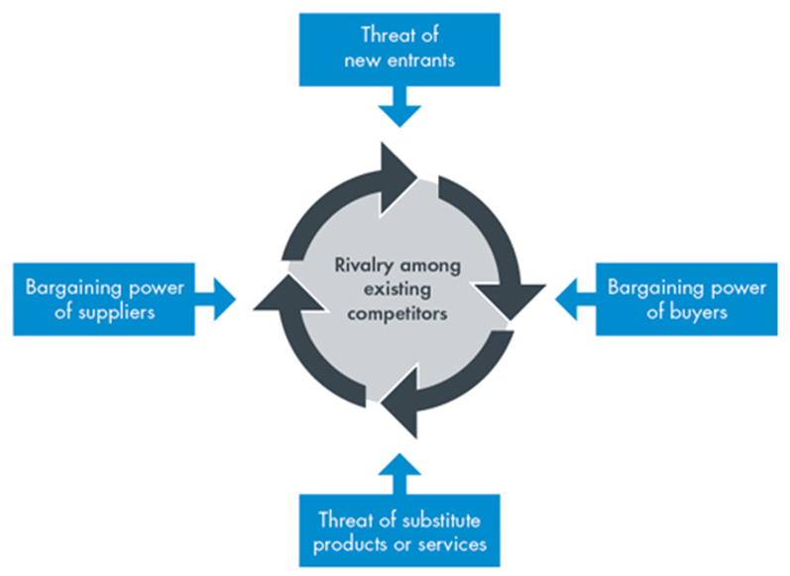Figure 1 Porter’s Five Forces
Buyer Power- analyzes how easily buyers within an industry push the prices down. This depends on the number of the buyers and the sizes of their orders. The buyer power analyzes how strong the buyers are to dictate the price of a product depending on its substitute. The buyer power of an organization such as Heritage textiles is likely to increase if it has many customers purchasing tits merchandise.
Supplier Power –measures how easily suppliers can change prices. Businesses rely on suppliers for products that help contribute to the supply chain. However, when there are fewer suppliers, the business will over-rely on them, leading to a stringer supplier power whose actions may impact the business
Competitive rivalry- Analyzes the level of competition that a business has. Heritage textiles, for instance is likely to be negatively affected if it has many stronger rivals whose products are of better quality, favorable prices and higher utility.
Threat of substitution- a Substitute is a product with the same utility as another. Heritage Textiles’ substitutes, for instance, could be processors of cotton whose products may substitute textile. The availability of substitutes makes a business less powerful
Threat of new entry- Measures the ease of entering an industry. The easier it is to enter an industry, the less powerful a business becomes
2. PESTEL analysis
PESTEL analysis analyzes the Political, Economic, Social, Technological, Environmental and Legal issues that may affect a business (Weeks, 2018)
Political Factors – Political issues such as trade restrictions, political stability, tariffs, policies and regulations, tax policies, among others impact a business
Economic Factors- The economic issues that are likely to impact an organization such as economic growth or decline as a result of changes in interest rate, inflation rates or exchange rates, wage rates such as minimum hourly or monthly pay and the availability of credit can influence a business and are therefore used during the analysis of a business
Social Factors- The social and cultural environment of a business can be used to analyze a business. These include issues such as population rates, age, health, cultural norms among others.
Technological factors- The technological environment of a business is used to analyze how a business could perform within the same environment.
Legal- The legal changes within the business environment such as employment laws taxation and access to raw materials can be used to analyze a business
Environmental – The level with which a business demonstrates responsible management practices such as sustainable and ethical operations can be used to analyze a business within the operating environment.
A.C 1.1 External Factors and their impact on business
Technology
Technology drives production. Organizations that can adopt the most efficient technology for production are likely to perform better compared to those that do not embrace technological change. Better production and strategic information technology can increase the growth of Heritage textile to be able to meet supplier demands. However, Heritage Textiles is likely to be outrun by fierce competitors if it has obsolete technology
Employment and Labour laws
Labour laws within various countries guide the employment relations process within an organization. Heritage Textiles, for instance, has to pay employees the recommended wages per hour. However, if Heritage Textiles cannot afford remunerate workers to the recommended level, they will downsize, hence affecting the organization’s production capabilities
Level of Education
The level of education within a society determines how knowledgeable and skilled people are to drive production and innovate essential production processes that will make the business profitable. An organization will therefore have access to large pool of skilled personnel to hire and grow the business. However, if an organization like Heritage Textiles operates within an environment where it is difficult to find skilled and qualified employees, its productivity is likely to reduce.
Credit Availability
Heritage Textiles requires capital to sustain their business growth strategy and meet future objectives and expectations of the business. Credit availability happens when banks can easily lend to companies for business growth and expansion at affordable rates. Credit unavailability raises the cost of capital which implies that Heritage Textiles will not be able to meet future demands of the business or sustain growth, creativity and innovation.
How the external forces impact of on the organizations function
Technological advancements imply that HR has to keep changing and adjusting for the organization to acquire and utilize the most efficient technology of managing the organizations human assets. Furthermore, technological changes call for HR to manage the change process by organization employees to embrace change and reduce resistance to technological change. Secondly, the employment and labour laws within a country guide the employee relationship process, including recruitment, selection, training, among others. Thirdly, availability of credit means that an organization can plan for its growth and expansion, which will necessitate the addition of more human power. However, less credit availability implies that the business will reduce or halt operations, necessitating a downsizing or restricting of the company. Fourth, a highly educated society impacts the labour market such that HR can hire the best talent to drive the organizations growth agenda.
AC 2.1 The key forces that influence the HR agenda
HRM is a strategic business function that influenced by various key forces.
Competition
HR monitors the activities of competitors with regards to human-power management to ensure that the business remains competitive within the industry. HR develops agile policies that are able to respond to the actions of competitors that pose threats to the existence of the business. The various activities, plans and changes by competitors can have an effect on a business if these actions make competitors stronger and more efficient compared to the business. HR also monitors competitors to identify the gaps and opportunities from their activities.
The employment markets
The labour markets involve employers demanding for labour and employees supplying it. The supply and demand for labour are influenced by factors such as population growth rates, age, level of education, and immigration policies. Labour markets with lower supplier and high demand means that HR has to spend more resources in talent acquisition, retention and management. The employment markets therefore influence the HR agenda.
Technological changes
Change is a constant within the workplace. With the increasing technological advancements, HR has to prepare employees to accept the most efficient technological changes in the market to enhance productivity, to improve communication, cut down operational costs and improve business efficiency. HR, being a strategic business function, has to be at the forefront of managing transformation. HR manages technological changes at the workplace by communicating planned changes, identifying change leaders, dealing with resistance to change and rewarding employees who embrace change. Technological changes therefore drive the HR agenda.
Government Regulations
The regulations and policies set by governments and regulatory agencies and authorities shape the HR agenda. The government makes regulations on employment and labour laws which implies that HR has to make policies and tailor their processes and procedures to be in line with government regulations on issues such as recruitment and selection, employee compensation through the minimum monthly and hourly wages, retirement, redundancies, statutory deductions and benefits, employee rights, occupational health and safety, among others. The HR agenda is therefore influenced by laws and regulations set by the government to guide the employment industry.

ORGANISATIONAL AND HR STRATEGY & PRACTICE

A.C 2.3 Stages of Strategy Formulation and Implementation.
Strategy formulation can be rational, emergent and symbolic (Taylor and Woodhams, 2016). The process of strategy formulation and review is explained by the diagram below.
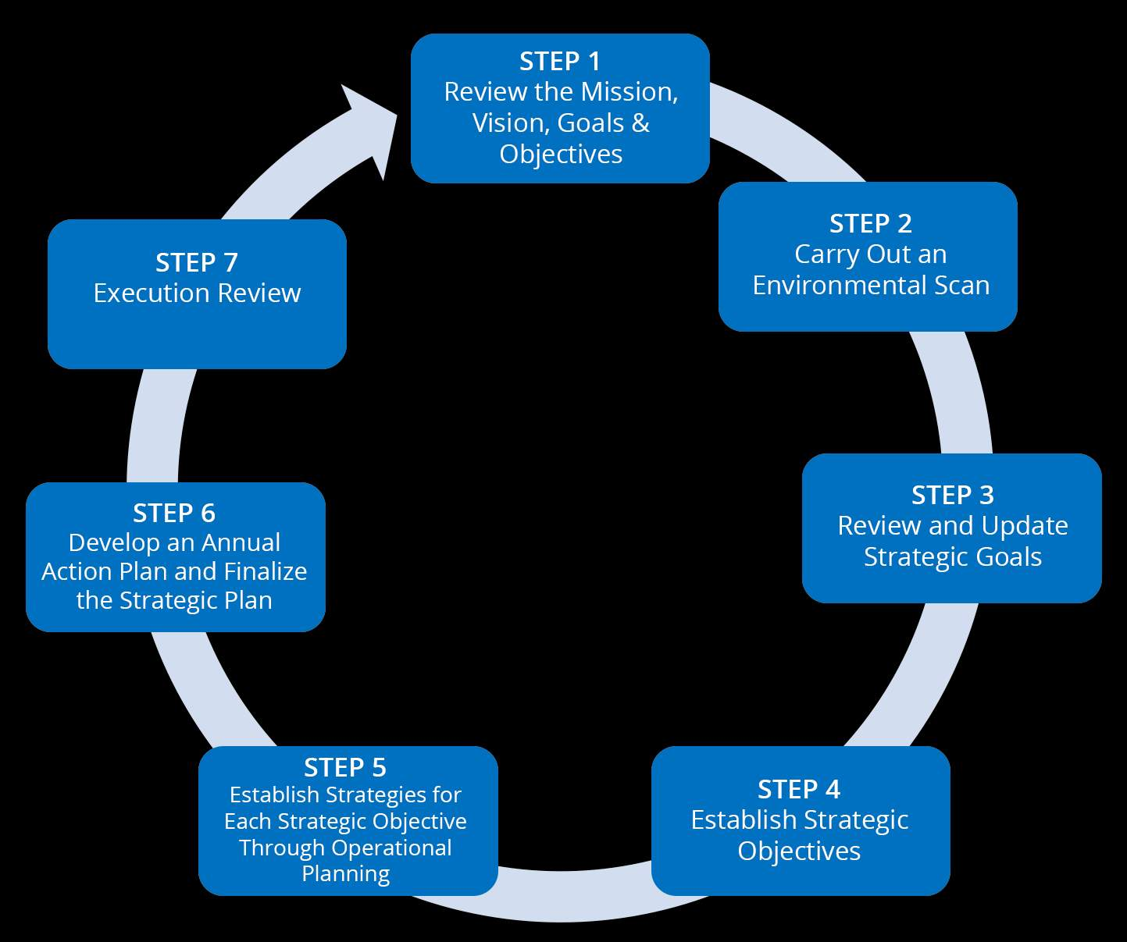
Figure 2: Strategy Formulation and Implementation steps
The organization reviews its mission, vision, goals and objectives. These explain what the organization intends to achieve within a set period. The objectives of the organization should be clear in both the long term and short term for easy strategy formulation. At the second step, the organization analyzes the environment using various tools such as Porter’s Five Forces, SWOT and PESTLE. The understanding of the business environment enables the organization to understand its strengths, weaknesses and potentials, and come up with plans to deal with the both internal and external forces that are likely to affect the business. Thirdly, the business uses the additional information obtained from environmental analysis to review the goals and objectives of the business and develop strategic goals by aligning.
The next step involves setting strategic objectives based on the strengths, opportunities and competitive advantage of the business. Strategic objectives also involve aligning the organization’s HR needs to reflect on the general needs of the organization. The fifth step involves establishing the strategies of meeting each business objective while the sixth step involves the development of an annual plan of action that will help the business to achieve both long term and short-term plans. The last step involves review of the strategies and performance analysis to establish the changes that need to be made to ensure success.
The strategy formulation and implementation process can be undertaken using the Mintzberg Model. The Mintzberg Model categorizes an organization into different parts such as the ideology, strategic apex which involves top management, the middle management, technostructure, support staff and operation core.
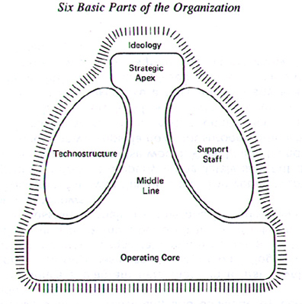
Figure 3: The Mintzberg Model
The second model of strategy formulation and implementation is McKinsey’s 7 S Model which involves the structure, strategy and systems that support the shared values, skills, style and staff (Dudovskiy, 2017).
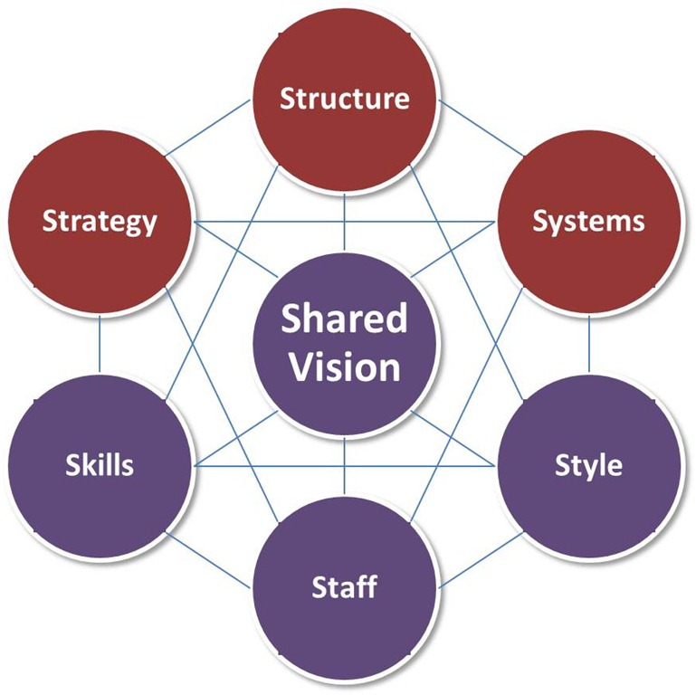
Figure 4: McKinsey 7 S Model
The Role of HR in Strategy Formulation and Implementation
First, HR should assist the executive leadership in the formulation and implementation of change management to ensure that the organizations objectives are met. Secondly, HR can assess the internal factors of the business such as strengths, weaknesses, opportunities and threats and compare them with competitors to assess the competitive advantage of the business. Thirdly, HR can prepare and lead teams that will spearhead the implementation of the various strategies to achieve business objectives. Furthermore, HR should shape the organizational culture to ensure there is a shared ideology and cooperation to meet objectives (Houghton & Young, 2019).
AC 2.4 How HR contributes to business ethics
The various activities undertaken by HR can contribute to business ethics and accountability. Ethics and accountability are part of responsible management which HR contributes to in the following ways:
Setting and implementing ethics-related policies
HR develops the policies within organizations that guide employee conduct and relationships. Such rules stress on ethical conduct, responsible employee behavior and adherence to the company culture through cooperation and positive engagements. For example, Heritage Textiles HR can promote an ethical code of conduct that promotes values within the organization to guide employee conduct and behaviour.
Encouraging Diversity
Diversity brings people from different cultures to help the business meet its objectives. When HR carries out fair recruitment activities, the organization is likely to end up with people from different gender, ages and cultures which creates harmony and cohesion
Equality and Fair Treatment
HR implements policies that seek to ensure equality at the workplace, such as equal pay for equal work. Equality ensures that people from diverse genders, cultures, races, among others are remunerated equally, for equal work done (Equality Act, 2010). Fair treatment involves the implementation of policies and practices that promote fairness at the workplace without making others feel discriminated against. Equality and fair treatment promote a sense of justice which is part of business ethics.

RESPONDING TO CHANGE

A.C 3.1 Evaluating the business performance of Heritage Textiles
Benchmarking
Benchmarking is a business tool of assessing the performance of an organization against other leading institutions. Heritage Textiles can use benchmarking to compare its performance with the leading organizations within the same industry, a leading organization within a different industry and other recognized operations of best practice (Strategic Human Resource, 2018). To compare the organizations health and wellness program, for instance, the organization can benchmark itself with a global leader in employee health and wellness such as Johnson & Johnson (Henke et al. 2011). For innovation and employee engagement, Heritage Textiles can compare itself to companies such as 3M, which has been feted as among the most innovative companies, and Starbucks, which has an effective employee engagement program.
Through such comparison, Heritage Textiles can identify its weaknesses by comparing themselves to organizations that have better performance. One advantage of benchmarking is that it creates focus on areas that the business should give attention. However, benchmarking may make Heritage Textiles fail to develop innovative solutions but prefer to copy from other organizations.
HR’s role in business planning
HR plays a significant role in business planning through
Recruitment, selection and staffing- HR ensures that an organization has the right skills and talent to support business operations and meet its planned objectives. HR selects qualified and experienced employees and implements various strategies such as performance management, compensation, engagement, motivation, among others to ensure that employees are developed and retained within the organization to promote productivity in line with business plans.
Organizational Development – HR supports business planning by influencing business processes, systems and procedures that can help the business achieve its plans. Organizational development aligns the business capabilities to support business plans and ensure that the organization is structured in a manner that supports it to achieve its objectives
Employee learning and development- HR helps the business to meet its planned objectives by ensuring that the employee knowledge and skills are in line with industrial trends and can support the organization to meet its long-term needs. As such, HR develops employees through continuous training and professional development to be able to meet the objectives of the business.
Role of HR in change management
HR plays a critical role in the introduction, implementation and management of change within an organization. HR identifies and trains the leaders who will drive the change agenda across different business units. Furthermore, HR communicates the change process and manages and implements change, as well as dealing with employee resistance to change using various strategies such as Lewin’s Unfreeze, Change, Refreeze Model. HR also measures the impact of change in the organization, assess performance and reduces costs during change management (Mind Tools, 2020).
A.C 3.2 Sources of Business Information
There are various sources of business data that can be used for business planning.
Primary Sources of business data
Questionnaires to collect feedback from internal and external stakeholders
The organization can design questionnaires to collect the relevant information required for business planning from various stakeholders. The organization can for instance collect employee feedback using questionnaires to help in planning activities or functions such as employee engagement or retention. Clients can also give their feedback through questionnaires which will then help the business analyze its operation aspects such as product quality and customer satisfaction. These questionnaires can provide quantitative data that will provide insight to the business regarding its operations.
Semi-structured in-depth interviews
These include open-ended interviews conducted on various groups of people to collect qualitative data that can be used to assess human behaviour. Such interviews can give the business access to information that can be used by the business to improve various aspects such as retention and learning and development.
Secondary Sources of information
Government and industry reports
Government agencies usually release reports and other information that can be used by a business for strategic planning. Such reports include market share, consumer satisfaction, market performance, number of consumers, among others. These can be analyzed by an organization to inform decision-making and strategy.
Competitor analysis reports
A business can carry out a competitor analysis to establish the activities and strategies employed by competitors to improve performance. The analysis of competitor activities such as marketing strategies, product price, procurement strategies, among others can help a business to strategically position themselves to gain a competitive advantage.
Three areas of focus for Heritage Textiles and the sources of business information.
Employees
The organization can place its focus on improving employee performance through strategies such as rewards, employee engagement and employee motivation. Such activities are likely to motivate employees to be more productive, leading to overall job performance. The business will need to administer exit questionnaires to its employees to establish their reasons for living and hence reduce employee turnover. Secondly, the organization can measure employee expectations through interviews to inform business decisions on how to meet these expectations.
Customers
Heritage Textiles can focus on their clients by seeking to understand their level of satisfaction with their products as well as their needs that can be met by the business. The data can be obtained by administering questionnaires to collect feedback from employees. Furthermore, the business can assess consumer behaviour through market surveys and analysis.
Cashflows
The financial cashflows of a business are an indication of whether the business is productive, profitable and sustainable. Heritage Textiles can assess the company’s statement of profit and loss to determine whether the business is profitable. Additionally, the organization can assess its production costs and expenses and compare them to revenue to determine whether the business operations are sustainable or within the budget

References:

Armstrong, M. (2011) Armstrong’s Handbook of Strategic Human Resource Management. 5th ed. London: Kogan Page Limited.
CIPD, (2020) Employment law. Retrieved from https://www.cipd.co.uk/knowledge/fundamentals/emp-law
CGMA, (2013) Porter’s Five Forces of Competitive Position Analysis. Retrieved from https://www.cgma.org/resources/tools/essential-tools/porters-five-forces.html
Dudovskiy, J. (2017) IKEA McKinsey 7S Model – Research Methodology. Research Methodology. Retrieved from <https://research-methodology.net/ikea-mckinsey-7s-model/>
Houghton, E and Young, J (2019) Organisational culture and cultural change. CIPD. Retrieved from https://www.cipd.co.uk/knowledge/culture/working-environment/organisation-culture-change
Equality Act, (2010) Retrieved from https://www.gov.uk/guidance/equality-act-2010-guidance
Employment Act, 2002. Retrieved from http://www.legislation.gov.uk/ukpga/2002/22/contents
Henke, R.M., Goetzel,R.Z., McHugh,J and Fik, I. (2011) Recent Experience In Health Promotion At Johnson & Johnson: Lower Health Spending, Strong Return On Investment. Health Affairs Vol 30 No. 3
Mind Tools (2020) Lewin's Change Management Model. Retrieved from https://www.mindtools.com/pages/article/newPPM_94.htm
Strategic Human Resource, (2018) Human Resources Benchmarking. Retrieved from http://www.strategic-human-resource.com/human-resources-benchmarking.html
Taylor, S. and Woodhams, C. (2016) Studying Human Resource Management. 2nd ed. London: Chartered Institute of Personnel and Development.
Weeks, A (2018) PESTLE analysis. CIPD. Retrieved from https://www.cipd.co.uk/knowledge/strategy/organisational-development/pestle-analysis-factsheet

Bibliography:

CIPD (2017) Change Management | Factsheets | CIPD. Retrieved from https://www.cipd.co.uk/knowledge/strategy/change/management-factsheet
CIPD (2012) Responsible and Sustainable Business: Retrieved from https://www.cipd.co.uk/Images/responsible-and-sustainable-business_2012-hr-leading-the-way-sop_tcm18-9318.pdf

