Description of Project
You plan to start a business with your team members. Your investment is limited to $200,000. You will operate the business for 12 years.
After comprehensive market research, and assessment of the local and global economy, political situation and business risk, each member will propose a business idea. You will select the best business after analysis of all the businesses. Example if the group has 5 members there must be 5 business proposals analyzed. Then select the best recommendation based on your analysis and comparison of NPW and Payback Period.
You will select the best business using Net Present Worth criterion and payback period (without interest).
4. Requirements:

You are required to provide the following before carrying out analysis:
- Describe the nature of each member’s proposed business.
- You will evaluate and assess all the proposals basing on the yearly returns.
- Your investment is limited to $200,000.
- Estimate the salvage value for each business if any.
- Determine your MARR and justify MARR. Use same MARR for all proposed businesses
- For each business, show detail cash flows (revenues and expenses) over a 12-year period.
- For each business, provide detail monthly estimations of cash flows in first year – list the cash inflows and cash outflows for each month (Jan – Dec). Examples of cash inflows are: sales revenue, salvage value, loan from bank. Examples of cash outflows are: rental expenses, salaries expenses, interest expenses, transportation expenses, payments for bank loan, insurance premium and etc. Determine the net monthly cash flow (receipts minus expenses).
- Do not include depreciations in expenses.
- For the subsequent year after year1, detail estimations of the monthly cash flows for each business are not required. You need to estimate net yearly cash inflows and net yearly cash outflows.

i. Microsoft Word report with declaration page providing the description of the businesses and selected business proposal.
ii. EXCEL file containing the spreadsheets of all the business analyses.

2.
For each business, list all items of receipts and expenses and net cash flows.
Example of Year 1 for each month (Jan – Dec) net cash flows.
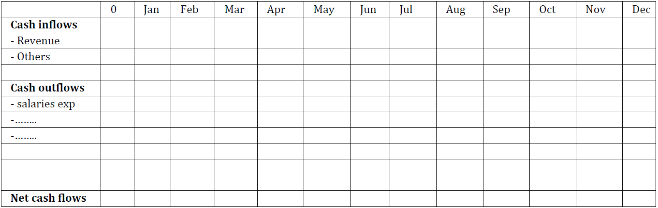

Example of Yearly net cash flows.
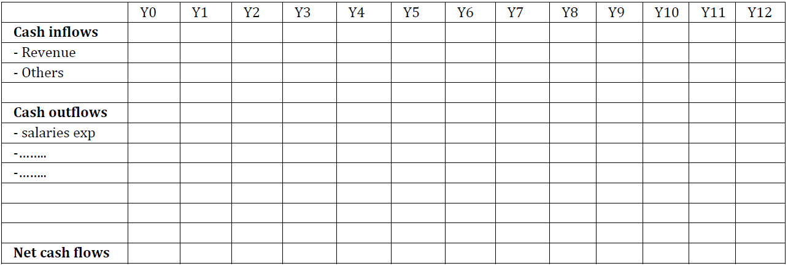
3.
Assessment Criteria
The assessment criteria of the project include the followings.
- Content page
- Description of each business.
- Detail estimations of first year monthly cash flows for the businesses (list items of receipts and expenses for each month (Jan – Dec) and net monthly cash flow.
- Estimate net yearly cash flows after year 1.
- Use of charts for each business.
- Selection of our MARR. Justify and explain how you decide your MARR.
- Select and justify the best business option basing on Net Present Worth.
- Determine Payback period without interest for each business. Show detail of the workings.
- Select the best business option basing on payback period without interest.
- Compare the selection of alternatives based on Net Present Worth and payback period without interest. Explain which is the best method to use for evaluation of alternatives?
- Application of EXCEL Functions to improve productivity in the tabulation.

