Week 3 Assignment – International Expansion: New Venture

Amalgamated Construction Co. Overview
The Amalgamated Construction Company is a mid-size construction company based in California, North America. The company started its official operation in 2015 after its launching in December 2014. For the past seven years since its debut, the company has been providing quality construction services such as equipment for hire, office buildouts, renovation and expansion, construction management, construction services, preconstruction design and estimation cost, and building sustainability. The company has gained recognition for taking large and complex projects, fostering innovation, delivering high-quality and reliable construction services, and embracing emerging technologies. The company's experienced and licensed specialists in all aspects of building construction and maintenance, refurbishment programmed maintenance works, and other specialized jobs have made this possible. Additionally, pacesetting, coaching, and servant leadership styles adopted by Amalgamated Construction Company have played an essential role in the company's success. Currently, the company has 1,000 workers and has completed over 600 projects over the past five years.
Host Countries Targeted By Amalgamated Construction Company
Since its operation debuted in 2015, Amalgamated Construction Company has completed various construction tenders throughout the United States. As a result, the company has gained popularity for delivering high-quality and reliable construction services without any reported incidents of poor construction, errors when making project prices, and theft or fraud cases. This has instilled confidence in the mind of the potential customers making the company become one of the best accepted and fastest-growing companies in the construction industry. However, the company faces stiff competition from the existing companies, as shown in Table 1 below. See additional graphs provided in fig 1-1 and fig 1-2 that show infrastructure and construction forecasts that support our expansion initiative.
The success in the U.S. domestic market has motivated the construction company to extend its boundaries internationally and seek new customers in foreign markets as it faces stiff competition from existing construction companies. Therefore, the company has focused on expanding its boundaries to three countries: India, Brazil, and Mexico.
Table 1: Existing Competitive construction companies
 | Company Name | Completed Projects
1 | Bechtel | 25,000
2 | The Turner Corp | 1,500
3 | Flour | 1,000
4 | Kiewit Corp | 900
5 | Amalgamated Construction Co | 600
India
Analysis and Viability of Expanding Amalgamated Construction Co. Into India
India utilizes the construction industry as the engine to drive and boost its economy. Hence, India plans to spend about $1.4 tn worth of investment on the country’s infrastructure. The construction industry in India also offers several investment opportunities for foreign companies since the country is a developing country with ambitious scope for infrastructure reconstruction, construction of smart cities, enhancing transportation routes, and safeguarding affordable housing for Indian citizens. The growth momentum is expected to continue, recording a CAGR of 9.5% during 2022-2026, and the construction output in the country is expected to reach INR 60,508.9 billion by 2026 (Yahoo, 2022). Thus, Amalgamated Construction Company should take advantage of this situation and invest in India.
Mode of Entry
The mode of entry that the Amalgamated Construction Company should use is a foreign direct investment (FDI) since the company is interested in entering the overseas market by making a substantial investment in the country. The Indian government allows 100% foreign direct investment under the Foreign Direct Investment Policy (FDI) in completing urban and development projects such as residential or commercial premises such as hospitals and educational institutions, construction of industrial parks, and establishment of projects under Special Economic Zones (SEZs) (Kapur, 2021). Therefore, Amalgamated Construction Company should take advantage of this situation; engage the government about starting a sub-branch in India to offer employment opportunities to the unemployed middle-class individuals. Since the government is concerned with the employment of its youths, the company will be granted the wish to start its operation and invest in the Indian construction industry, thus earning more capital.
Challenges to Enter
India remains a challenging market, attracting global organizations to invest while expanding their international boundaries and earning more income. However, several challenges and/or mega headaches include bureaucratic rules and regulations, strong labor unions, corruption, underdeveloped institutions, inadequate physical infrastructure, and difficulty acquiring land (Venkatesan & Govindarajan, 2018). Exposure to these political risks, especially when the Indian government decided to adopt protection policies to support and protect the local business from the foreign organization and delays due to government bureaucracy and local political demands, may arise due to foreign direct investment. The Indian media also pointed out that the Indian shallow middle class continues to experience unemployment, growing inequality, and a trail of multinational frustration due to a lack of China-like success in India (Venkatesan & Govindarajan, 2018). However, collaboration on how the business operates under the Indian government policies could help mitigate these challenges.
Brazil
Analysis and Viability of Expanding Amalgamated Construction Co. Into Brazil
Brazil attracts more customers due to a domestic market with a largely middle-class and a large domestic market (5th largest population in the world), strategic geographical position, availability of easily useable resources, and a diversified economy that is less susceptible to worldwide crises. Additionally, the construction industry in Brazil is a vital determinant of GDP growth since the most prominent cities are located throughout the region, and there is the availability of a vast workforce to operate in the growing industry. Brazil's construction market size was valued at $75.6 billion in 2021, and the market is projected to grow at an AAGR of more than 2% from 2023 to 2026 (Business Wire, 2022). Thus, the construction industry provides viable opportunities for foreign international organizations to invest in the industry. In addition, the country is a valuable resource offering construction materials such as steel and cement available at an affordable cost (de Araujo et al., 2016). Therefore, in reference to the above factors, Amalgamated Construction Company should take the opportunity and invest in Brazil since the country has a promising construction industry and in-country resources for the company to invest in to increase earnings.
Mode of Entry
The best entry mode should be a partnership and strategic alliance with an existing Brazilian construction company to reduce the entity's cost, which is very high. So, the equity mode of a 50/50 joint venture is the best mode of industry into Brazil. First, the advantages of this model include shared costs, risks, and profits with a local partner, possessing a degree of control but limiting risk exposure. Second, it allows access to knowledge about the host country and the local firm; they benefit from the host country's technology and maybe more politically acceptable in host countries (Peng, 2017).
Challenges to Enter
When entering the Brazilian construction industry, Amalgamated Construction Company may experience challenges. Investment in Brazil remains risky because of some negative factors, including cumbersome and complex taxation, bureaucratic delays, and heavy and rigid labor legislation (Santander Trade, 2022). However, since most cities in Brazil are under-developed and require newly modern constructed buildings to display, Amalgamated Construction Company should focus on investing in Brazil's construction industry since the company is experienced in advanced infrastructure projects and constructing modern buildings. Moreover, Amalgamated Construction Company has some of the best logistics practices in the construction sector. Therefore, the company should invest in Brazil since the logistics in this country is another industry, especially in the construction industry, where deep knowledge is required to transport materials. This is probably why, as part of the country's ongoing effort to strengthen its business environment, Brazil introduced electronic certificates of origin, which reduced the time required for import documentary compliance, facilitating and simplifying the whole process (Santander Trade, 2022). In addition, the country has also made several infrastructure concessions that have helped foster investment, which Amalgamated construction can capitalize on.
Mexico
Analysis and Viability of Expanding Amalgamated Construction Co. Into Mexico
According to The World Bank (n.d.), with a population of almost 130 million, a rich cultural history and diversity, and abundant natural resources, Mexico is among the 15 largest economies globally and the second-largest economy in Latin America. In addition, Mexico is one of the most competitive countries with viable, productive investments and is ranked 9th as the foreign direct investment recipient. In early February 2022, the Ministry of Finance reported that the country is currently preparing a multibillion-dollar infrastructure package with private companies and is stepping up efforts to attract American investments to revive the stagnant economy, leading to is a 5.4% increase in the construction industry in real terms this year, before stabilizing to an annual average growth rate of 2.3% between 2023 and 2026 (Yahoo Finance, 2022). The country also has readily available construction materials such as aluminum, cement, copper, steel, and inexpensive insulation materials. Therefore, Amalgamated Construction Company should utilize the above advantages, invest in Mexico, and benefit from these strategic advantages. Additionally, Mexico is moving towards friendlier environmental activities, and the construction industry in the country has embarked on a green building movement, which the Amalgamated Construction Company is experienced in. Moreover, the country has a strategic geographical position, competitive cost with a young and talented population, and opens an economy that secures access to the most critical global markets through free trade agreements (Garriga, 2021). Therefore, it will be easy for Amalgamated Construction to invest in the Mexican construction industry, get construction proposals and make more profits.
Mode of Entry
Since Mexico has a stable government and has amended its political reforms, making it more attractive to foreign investors, the best mode of entry for Amalgamated Construction Company will be a foreign direct investment. Firms become Multinational Enterprises (MNE) because FDI provides the three-pronged ownership, location, and internalization (OLI) advantages that they otherwise would not obtain (Peng, 2017). This foreign direct investment will create new jobs and opportunities for the Mexican citizens, boost the construction sector, and ease international trade between Mexico and the U.S. The mode of entry should be to establish a wholly-owned subsidiary (WOS). A WOS is defined as a subsidiary located in a foreign country entirely owned by the parent multinational (Peng, 2017). This allows Amalgamated Construction to have complete control of business decisions, while the Mexican government allows its operations, resulting in increased income.
Challenges to Enter
Although Mexico approved the amended United States-Mexico-Canada Agreement (USMCA) protocol in December 2019, uncertainty about contract enforcement, insecurity, informality, and corruption hinder Mexican economic growth (U.S. Department of State, n.d.). Some of the challenges that Amalgamated Construction Company is likely to experience in its entity in Mexico include unclear policies imposed by the government, long delays in acquiring permits, and a high crime rate in some areas. With any investment opportunity comes inherent risks; while Mexico has been ranked highly in ease of doing business, there are still factors to consider before investing. For example, Mexican cartels have an outsized hand in the goings-on of the country, leveraging their power, money, and the threat of violence to exert control over both the government and police and, as of 2020, was ranked No. 104 in the international corruption perception index (Safeguard Global, 2022). There isn’t a secret that companies experience significant benefits when they choose to move operations or invest in Mexico. They still benefit from access to the highest number of free trade agreements and a highly skilled labor force, which drive costs down and boost operational efficiencies. Exactly the opportunity Amalgamated construction is seeking, which is why Mexico is one of their targeted regions for expansion.
Conclusion
The Amalgamated Construction Company is a growing construction company that started its operation in 2015. The company is widely accepted in the U.S. construction industry and has completed hundreds of projects without any reported incidents of poor construction, errors when making project prices, or theft cases. However, the company faces stiff competition from the existing companies in the U.S. construction industry. Therefore, to deal with the stiff competition, the company has embarked on extending its boundaries internationally by investing in India, Brazil, and Mexico to seek new customers in foreign markets where the company's competitors have to compete for business. Although the challenges associated with internationalization are daunting, the complexities are enormous, and the stakes high, managers need to match entries with strategic goals (Peng, 2017). This is why the company's research and development (R&D) group has analyzed the viability of expanding Amalgamated Construction Co. into these countries, researched the specific government foreign direct investment policies, and has divulged the multiple challenges in entering these countries. Amalgamated construction thinks the threats are worth risking for the company's global expansion initiative.

Fig: 1 -1 Size of the global construction market in 2020, with forecasts from 2021 to 2030 (in trillion U.S. dollars). (Statista, 2022).
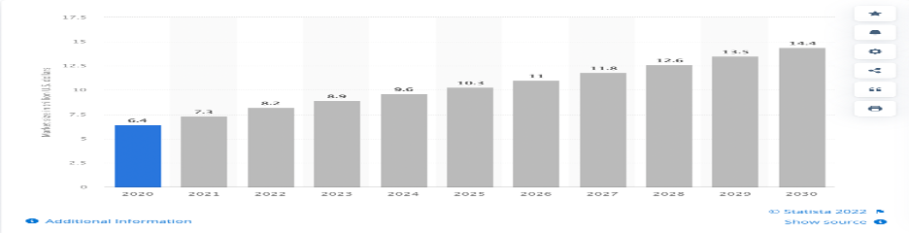

Fig: 1 -2 Global construction market by Segment (in billion U.S. dollars)
(Emergen Research, 2021).
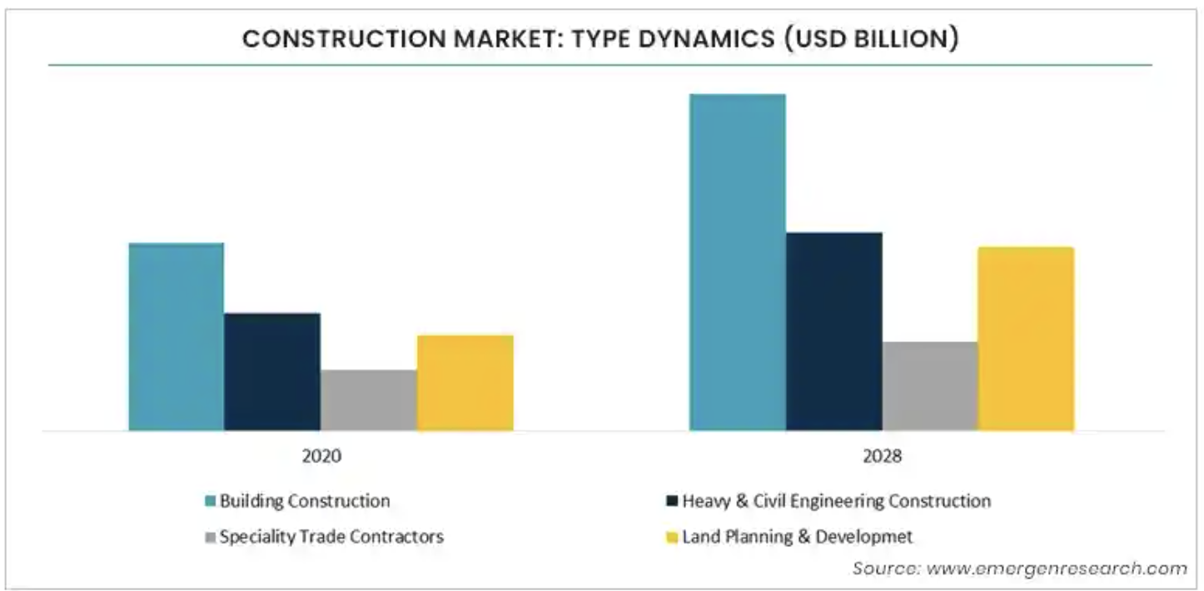
References

Business Wire. (2022). Brazil Construction Industry Report 2022: Market was Valued at $75.6 Billion in 2021 and is Projected to Grow at an AAGR of More than 2% During 2023-2026 - ResearchAndMarkets.com. Retrieved on May 20 2022 from https://www.businesswire.com/news/home/20220519005859/en/Brazil-Construction-Industry-Report-2022-Market-was-Valued-at-75.6-Billion-in-2021-and-is-Projected-to-Grow-at-an-AAGR-of-More-than-2-During-2023-2026---ResearchAndMarkets.com#:~:text=The%20Brazil%20construction%20market%20size,2%25%20during%202023%2D2026.
de Araujo, A., Rohan, U., Branco, R., Chinelli, C., & Soares, C. (2016). Leading for Sustainability in the Brazilian Construction Industry. Open Journal Of Civil Engineering, 06(05), 737-748. https://doi.org/10.4236/ojce.2016.65059
Emergen Research. (2021). Construction Market By Type (Building Construction, Heavy and Civil Engineering Construction, Specialty Trade Contractors, Land Planning and Development), By Building (Residential Building, Non-Residential Building), By Construction Machinery, By End-Use, and By Region Forecast to 2028. Retrieved on May 21 2022 from https://www.emergenresearch.com/industry-report/construction-market
Garriga, A. (2021). International Capital and Subnational Politics: Partisanship and Foreign Direct Investment in the Mexican States. Political Research Quarterly, 106591292110303. https://doi.org/10.1177/10659129211030331
Kapur, Y. (2021). Investment Opportunities in India's Construction Industry. India Briefing News. Retrieved May 10 2022, from https://www.india-briefing.com/news/investment-opportunities-india-construction-industry-market-growth-drivers-2021-budget-21692.html/.
Peng, M. W. (2017). Global business (4th ed.). Retrieved from https://redshelf.com/
Safeguard Global. (2022). Pros and cons of doing business in Mexico. Retrieved on May 20 2022 from https://www.safeguardglobal.com/resources/blog/pros-and-cons-of-doing-business-in-mexico
Santander Trade. (2022). BRAZIL: FOREIGN INVESTMENT. Retrieved on May 20 2022 from https://santandertrade.com/en/portal/establish-overseas/brazil/foreign-investment
Statista. (2022). Size of the global construction market in 2020, with forecasts from 2021 to 2030. Retrieved on May 21 2022 from https://www.statista.com/statistics/1290105/global-construction-market-size-with-forecasts/
U.S. Department of State (n.d.). 2021 Investment Climate Statements: Mexico. State.gov. Retrieved on May 20 2022 from https://www.state.gov/reports/2021-investment-climate-statements/mexico/
Venkatesan, R., & Govindarajan, V. (2018). 3 Reasons Global Firms Should Keep Investing in India. Harvard Business Review. Retrieved May 10 2022, from https://hbr.org/2018/02/3-reasons-global-firms-should-keep-investing-in-india.
Yahoo. (2022). India Construction Industry Databook 2022: Insights and Forecasts (2017-2026) by Housing Type, Key Cities, Price Point/Income Level, Construction Stage, and More - ResearchAndMarkets.com. Retrieved on May 20 2022 from https://www.yahoo.com/now/india-construction-industry-databook-2022-161700077.html#:~:text=According%20to%20the%20Q4%202021,story%20in%20India%20remains%20intact.
Yahoo Finance. (2022). Mexico Construction Industry Report 2022: Mexico Expanded by 7.2% in Real Terms in 2021 Following a Sharp Contraction of 17.6% in 2020 - Forecast to 2026 - ResearchAndMarkets.com. Retrieved on May 20 2022 from https://finance.yahoo.com/news/mexico-construction-industry-report-2022-164500375.html

