Analyze the four different graphs and answer the ten questions listed below the graphs. Once answered, submit this file as your assignment.

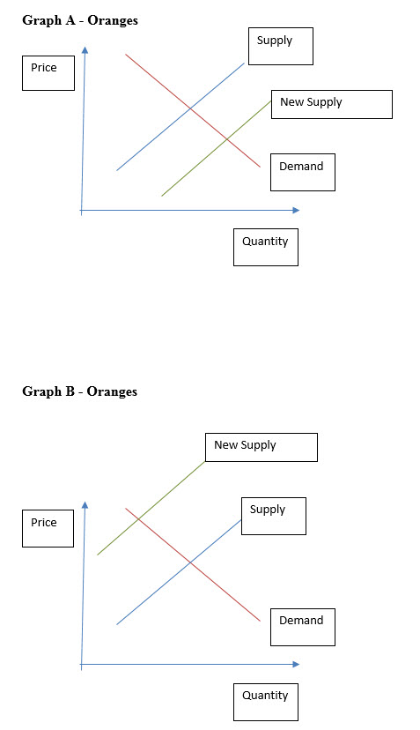

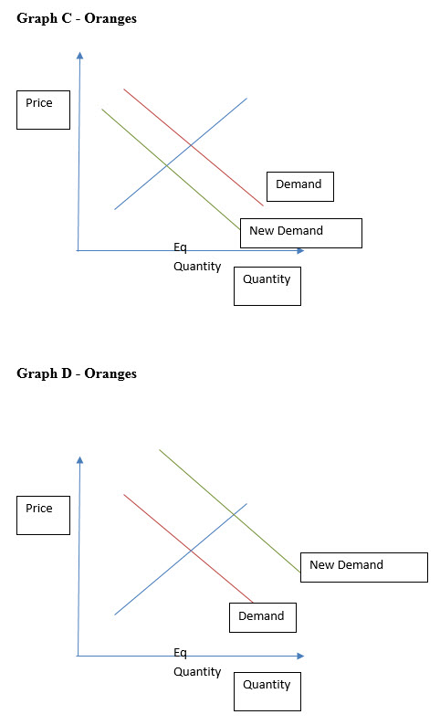

What would happen to the curves in each of the following scenarios? To answer this question, write the letter of the graph you would use in each scenario, and explain in one or two sentences why.
- There was a freeze in the orange groves and much of the crop was lost.

- A new report came out that said oranges have more antioxidants than other fruits.

- There was a “baby boom” and population doubled.

- New government regulations increased the tax on all oranges.

- A subsidy was created to decrease the price of fruit.

- Orange seedlings were cheaper relative to other seedlings.

- Producers switched from growing apples to growing oranges due to climate change.

- A report came out that said oranges cause heart disease.

- Irrigation equipment (an input of growing oranges) increased in price.

- Apples (a substitute for oranges) went down in price.

