BONUS QUESTION SP20 MIS3613 DATA COMMUNICATION AND COMPUTER NETWORKS

You are an electrical engineer and the IT Director of Therall Industries, a small company that makes a very intricate high technology device, the metapolar refractive pilfrometer for Rockwell Industries Turboencabulator. If you wish to know more about the device, you may watch the video at https://www.youtube.com/watch?v=2fjcJp_Nwvk .

Your company works out of two small locations in two different cities. The two offices, almost identical on the outside to be easily recognizable as a Therall facility (an icon featuring the buildings is on the company logo), are approximately 600 feet long and 400 feet wide. The first location, Headquarters, houses Executive Management and Research and Development Engineering. The second, Remote, is where other engineering and production takes place.

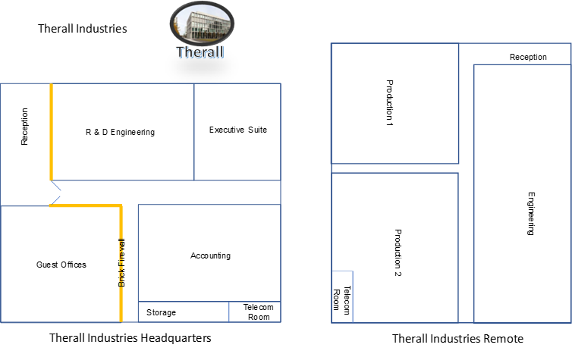
Therall Industries

Your boss, Tom Frantype, has asked you to, 1) develop an internal network leading to a secure wired communication system between the two offices, and, 2) install a wireless network in each facility.

The facility layouts are available on the accompanying Powerpoint Presentation and reproduced above.

Here are the exact tasks.
- Discuss your intrabuilding networks. At Headquarters, you will need:
  - Two hosts in the Executive offices
  - Four hosts in R&D
  - One host in Reception
  - Four hosts in Guest Offices
  - Two hosts in Accounting
  - VoIP service to each area
Layout your hosts on the diagram, being sure to discuss what type and grade of structured cabling you will use, where the runs will map, what jacks you will use and where they will be located, and the physical and logical topology to be used. Also discuss your building connection to the ISP through your telecom room, including type of patch panels and what your demarc looks like and where it is connected. (10 Points)

- At Therall Remote, you will need:
  - Sixteen hosts in Engineering
  - Four hosts in each production area
  - One host in Reception
  - POTS service throughout
Layout your hosts on the diagram, being sure to discuss what type and grade of structured cabling you will use, where the runs will map, what jacks you will use and where they will be located, and the physical and logical topology to be used. Also discuss your building connection to the ISP through your telecom room, including type of patch panels and what your demarc looks like and where it is connected. (10 Points)

- The secure communications channel should allow the employees of both offices to communicate securely with each other and the servers located at Headquarters. It should also allow employees to work remotely using the network at either Headquarters or Remote. What is this secure network, how it is formed, what protocol(s)does it use, etc? Convince Tom Frantype that you can secure it by explaining how it works. (10 points).

- The WAN communication channel from both ISPs to the facilities is a T3. Explain how a T3 WAN channel works, what the available bandwidth is, what sort of communication protocol it uses, how it might communicate over long distances (Headquarters is in Houston, Remote is in Ada), and how it is terminated at the demarc. (10 points).

- Now it is time to setup the wireless network in each facility. Explain how you will set it up, what type of communication device you will use, what band it operates in, where the device(s) will be positioned, and how fast the connection will probably be and why. Don’t forget your most important wireless connection will be at Headquarters between the receptionist and the CEO in the Executive Suite. To make the CEO happy, that connection needs to be fast and certain to make. (10 points).

- At Remote, there are 6 dapoplar presserstops in Production 1, and 7 in Production 2. These machines are controlled from a central control booth in each room. The machines are monitored via a PAN in each room. Explain how this PAN works, including the communication method, the frequency, the range of the devices, and anything else Tom Frantype may ask about these smaller networks. Try to anticipate his questions. (10 points).

- Oh no! Interbuilding comms are down and R&D in Headquarters cannot talk to Engineering at Remote. Explain the steps you would go through to troubleshoot this problem. (10 points).

- While one of your engineers was on a chat line discussing one of the dapoplar presserstops that was acting up with a representative from Shadrach (the company that makes the machine), his monitor went blank. After a few moments, a message popped up that said, “If you want your data back, you must send a certified check for £500,000 to Cayman National Bank, Peter A. Tomkins Building, 200 Elgin Ave, George Town KY1-1102, Cayman Islands”. No matter how he tried, the engineer was unable to access the secure data folder on the server where the Therall company proprietary manufacturing data is kept. What has happened? Is there a way to fix this? (10 Points).

- Wow, you have done a great job on your system! In fact, Tom (was MISTER Frantype, but now you are on a first name basis) was so impressed he gave you a raise and a part of the profit-sharing bonus pool. This almost doubled your salary. Last Friday night when you were at a barbeque at Tom and Marie’s house in the Woodlands outside of Dallas, Tom told you, “You know, I have heard a lot about this networking thing but I really don’t understand how a computer forms a message, asks for a webpage and gets the correct one, or really anything about it. It all seems like magic to me. I said something to Fred over in R&D and he said, ‘It’s simple, it’s all about the OSI model and encapsulation and de-encapsulation. That explains everything.’ I must admit I felt a bit foolish asking anymore because Fred said it was so simple. Can you explain to me what he was talking about? What does he mean, ‘Seven layers?’, and ‘Headers and Footers’? And then he said something about another model, the TCP/IP? Can you help me here?”

It appears staying in Frantype’s good graces is going to require you to explain what the two models are, what they do, and how they work. You should do that by, 1) explaining the OSI model, and, 2) explaining the TCP/IP model by helping him understand how a web page is requested and received, including protocols, etc. Your new salary, in fact, your entire job, may depend on this. Good luck. (10 points).

- Please ensure your submission is neat and easily readable. Do your best work. (10 points)

Thank you.

If you want a full explanation of the Turboencabulator, including history, uses, and companies that employ it, visit https://www.youtube.com/watch?v=kkH20fNavoI or reference the Wikipedia article on this amazing invention.

