Kingdom of Saudi Arabia  Ministry of Education  Saudi Electronic University |  | المملكة العربية السعودية  وزارة التعليم  الجامعة السعودية الإلكترونية

College of Administrative and Financial Sciences
Assignment 1
Communication Management (MGT 421)
Due Date: 8/10/2022 @ 23:59

Course Name: Communication Management | Student’s Name:
Course Code: MGT421 | Student’s ID Number:
Semester: 1st Semester | CRN:13569
Academic Year: 2022-23-1st

For Instructor’s Use only
Instructor’s Name: Dr. Majed Helmi
Students’ Grade: /15 | Level of Marks: High/Middle/Low

General Instructions – PLEASE READ THEM CAREFULLY
- The Assignment must be submitted on Blackboard (WORD format only) via allocated folder.
- Assignments submitted through email will not be accepted.
- Students are advised to make their work clear and well presented, marks may be reduced for poor presentation. This includes filling your information on the cover page.
- Students must mention question number clearly in their answer.
- Late submission will NOT be accepted.
- Avoid plagiarism, the work should be in your own words, copying from students or other resources without proper referencing will result in ZERO marks. No exceptions.
- Use APA reference style.
- All answered must be typed using Times New Roman (size 12, double-spaced) font. No pictures containing text will be accepted and will be considered plagiarism).
- Submissions without this cover page will NOT be accepted.

Learning Outcomes:
- Understand and apply concepts of communication theory as they affect business organizations and the individuals in them.
- Communicate better, knowing that good communicators make better managers and that communication is a dynamic process basic to individuals and organizational life.
- Analyze effective business letters, memorandums, and case studies.

Assignment Question(s):
Part 1 (5 Marks)
Credibility for an Entry-Level Professional
Mohammad, Amal, and Noura were recently hired as audit assistants. This is the first full-time professional position for each of them. During the first few months of work, each of them experienced successes and failures.

Mohammad gained a reputation for finding out exactly what clients wanted. He asked the right questions, he respectfully explained points of disagreement with them, and he showed them he was genuinely interested in them. Several of his colleagues commented that clients trusted him to act appropriately on their behalf. His supervisor was pleased that Mohammad always followed through on commitments and was positive he wouldn’t avoid reporting tax violations made by clients. However, Mohammad’s performance was far from perfect. His supervisor noticed that Mohammad sometimes made fairly basic mistakes in his audits and his colleagues would have to redo some of his work.

Amal has gained a reputation for completing audits more accurately than all other new audit assistants. Her supervisor is worried, however, about her long-term success at the firm. Amal tends to overpromise. Last week, she told her supervisor she’d finish an important project but instead worked on other tasks. Last month, she called in sick for a few days. On one of her sick days, her supervisor saw pictures of her at a party that she had posted to Facebook.

Noura is the top performer on audits among the new group of employees at the firm. She is precise and efficient. She can typically accomplish many tasks in about half the time of most other audit assistants. Her supervisor is concerned, however, about her interpersonal skills. She tends to often criticize her colleagues for their mistakes and rarely offers appreciation for their help. She also seems to rub clients the wrong way and comes across as “antisocial” according to one valued client.

Read the case above and answer the following questions:
- Which element of credibility does Mohammad lack? What would you recommend to Mohammad to improve his credibility? (1 Mark)
- Which element of credibility does Amal lack? What would you recommend to Amal to improve her credibility? (1 Mark)
- Which element of credibility does Noura lack? What would you recommend to Noura to improve her credibility? (1 Mark)
- What is the importance of establishing credibility in business communication?
(2 Marks)

Part 2 (5 Marks)
Create a sample business message to propose a new marketing approach.
Note: You will be evaluated based on applying the process for creating effective business messages. (5 marks)
Part 3 (5 Marks)
Read the email and answer the questions that follow:
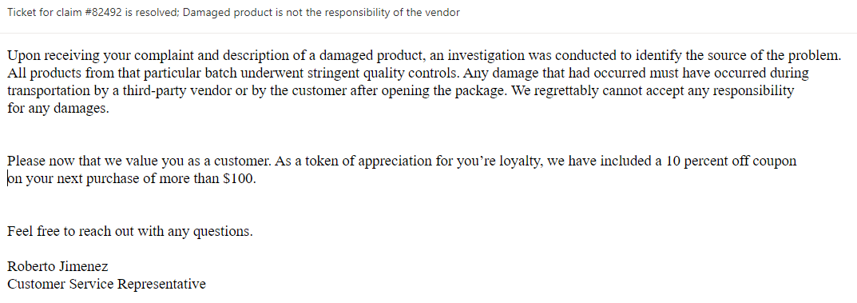
- Identify five principles violated in this email. (2.5 Marks)
- Re-write the email following the principles of writing an effective email. (2.5 Marks)

Answers

- Answer-

- Answer-

- Answer-

