Saudi Electronic University

College of Administrative and Financial Sciences

E-commerce Department

|  |  |
| --- | --- |
| Student Name: | Student ID: |
| Course Title: Management Information System | Course Code: MIS201 |
| Academic Year/ Semester: | CRN: |
| Instructor Name: | |
| Student Grade: | Grade Level:  Low/ Middle / High |

**Saudi Electronic University**

**College of Administrative and Financial Sciences**

**Assignment of MIS201- Management Information System**

**MIS201 - Project**

**First Semester 2021-2022**

|  |  |
| --- | --- |
| **Submission** | |
| **Part 1** | **End of week 6 Saturday 16/10/2021** |
| **Part 2** | **End of week 13 Saturday 11/12/2021** |
| **Part 3** | **Instructors will manage the date and time for presentation during week 13&14** |
| **25 Marks** | |

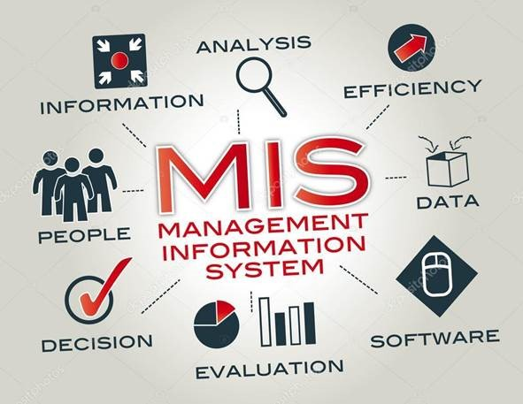

**Assignment Details**

The project involves studying the IT infrastructure of a relevant information system (IS)/ information technology (IT) used by selecting any organization of your choice locally or internationally

The idea is to investigate the selected organization using the main components of IT (Hardware, software, services, data management and networking). Infrastructure Investigation, which is in a selected industry, should be carried out by using articles, websites, books and journal papers and /or interviews. In the report, you are expected to discuss:

|  |
| --- |
| **Project Report Structure: Part 1**  **Submission: End of week 6 Saturday 16/10/2021 Marks**: **10** |
| 1. **Cover Page** This must contain topic title, student names and Students ID, section number and course name. *(you can find the cover page in the blackboard)* |
| 1. **Table of Contents (0.5 mark).** Make sure the table of contents contains and corresponds to the headings in the text, figures, and tables. |
| 1. **Executive Summary (1 marks).** What does the assignment about, briefly explain the distinct features |
| 1. **Organizational Profile (1.5 marks).** Brief background of the business including organization details, purpose, and organizational structure. |
| 1. **Strategies (3 marks).** Discuss different types of strategies for competitive advantages and then select and discuss the most appropriate strategies to improve the performance of the organization.   ***Hint:*** *You can discuss any points that you learned in this course and its related to your selected organization* |
| 1. **Technology Involved (4 marks).** How is the organization set up in terms of its IT infrastructure? Discuss the hardware, software, telecommunication, information security, networks, and other elements.   ***Hint:****You can discuss any points that you learned in this course and its related to your selected organization* |

|  |
| --- |
| **Project Report Structure: Part 2**  **Submission: End of week 13 Saturday 11/12/2021 Marks**: **8** |
| 1. **Analysis of Existing System (5 marks).** Analyze the key problems of the existing system used by the company. Also discuss the Information Systems used within the company for example:  * Transaction processing systems (TPS) * Enterprise Resource Planning (ERP) Systems * Functional Area Information Systems * Business intelligence * DSS   ***Hint:****You can discuss any points that you learned in this course and its related to your selected organization* |
| 1. **Possible Solutions and Suggestions for the company (1 mark).** What are your suggestions to help the organization in solving the key problems? |
| 1. **Conclusion** **(1.5 mark).**   Summarize your report |
| 1. **References (0.5 mark).**   Use APA referencing style format. |

|  |
| --- |
| **Part 3: Presentation**  **Submission: Instructors will manage the date and time for presentation during week 13&14 Marks**: **7** |
| Make a power-point presentation of your Project work mentioning all the above contents and present in a group. There must be minimum 10 slides in the presentation with a good background design, readable font size and style with appropriate color.  Presentation must have the following format:   * First slide: Group members name and Student id & Title of the Project * Company Profile * Strategies * Technology Involved * Analysis of Existing System * Possible solutions and suggestions * Conclusion * References |

**Guidelines for the assignment:**

* Make sure to include the cover page with all information required. One mark will be deducted if there is no cover page
* This is a group project (2-3 students), which is part of your course score. It requires effort, research, and critical thinking.
* Use font Times New Roman, 12 font sizes
* Use 1.5 line spacing with adjust to all paragraphs (alignment).
* Use the footer function to insert page number.
* Ensure that you follow the APA style in your project and references.
* The minimum number of required references is 5.
* Your project report length Part 1 & Part 2 should be between 2500 to 3000 words in total.
* You must check the spelling and grammar mistakes before submitting the assignment.
* Up to 20% of the total grade will be deducted for providing a poor structure of assignment. Structure includes these elements paper style, free of spelling and grammar mistakes, referencing and word count.
* Assignment must be in Word format only NO PDF
* Your file should be saved as Word doc [Example]: [Your Name] [CRN] MIS201 - Project Assignment Part 1.doc