**MinPet Homework 6: Binary Phase Diagrams!**

I can talk this all day, but really it's much easier if we just do it: that is, determine what minerals are crystallizing from melts for different compositions, as shown on phase diagrams. All phase diagrams depict what SHOULD happen during crystallization if the system is in **Chemical Equilibrium** - that is, all chemical reactions proceeding to completion, as per the mass balance requirements of our composition. If we're at equilibrium, then the minerals and melts that we get for any composition and any temperature we select will be defined by the Phase Rule:

**F + P = C + 2 (+/- 1)**

Where **P** represents **Phases** (Minerals crystallized, or melt remaining)

**C** represents **Components** (chemical constituents, as defined on the diagram)

And 2 +/- 1 represents the external variables of **Temperature** (always examined) and **Pressure** (often assumed to be constant - thus the +/- 1) **[General Rule: when Pressure is not EXPLICITLY denoted as a variable on the diagram, it IS assumed constant!]**

**F** stands for **Degrees of Freedom**, which really just means you need to define additional parameters to complete the equation. The other parameters are going to be either Temperature or Composition in most cases.

For our purposes, there are three kinds of phase diagrams that we need to know about: Unary, or one component diagrams; **binary or two-component diagrams, and Ternary, or three component diagrams. We'll focus on Binary diagrams here.**

**Binary phase diagrams describe what happens to systems with only two compositional Components. The salt-water diagram I drew on the board, and the leucite-silica and plagioclase and olivine diagrams in your handout, are all binary phase diagrams. All binary diagrams are plots of composition (varying percentages of two chemical Components) versus temperature - pressure is assumed to be constant.**

**Parts of a Binary Phase Diagram: (find these on the Leucite-silica plot!)**

**Liquidus Curve: curve marking the temperatures at which the first crystals form (or the boundary between all melt and the melt+crystals fields).**

**Solidus Curve: Curve or line below which everything is solid - no melt is present**

**Two Phase fields: Between the solidus and Liquidus curves are fields of temperature-composition space where a mineral and melt can coexist.**

**Eutectic: The lowest point on the Liquidus curve, and the lowest temperature at which liquid can exist in the system. The Liquidus and Solidus curves meet here! 3 phases coexist at the Eutectic (melt + 2 minerals)**

**Peritectic: Only encountered on phase diagrams that depict mineral-melt reactions (i.e., olivine + silica = enstatite, or Leucite + silica = K-feldspar) 3 phases coexist here, too (melt + 2 minerals, but in this case one mineral is reacting to form another**

**For each of the diagrams, compositions, and temperatures listed, I want you to tell me which phases are coexisting, and in what proportions.**

**http://www.cas.usf.edu/%7Ejryan/LC-QZbinary.jpg**

**KalSi2O6 (Lc) - SiO2 (Qz) Binary System**

**90% Lc, 10 % Qz, at 1200° C**

**90% Lc, 10 % Qz, at 1100° C**

**70% Lc, 30 % Qz, at 1100° C**

**70% Lc, 30 % Qz, at 900° C (if it's not on the plot, assume the boundaries continue to lower temperature.**

**http://www.cas.usf.edu/%7Ejryan/plagbinary.jpg**

**Plagioclase System (CaAl2Si2O8 (An) - NaAlSi3O8 (Ab)**

**80% An, 20% Ab, at 1500°C**

**80% An, 20% Ab, at 1400°C**

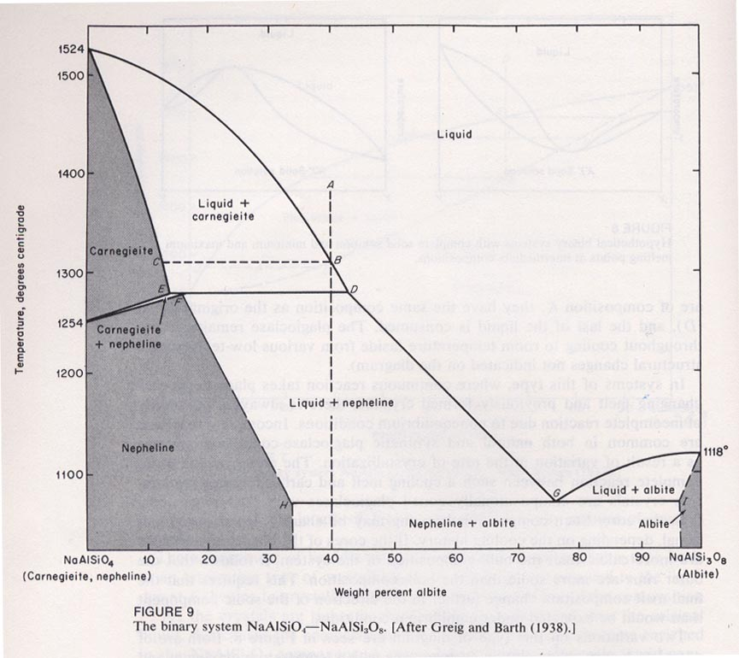

**NaAlSiO4 (Ne) - NaAlSi3O8 (Ab) system:**

**70% Ne, 30% Ab, 1300°C**

**75% Na, 25% Ab, 1100°C**

**We can also track the process of Crystallization on these diagrams, by looking at how the phases in equilibrium change along a line of constant composition, or an Isopleth.**

* **On the Lc-Qz binary, follow the isopleth at 70% Lc, 30% Qz from when it reaches the liquidus until it cools to the solidus. Determine the liquid composition at 1400°C, 1200°C, and 1100°C. How is the liquid changing as the system cools?**
* **On the plagioclase binary, record Both the Liquid AND Solid compositions of an isopleth at 50% An, 50% Ab, at 1400°C, 1350°C, and 1300°C. How are they changing, and why?**
* **For an isopleth on the Ne-Ab binary diagram, at 60% Ne, 40% Ab, tell me the composition of the FIRST melt that forms as this composition is heated up. Where does this composition fall on the diagram?**