**PART 1: DIODES**

**Yenka activity: Current in Diodes**

City planners have to consider how best to keep traffic moving to deliver goods to homes and businesses served by roads. Many cities now have one-way streets to control where vehicles can go. Diodes perform a similar function in an electric circuit.

**Task 1: Current in a diode**

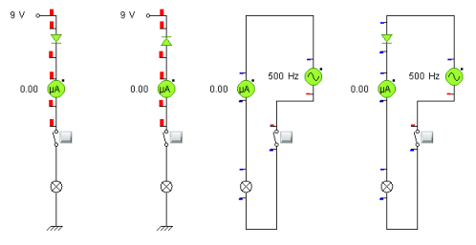

Model 1

1. Open the Yenka activity week 9 file **Diodes_model1.cxp**.
2. Use the switches to turn on each of the circuits. Observe any current arrows.
3. Give two differences between the first two circuits.

1. The last two circuits use an alternating current source. How many times does each of the bulbs in the last two circuits flash in one minute? Explain the difference.

A diode acts as a one-way street for current. When it is connected with the arrow symbol pointing away from the more positive terminal, electrons can flow through the diode causing a current.

**Task 2: A practical application of diodes**

1. Open the Yenka activity week 9 file **Diodes_model2.cxp**.
2. Make sure you have the graph visible and turn on the switch for the first circuit. Observe the current graph. Sketch the circuit and the graph below.

***Circuit Graph (label axes)***

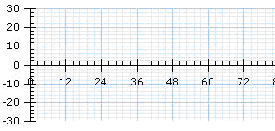

1. Repeat 2 for the second circuit. What is the difference? Why?

Sketch the circuit and the graph below.

***Circuit*** ***Graph (label axes)***



1. Repeat 2 for the last circuit. How does it compare with the other two? What is the practical benefit to energy efficiency of this arrangement?

 Sketch the circuit and the graph below.

***Circuit*** ***Graph (label axes)***



1. Use your finger to trace the current from the top of the voltage supply, through the diodes, through the resistor and back to the bottom of the supply. Then follow it back again as the current reverses. On your previous circuit diagram show the direction of current flows in opposite directions through the circuit using arrows of two different colours. Remember the diodes act as one-way streets for current. Why would this arrangement be necessary for a device that uses direct current?

A single diode produces half-wave rectification when used with an AC signal. The third circuit uses diodes in an arrangement that gives full wave rectification. When used with a capacitor, afull wave rectifier can provide a DC supply from an AC source.

**PHYSICS QUESTIONS: DIODES**

**Give answers to 2 significant figures**

|  |  |
| --- | --- |
| 1 | Consider the circuit shown below to answer Questions 1 – 4.  **30Ω**  **60V**  **60Ω**  **40Ω**  **50Ω**  Calculate the effective resistance of this circuit.  ***Equivalent circuit diagram + calculations*** (2 marks) |

Ω

|  |  |
| --- | --- |
| 2 | Calculate the current in each of the four resistors shown above.  ***Show all formula(s) and calculations*** (2 marks) |

I30A

I40A

I50A

I60A

|  |  |
| --- | --- |
| 3 | Calculate the voltage drop across each resistor. Answer on next page  ***Show all formula(s) and calculations*** (2 marks) |

V30 V

V40 V

V50 V

V60 V

|  |  |
| --- | --- |
| 4 | Calculate the total power dissipated in this circuit.  ***Show all formula(s) and calculations*** (2 marks) |

W

|  |  |
| --- | --- |
| Questions 5-7 refer to the following information.  You have a battery, four 3Ω resistors and a switch. How would you arrange the resistors to give a total effective resistance of: | |
| 5 | 0.75Ω  ***Circuit diagram + calculation required*** (1 mark) |
|  |  |
| 6 | 4Ω  ***Circuit diagram + calculation required*** (2 marks) |
|  |  |
| 7 | 7.5Ω  ***Circuit diagram + calculation required*** (2 marks) |

|  |  |
| --- | --- |
|  | Questions 8 – 14 refer to the following two graphs.  A diode and a light globe have I-V characteristics shown in the figures below:  image058  The diode and light globe are connected to a 2.0 V DC source as shown in the diagram below. |
|  |  |
|  |  |
| 8 | Does the globe light up? Yes or No.  (1 mark) |

|  |  |
| --- | --- |
|  |  |
|  | Answer either Question 10 or 11 below, depending on your answer to Question 9 above. |
| 9 | If globe ***does*** light up, calculate the current – **in mA** – that flows in the globe.  ***Include an explanation and calculations*** (1 mark) |
|  | mA |
| 10 | If globe ***doesnot*** light up, explain why not.  (1 mark) |

|  |  |
| --- | --- |
|  | The diode and light globe are now connected as shown below. Note that the new battery voltage has been increased to 2.3 volts DC.  **2.3V DC** |
| 11 | Does the globe light up? Yes or No.  (1 mark) |
|  |  |
|  | Answer either Question 13 or 14 below, depending on your answer to Questions 12 above. |
| 12 | If globe lights up, calculate the current – **in mA** – that flows in the globe.  ***Include explanation and calculations Answer in mA***(1 mark) |
|  | mA |
|  |  |
| 13 | If globe does not light up, explain why not.  (1 mark) |

|  |  |
| --- | --- |
| 14 | The 2.3V DC source is now replaced with a ***low frequency AC source****.* What do you observe? Explain your observation.  ***Observation + explanation required.***  (2 marks) |

***Observation:***

***Explanation:***

Questions 15 -17 refer to the following graph.

A thermistor is a device the resistance of which varies with temperature. The resistance-temperature characteristic for a thermistor is shown below.

|  |  |
| --- | --- |
| 15 | What is the value of the resistance of the thermistor at 20°C?  ***Answer required.***  (1mark) |



Ω

The thermistor is incorporated into the control circuit for the refrigeration unit of a coolroom the circuit is shown below.



The relay switches the refrigeration unit ON when voltage, V, across variable resistor R≥4V and switches OFF when V < 4 V.

The refrigeration unit must turn on when the temperature of the coolroom rises to, or exceeds, 5°C.

|  |  |
| --- | --- |
| 16 | At what value should variable resistor R be set so that the refrigeration turns on at this temperature?  ***Formula and calculations required.***  (2 marks) |

Ω

|  |  |
| --- | --- |
| 17 | The coolroom is not cold enough. To set the temperature lower, should R be increased or decreased? Explain your answer.  ***Explanation required.***  (3 marks) |

**Yenka activity: TheAmplifier**

**PART 2: AMPLIFIERS**

Open **Yenka.** Click on**New Model**. From the Parts Library (on the left of screen) click on **Electronics**, **Analogue.** Drag the following components shown below on to the simulation window: **Power supplies** (Zero volt rail), **Passive components** (resistors ×2), **Signal Generators** (Signal generator), **Integrated circuits** (741 Operational amplifier), **Meters** (Voltmeter). Click on each component to rotate it if required (a small circle should appear above the component).Clickon the signal generator to select it, and change the frequency to 0.1 Hz and the peak voltage to 2 volts in the properties pane that appears to the left of the workspace**Save your file as you go along**!

To wire components together, click and drag with your mouse. Refer to the **Help** menu if you are not sure what to do here. **Save your file!**

From the Parts Library click **Presentation** and drag the **Graph** icon onto the simulation window.

Click and drag on the **Target** tool next to the red dash on the graph part so that a dashed line connects the tool to the signal generator of the circuit. It connects when the line goes solid (to show that an association has been made). Release the mouse button. The line now turns a red-dashed colour. Click on the graph pane and go to **Traces** in the graph window at left and make sure that this is **Trace 1** and **Red.** Click on **Trace 2** in the drop down menu. Tick the **Show Trace** box. It should be blue. Another Target tool should appear in the graph window. Repeat the above procedure for the Target tool but this time drag the tool to the voltmeter. This should be a blue-dashed colour**. Save your file!**

Click on Property... just to the left of the Y-axis on the graph and choose Voltage from the list that appears for both Target tools. Select the graph and open the Properties pane. Open the Y-axis section and set the Min. and Max. values to -10 and 10V. Open the X-axis section and set the Min. and Max. values to 0 and 50s. Two traces should appear on your graph. **Save your file!**

**Feedback resistor**

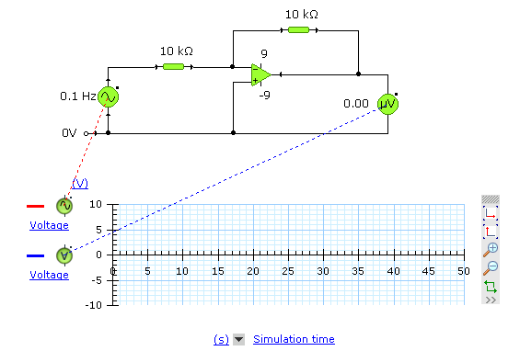

**Click if need to re-start the graph**

**Yenka activity: Transistor Amplifier**

**Question 1**

Copy the two traces from your Yenka graph. You should have a **red** trace and a **blue** trace.Clearly label and number your axes and traces.

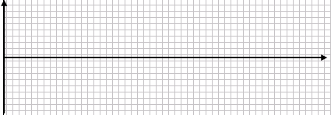

**Question 2**

Is this an inverting or a non-inverting amplifier? Explain your answer.

What is the voltage gain of this amplifier?

**Question 3**

Change the value of the feedback resistor to achieve the maximum voltage gain for this particular amplifier. Sketch the graphs and write the feedback resistor value.



**Question 4**

Change the value of the feedback resistor to observe the clipping of the output voltage. Sketch the graph and write the feedback resistor value.



**PHYSICS QUESTIONS: AMPLIFIERS**

|  |  |
| --- | --- |
|  | A small voltage amplifier has the transfer characteristic shown below.  image031  **VOUT**  **VIN** |
| 1 | Calculate the linear gain of the amplifier (magnitude and sign) and state whether this amplifier is inverting or non-inverting.  ***Formula and calculation required***. (2 marks) |

Linear Gain

Mag Sign

Inverting / Non-inverting

|  |  |
| --- | --- |
|  | A 2.0Vp-p (±1.0V) AC input signal is applied to the amplifier as shown below.    time (ms)  Input signal  (Volts) |
| 2 | On the graph above draw the **output AC signal**. (2 marks) |

|  |  |
| --- | --- |
|  | *Questions 3-7 refer to the following information.*  A single stage npn transistor amplifier and its transfer characteristic are shown on the next page. The transistor is correctly biased. |

+10V

R1

R2

**VOUT**

VR2

**VIN**

°

°

°

°

°

°

|  |  |
| --- | --- |
|  | Vout (V)  Vin (V)  0  1.8  10  0.8 |
|  |
| 3 | What are the DC input and output biasing voltages? (2 marks) |

V

V

Biasing Input Voltage Biasing Output Voltage

|  |  |
| --- | --- |
| 4 | What are maximum and minimum possible output voltages? (2 marks) |

Max: V

Min: V

|  |  |
| --- | --- |
| 5 | What is the value of R2 when R1 is 10kΩ?  ***Formula and calculations required***. (3 marks) |

Ω

|  |
| --- |
| A 1.6Vp-p (±0.8V) AC input signal VIN is now applied to the transistor as shown below. |

**2**

**4**

**6**

**8**

**t (ms)**

**VIN**

**(V)**

**0.8**

**−0.8**

|  |  |
| --- | --- |
| 6 | On the axes below sketch the AC input signal after biasing when a 1.6Vp-p (±0.8V) AC input signal is applied.  ***Biasing voltage graph + clearly numbered axes***(2 marks) |

**t (ms)**

**2**

**4**

**6**

**8**

**VIN after**

**biasing**

**(V)**

|  |  |
| --- | --- |
| 7 | On the axes below sketch the AC output signal (see circuit diagram) when an AC input signal VINof 1.6Vp-p (±0.8V) is applied.Comment on the quality of the signal.  ***Complete Graph. Clearly numbered Y-axis*** (3 marks) |

**t (ms)**

**2**

**4**

**6**

**8**

**VOUT**

**(V)**

|  |
| --- |
| ***Comment on signal*** |

|  |  |
| --- | --- |
| 8 | What is attenuation?  ***Explanation required*** (2 marks) |

|  |  |
| --- | --- |
| 9 | Describe the skin effect in copper wires and explain why it occurs?  ***Explanation required*** (3 marks) |

|  |  |
| --- | --- |
| 10 | Explain why the light signals in optical fibres are not affected by the skin effect?  ***Explanation required*** (2 marks) |

|  |  |
| --- | --- |
| 11 | Compare the information-carrying capacity of copper wires and optical fibres?  ***Explanation required*** (2 marks) |

**MORE PHYSICS QUESTIONS**

|  |  |
| --- | --- |
| A circuit using an LDR is shown below. The fixed resistance R1 is 9.0kΩ.  **VOUT**  R2  10 V  **10V**  **R1** | |
| The LDR has the characteristics shown below. The resistances on the Y-axis are in kΩ    **Light Intensity**  **(lux)**  **Resistance**  **(kΩ)** | |
| 1 | What will be the output voltage VOUT when the light intensity is 500 lux?  ***Formula and calculation required*** (2 marks) |

V

|  |  |
| --- | --- |
| 2 | It was decided to use the circuit above as a night light, ie, a light will switch on at VOUT when the light level outside decreases to a certain level.  Will this circuit work as a night light? If so explain why it works. If it does not work explain why not and suggest an alternative circuit that will allow VOUT to turn on.  ***Answer + explanation/circuit diagram*** (3 marks) |

***Does this circuit work as a night light?***

***Explanation:***

|  |  |
| --- | --- |
|  | A light-emitting diode (LED) is a special type of diode that emits light when the current is greater than about 20mA. The figure below shows the I-V characteristic for an LED.  image062 |
|  | The LED is used in the circuit shown below and is observed to glow brightly. The 50Ω resistor is included to prevent too large a current flowing which might damage the LED.  image064 |

|  |  |
| --- | --- |
| 3 | Calculate the potential difference across the 50Ω resistor, VYZ  ***Explanation and calculations required in your solution*** (2 marks) |

V

|  |  |
| --- | --- |
| 4 | What is the current, in ***milliamps***, through the LED in the circuit shown above?  ***Explanation and calculations required in your solution*** (2 marks) |

V

|  |  |  |  |
| --- | --- | --- | --- |
|  | A student carries out a practical activity on an LED. She initially sets up the circuit shown below. She can measure the voltage across the diode and the resistor as well as the EMF supplied by the variable DC power supply, giving an I-V graph for the diode (see below). The light output increases as the forward current, IF, through the LED increases. | | |
| **A**  A  IF  R=500 Ω | | | | Week13a |
| 5 | | The current IF in the circuit is 150 mA. Calculate the voltage drop across the resistor. | |
|  | | ***Formula and calculations required*** (2 marks) | |

V

|  |  |
| --- | --- |
| 6 | Calculate the voltage of the supply.  ***Formula and calculations required*** (2 marks) |

V

|  |  |  |
| --- | --- | --- |
| 7 | Audio CDs are scanned by laser light. The reflected light is detected by a photodiode. A possible circuit is shown below right. The variation in photodiode current as a function of light intensity is shown below left. | |
| **10**  **20**  **30**  **photodiode current**  **(μA)**  **light intensity (lux)**  **50**  **150**  **250** | | **+5V**  **°**  **R = 200 Ω**  photodiode  **VOUT**  **°**  **°** |
|  | When light falls on the photodiode the output voltage VOUT  is 6.0mV. What is the intensity of the light, in lux, that is striking the photodiode? Note: the phototdiode current is proportional to the light intensity.  ***Formula and calculations required*** (2 marks) | |

lux

|  |  |
| --- | --- |
|  | The following is a phototransistor (PT) circuit. The light is incident upon the base region of the PT and produces a collector current IC.  **RC**  **IC**  **10V**  **VOUT**  PT |

|  |  |
| --- | --- |
| 8 | When light of intensity 100 lux falls on the PT a current of 1.0μA flows in the circuit and the output voltage VOUT = 4.0V. What is the value of RC in MΩ?  ***Formula and calculations required*** (2 marks) |

MΩ

|  |  |
| --- | --- |
| The light intensity is changed, and the output voltage VOUT is now 7.0V. | |
| 9 | What is the value, in lux, of this new light intensity?  ***Formula and calculations required*** (3 marks) |

lux

|  |
| --- |
| The circuit below is used to detect a customer as they enter and leave a shop by walking through a light beam. The light source is a light-emitting diode (LED), and the light sensor is a light-dependent resistor (LDR). The 11V power supply delivers a current of 3.0mA. |

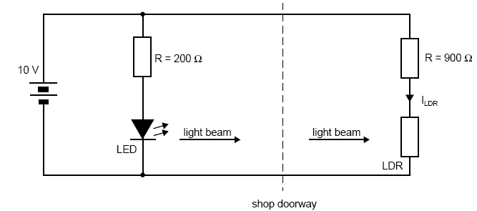

**11V**

**R=1.0kΩ**

**I=3.0mA**

**R = 5.0kΩ**

**ILDR**

|  |  |
| --- | --- |
| The characteristics of the LDR are shown on the next page. | |
|  |  |

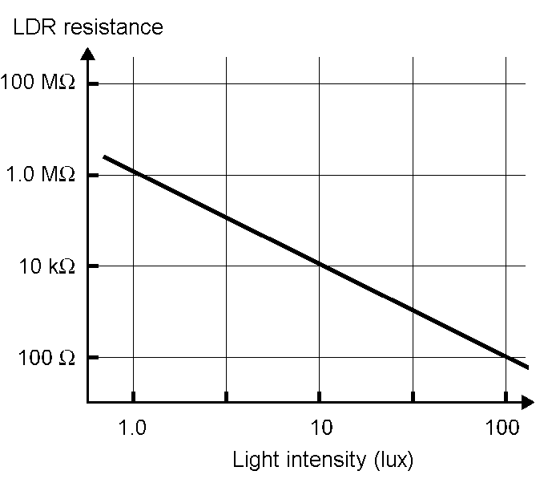

|  |  |
| --- | --- |
| A butterfly happens to fly through the shop door and momentarily breaks the light beam. The incident light intensity at the LDR is 10 lux. | |
| 10 | Calculate the currentILDR. , in mA, in the LDR circuit.  ***Formula and calculations required*** (2 marks) |

mA

|  |  |
| --- | --- |
| 11 | Calculate the resistance of the LEDthat gave rise to the light beam.  ***Formula and calculations required*** (3 marks) |

Ω